How to enable social logins in the Document Delivery Notification Letter

The Document Delivery Notification Letter is sent to patrons with links to files that have been digitally received for fulfilling a resource sharing request. The links in the email require authenticated access to the resource.
The out of the box email has link examples that support 4 authentication schemes:
- Alma internal logins using the Ex Libris Identity Service
- Login via the locally managed LDAP server
- Login using a SAML based IdP such as Shibboleth
- Login using CAS
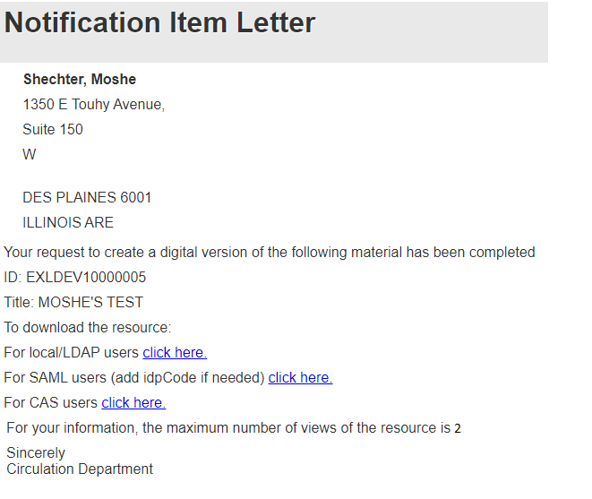
If you would like to add options for social login, the following needs to be added to the XML template of the Document Delivery Notification Letter.
Note that each type of social authentication is added as a separate link to the email. The below example shows adding a GOOGLE and an EMAIL option using ‘provider=GOOGLE’ and ‘provider=EMAIL’ in the configured URL respectively, as highlighted below. For Open ID Connect, Twitter and Facebook the configured ‘provider’ should be OIDC, TWITTER and FACEBOOK respectively:
- Add the below variables to the XSL of the notification email:

- Add the below links to the link options of the XSL of the notification email
<tr>
<td>
To log in with Google
<a><xsl:attribute name="href"><xsl:value-of select="$GOOGLE_URL"/> </xsl:attribute>@@click_here@@</a>
</td>
</tr>

<tr>
<td>
To log in with Email
<a><xsl:attribute name="href"><xsl:value-of select="$EMAIL_URL"/> </xsl:attribute>@@click_here@@</a>
</td>
</tr>

<xsl:variable name="SAML_URL">
<xsl:value-of select="notification_data/download_url_saml" />
</xsl:variable>

<xsl:variable name="DOCID">
<xsl:value-of select='substring-after($SAML_URL,"digitalDoc")'/>
</xsl:variable>

<xsl:variable name="GOOGLE_URL">
<xsl:value-of select='concat("{YOUR ALMA URL}/services/login?auth=social&amp;provider=GOOGLE&amp;institute={YOUR INSTITUTION CODE}&amp;digitalDoc",$DOCID)'/>
</xsl:variable>

<xsl:variable name="EMAIL_URL">
<xsl:value-of select='concat("{YOUR ALMA URL}/services/login?auth=social&amp;provider=EMAIL&amp;institute={YOUR INSTITUTION CODE}&amp;digitalDoc",$DOCID)'/>
</xsl:variable>

The resulting email will be:
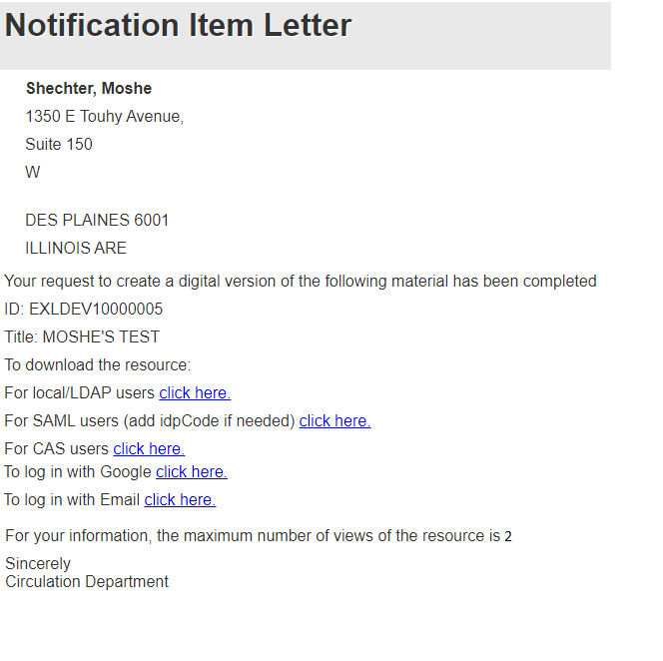

A clip of social authentication used for accessing a digitized document is here.
Below is a sample XSL.
<?xml version="1.0" encoding="utf-8"?>
<xsl:stylesheet version="1.0"
xmlns:xsl="http://www.w3.org/1999/XSL/Transform">
<xsl:include href="header.xsl" />
<xsl:include href="senderReceiver.xsl" />
<xsl:include href="mailReason.xsl" />
<xsl:include href="footer.xsl" />
<xsl:include href="style.xsl" />
<xsl:include href="recordTitle.xsl" />
<xsl:variable name="conta1">0</xsl:variable>
<xsl:variable name="stepType" select="/notification_data/request/work_flow_entity/step_type" />
<xsl:variable name="externalRequestId" select="/notification_data/external_request_id" />
<xsl:variable name="externalSystem" select="/notification_data/external_system" />
<xsl:variable name="isDeposit" select="/notification_data/request/deposit_indicator" />
<xsl:variable name="isDigitalDocDelivery" select="/notification_data/digital_document_delivery" />

<xsl:variable name="SAML_URL">
<xsl:value-of select="notification_data/download_url_saml" /></xsl:variable>
<xsl:variable name="DOCID">
<xsl:value-of select='substring-after($SAML_URL,"digitalDoc")'/>
</xsl:variable>

<xsl:variable name="GOOGLE_URL">
<xsl:value-of select='concat("http://il-yehad-3060.corp.exlibrisgroup.com:1801/services/login?auth=social&amp;provider=GOOGLE&amp;institute=EXLDEV1_INST&amp;digitalDoc",$DOCID)'/>
</xsl:variable>
<xsl:variable name="EMAIL_URL">
<xsl:value-of select='concat("http://il-yehad-3060.corp.exlibrisgroup.com:1801/services/login?auth=social&amp;provider=EMAIL&amp;institute=EXLDEV1_INST&amp;digitalDoc",$DOCID)'/>
</xsl:variable>

<xsl:template match="/">
<html>
<head>
<xsl:call-template name="generalStyle" />
</head>
<body>
<xsl:attribute name="style">
<xsl:call-template name="bodyStyleCss" />
<!-- style.xsl -->
</xsl:attribute>
<xsl:call-template name="head" />
<!-- header.xsl -->
<xsl:call-template name="senderReceiver" />
<!-- SenderReceiver.xsl -->
<div class="messageArea">
<div class="messageBody">

<table cellspacing="0" cellpadding="5" border="0">
<tr>
<td>@@your_request@@</td>
</tr>
<tr>
<td>ID: <xsl:value-of select="notification_data/external_request_id"/></td>
</tr>
<tr>
<td>@@title@@: <xsl:value-of select="notification_data/phys_item_display/title"/></td>
</tr>

<tr>
<td>@@to_see_the_resource@@</td>
</tr>
<tr>
<td>@@for_local_users@@<a><xsl:attribute name="href"><xsl:value-of select="notification_data/download_url_local" /></xsl:attribute>@@click_here@@</a></td>
</tr>
<tr>
<td>@@for_saml_users@@<a><xsl:attribute name="href"><xsl:value-of select="notification_data/download_url_saml" /></xsl:attribute>@@click_here@@</a></td>
</tr>
<tr>
<td>@@for_cas_users@@<a><xsl:attribute name="href"><xsl:value-of select="notification_data/download_url_cas" /></xsl:attribute>@@click_here@@</a></td>
</tr>
<tr>
<td>To log in with Google <a><xsl:attribute name="href"><xsl:value-of select="$GOOGLE_URL" /></xsl:attribute>@@click_here@@</a></td>
</tr>
<tr>
<td>To log in with Email <a><xsl:attribute name="href"><xsl:value-of select="$EMAIL_URL" /></xsl:attribute>@@click_here@@</a></td>
</tr>
<tr>
<td>@@max_num_of_views@@ <xsl:value-of select="notification_data/request/document_delivery_max_num_of_views"/>.</td>
</tr>
<tr>
<td>@@sincerely@@<br />@@department@@</td>
</tr>
</table>
</div>
</div>
<xsl:call-template name="lastFooter" />
<!-- footer.xsl -->
</body>
</html>
</xsl:template>
</xsl:stylesheet>

