

**Welcome to RefWorks!**

This guide will provide you with helpful tips needed to navigate RefWorks. For a comprehensive guide refer to the [RefWorks User Guide](https://knowledge.exlibrisgroup.com/RefWorks/Product_Documentation/RefWorks_User_Guide).

**CREATING YOUR ACCOUNT**

To get started with your new RefWorks account, go to [https://refworks.proquest.com](https://refworks.proquest.com/). Enter your institutional email address and create a password.

**NOTE:** RefWorks supports [Shibboleth and Open Athens](https://support.proquest.com/refworks3/articledetail?id=kA0400000004JJjCAM&key=shibboleth&pcat=All__c&icat=), which allows you to use your institutional credentials to sign into RefWorks.

Remote users accessing RefWorks from off-site or from a non-registered IP address, must either enter the unique URL provided by the institutional admin, log in via the organization’s proxy server, or log in using other institutional credentials (Athens, Shibboleth).

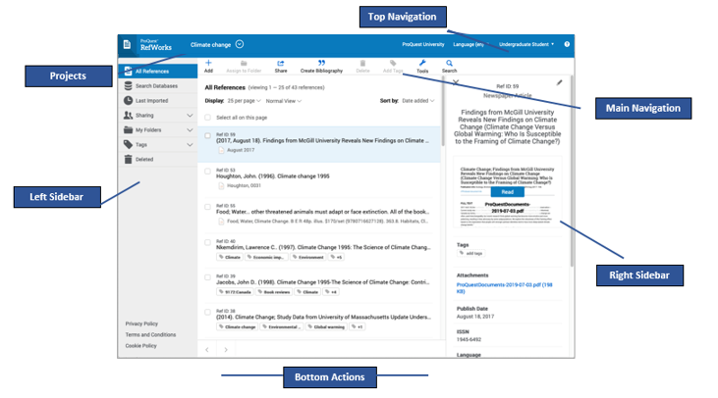

**NAVIGATING REFWORKS**

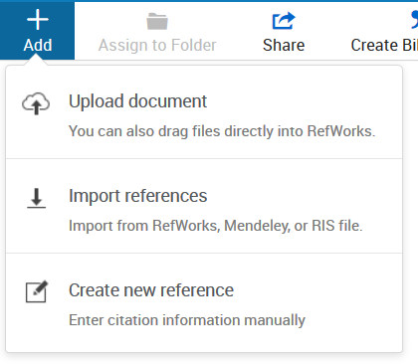

a. Click on the **Folder** icon to import into a specific folder. Choose an existing folder or create a new folder.

b. Click on Import. The newly imported references are placed in the **Last Imported** folder and can be assigned to folders by dragging and dropping or by using the ***Assign to Folder*** action in the Main Navigation.

**Create New Reference** – Search for a title or DOI, review the results and save the ones you choose, or manually add all reference meta data. When selecting **Create new reference** a new pane will appear on the right.

You can search for a reference or create it yourself.

1. Enter a title, or as much of the title as you can.
2. When available, click on the lightning icon button title_locate.png in the Title field to have RefWorks match the title with an item in the library. This button is also available after you enter a value in the DOI field, which appears for most reference types.
3. RefWorks displays possible suggestions at the bottom of the pane. If you select one, RefWorks completes the title and fills the fields with information from the library. You can later review or edit fields.
4. To keep the reference, click on ***Save***. The reference will be added to your **Last Imported**Folder*.*
5. If no match is found, you can create the reference by typing in the metadata yourself and clicking on ***Save***.

You can save references or articles, including full text (if available) from any website into RefWorks using the Save to RefWorks plug-in; refer to the **Tools** section below.

There are several ways to add references into Refworks.

Begin in the Main Navigation and click on **+Add**:

**Upload a Document** – these are documents from your own computer files. Example: PDF, PPT, Word Doc. They can also be uploaded with drag and drop anywhere on the All Documents page or Import a Reference page.

**Import a Reference** – allows you to import reference files from other reference managers, from legacy RefWorks and from other sources.

A successful import will generate a message similar to the following:

User-added image

To export references, navigate to the page or folder of the references you would like to export. Click on **Share** in the Main Navigation, then **Export references**. Select the relevant options and click on ***Export***.

**ADDING REFERENCES**

You can also add references by searching inlinked library catalogs and publicly available databases. Search results can be imported into your account with the click of a button.

1. Select the **Search Databases** tab from the left sidebar.
2. Open the dropdown and enter the name of the database you wish to search or select it from the list of recently used databases.
3. Enter the search term in the search box and click on the **Search** icon
4. Select the relevant items and use one of the following options to save the references:

**ORGANIZING REFERENCES**



RefWorks supports the full research process and provides a variety of options to help you better organize references.

**Left Sidebar:**

**All References** – Contains all references in the project.   
**Search Databases** – Used tosearch for items in external linked databases.  
**Last Imported –** Displays references imported in the last 30 days.  
**Sharing** – Enables you to view folders that were shared with you.  
**My Folders** – Allows you to organize references into folders and subfolders. A single reference can be in multiple folders. **Not in Folder** – Displays references that have not yet been moved into a folder.  
**Tags** – includes tags assigned to references that are imported and tags created by you when adding references. A reference can have multiple tags.  
**Deleted** – Contains all items that have been deleted.

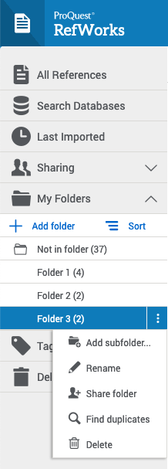

**ORGANIZING REFERENCES IN PROJECTS**

**ORGANIZING REFERENCES IN FOLDERS**

References can also be organized into projects, which are separate reference collections with unique folders, references, tags, etc. Most users will find they can organize their references sufficiently by using folders. For some users, especially those working on multiple research projects with different groups of people, the ability to isolate references and folders within a Project is needed. Your RefWorks account has a default project called Untitled Project. You can change the name and create new projects in the Manage projects page.

To add a folder:

1. Click on **+Add folder**
2. Name your folder
3. Click on ***Save***

To add a subfolder:

1. Click on the selected folder’s kabob icon User-added image(on the right)
2. Click on **Add subfolder...**
3. Follow prompts to name and save the subfolder.

You can sort folders alphabetically or drag and drop in your preferred order. You can toggle between the two sorting options using the **Sort** option under **My Folders**. When choosing the custom option, your latest custom sorting is restored.

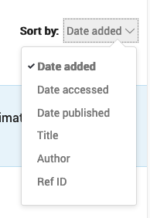

**VIEWING REFERENECES**

**Sort by:** Select how you want to display references: by date, title, author or Ref ID. RefWorks will remember your selected sorting the next time you open RefWorks.

**Number of references per page:** Select how many references you would like to appear on the page (from 25 to 2000 references).

**View type**: Select which view you prefer: Normal View (default), Table View, Full View or Citation View. RefWorks will remember your selected view the next time you open RefWorks.

****

Use the Advanced Search capability to find information in specific folders or reference metadata fields.

Access the **Advanced Search** by clicking on the **Search** icon in the Main Navigation.



Click on **Advanced** and an options panel will open.



Advanced searches can be created by selecting a variety of fields (including custom fields), search terms and Boolean operators.

**SHARING & COLLABORATING**

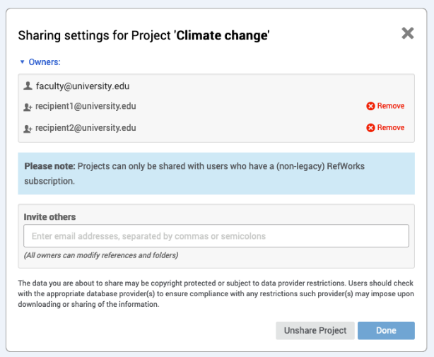

**PROJECT SHARING**

**FOLDER SHARING**

RefWorks sharing capabilities allow you to share folders and projects with others within or outside your institution. In addition to individual sharing, users can share folders with all users at their institution.

Select the folder you choose to share in your **My Folders** tab.

1. Click on the User-added image icon and select **Share Folder** or click on the **Share** icon in the Main Navigation.
2. In the Sharing Settings screen use the dropdown options to configure:
   * Settings for: Which references to share
   * Public URL: Create a URL to provide access to people who do not have a RefWorks account. They will be able to view, sort, export references and create a bibliography.
   * Shared with: Type the email addresses, designate if the recipients can read, annotate or modify and optionally add a message.
3. Click on ***Done***.

You can share a project with other RefWorks users.

* Doing so makes them a project owner and gives them full permissions within the project, including adding, deleting, and modifying folders and references.
* Any project owner can delete the project, as long as it is not the current project of any owner.

Select “Share this Project” from the Project dropdown menu or from a project’s “Actions” button on the My Projects page (Project Menu > Manage Projects):

The Project Sharing Settings page appears, allowing to invite users to the project, and displaying users with whom the project was already shared.

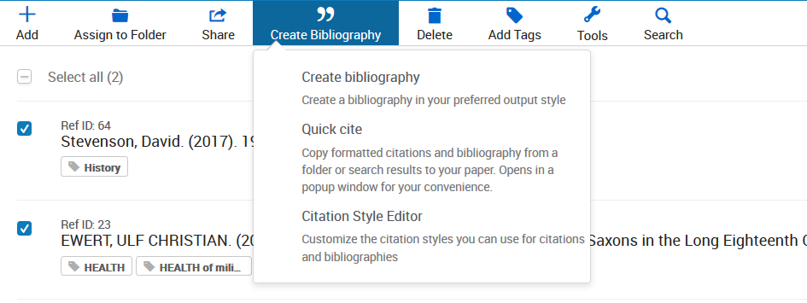

**TOOLS**

**RESOURCES/SUPPORT**

RefWorks offers add-on and plug-in tools to help with your research. To access these, click on **Tools** in the Main Navigation.

**Save to RefWorks**

By installing the Save to RefWorks plug-in in your browser, you will be able to save a reference or article, including full text (if available) from any website into your RefWorks account.

**Plug-ins for Microsoft Word and for Google Docs**

These plug-ins allow you to quickly insert citations and a bibliography to your document using references from your RefWorks folders. Follow the details in the Tools section to identify the plug-in relevant for you and follow the installation instructions.

**You can create citations and a bibliography from selected references or folders.**

* + 1. Navigate to the page or folder of references you want to use.
    2. Click on **Create bibliography** in the Main Navigation.
    3. Click on **Quick Cite**.

Choose your preferences:

1. **Citation Style:** RefWorks will remember the last citation style you used. You can change styles by clicking on the style name and either searching for a new style or selecting from the displayed list.
2. **Insert Citations:** Select the references for which you would like to create citations. As you select references, their corresponding citations will be displayed in the text box.
3. Click on the clipboard icon, navigate to your document and paste the formatted citations. Don’t forget to save your paper when you're done!
4. Click on **Continue to bibliography** to generate a bibliography which you can copy and paste into your document. You can also click on **Create bibliography** in the main Navigation and then again on **Create bibliography** to skip creating citations.

* [Ex Libris RefWorks Knowledge Center](https://knowledge.exlibrisgroup.com/RefWorks) offers various resources for Admins and users.
* [RefWorks YouTube Channel](https://www.youtube.com/channel/UCzmTj_AGeY59VoNv-0SvcCg)
* The RefWorks Technical Support team is available to assist you with any issues that come up while using RefWorks. Please [submit a case](https://supportcase.exlibrisgroup.com/?product=Refworks), case contact us by email: [support@refworks.com](mailto:support@refworks.com)

**You can create citations and a bibliography from selected references or folders.**

* + 1. Navigate to the page or folder of references you want to use.
    2. Click on **Create bibliography** in the Main Navigation.
    3. Click on **Quick Cite**.

**CREATING CITATIONS OR A BIBLIOGRAPHY**