|  |  |
| --- | --- |
| **How to suppress or delete all bibliographic records which have no inventory** |  |



In this example we will make a set of all records which have no inventory, and then show how to

1. Suppress the bibliographic records from discovery (this is in step three below)
2. Delete the bibliographic records from the repository (this is in step four below)

By either suppressing or deleting the records we can ensure more optimal search results for the end user in discovery.

**ONE**

Via an “All Titles” Advanced Search retrieve all Bibliographic records that do not have inventory. This can be done by searching via index ‘Has Inventory” with value “No”.

Click ’Advanced Search’

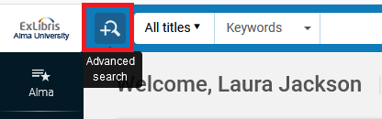

Perform a search in the institution for ‘Has Inventory = No”



**TWO**

Save the results as set.



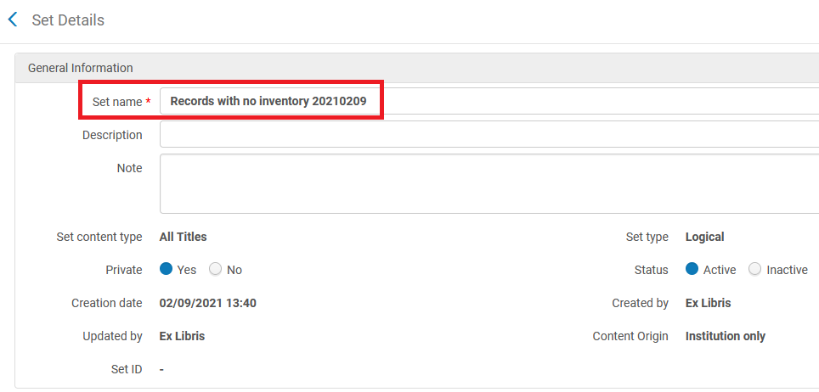

**THREE**

To do the first option, suppressing all records in the set, run the job “Suppress MMS from discovery”.

When running the job choose the set created above.

This job is accessed and run as follows:

Alma menu > Admin > Manage Jobs and Sets > Run a Job > Filter by Type ‘Management Tags’ > Select “Suppress MMS from Discovery” and click ‘Next’

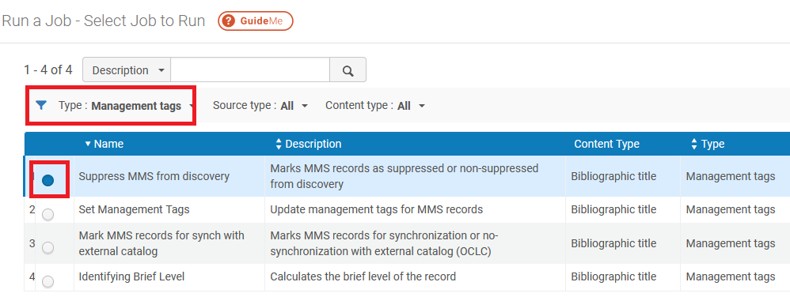

Select the set created above and click ‘Next’

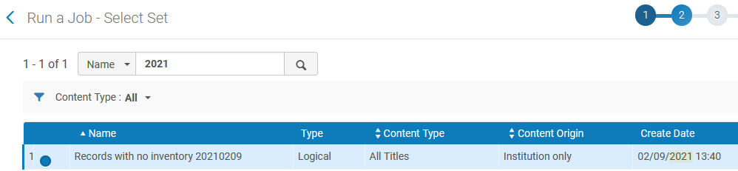

Select “Suppressed from discovery = true”

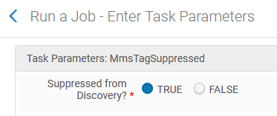

When job completes see that all records with no inventory are suppressed:

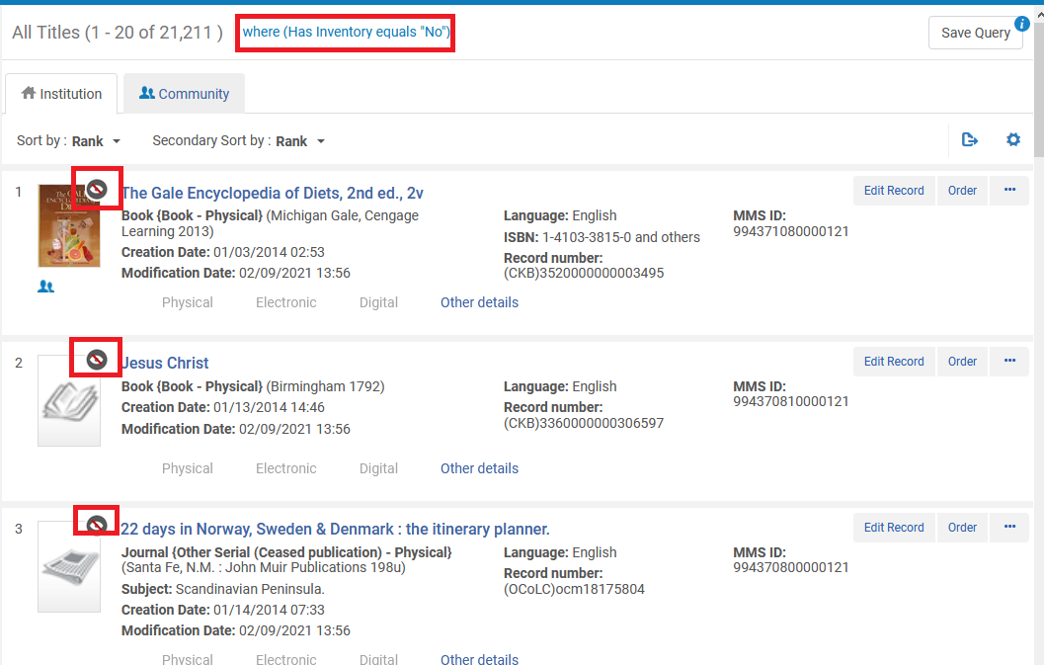

**FOUR**

To do the second option, deleting all records in the set, run the job “Delete Bibliographic Records”.

When running the job choose the set created above.

This job is accessed and run as follows:

Alma menu > Admin > Manage Jobs and Sets > Run a Job > Filter by Type ‘Withdraw’ > Select “Delete Bibliographic Records” and click ‘Next’

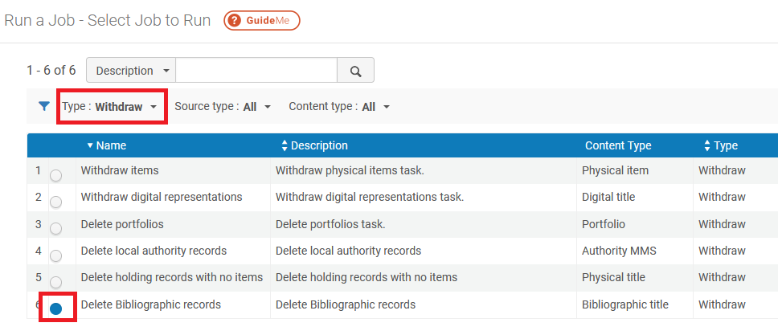

Select the set created above and click ‘Next’

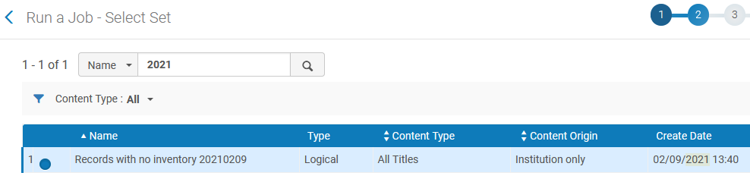

If desired select “Do not delete if related to other records”.

The option “Delete all associated inventory resources” is irrelevant because we created the set for records with no inventory.

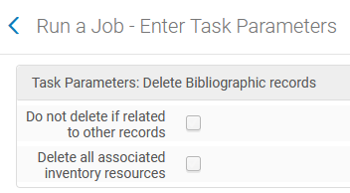

When job completes see that the records are deleted.