Statistical categories on User records

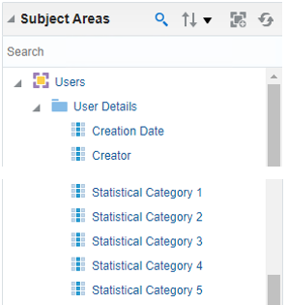

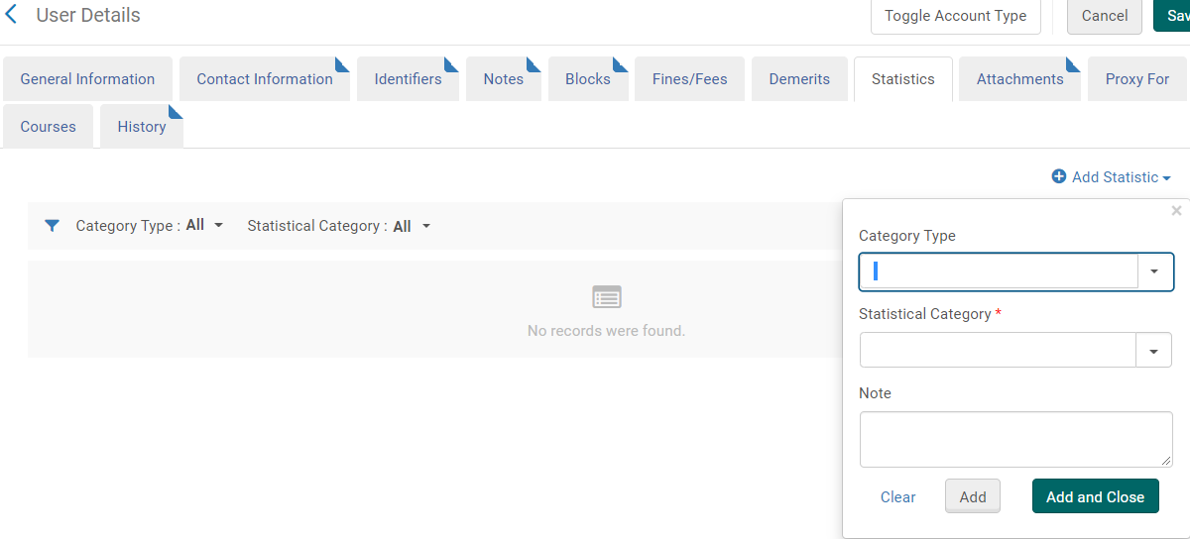

Explanation of configuring “Category type” and “Statistical category” can be found here https://knowledge.exlibrisgroup.com/Alma/Knowledge_Articles/Statistical_categories_in_user_records_and_Analytics

Reporting Codes on PO lines

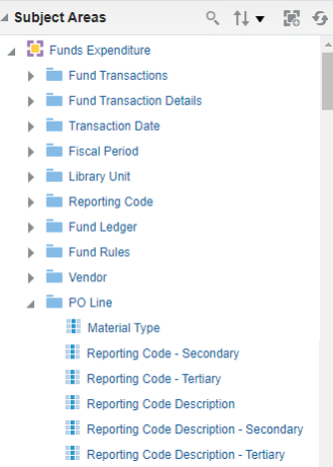
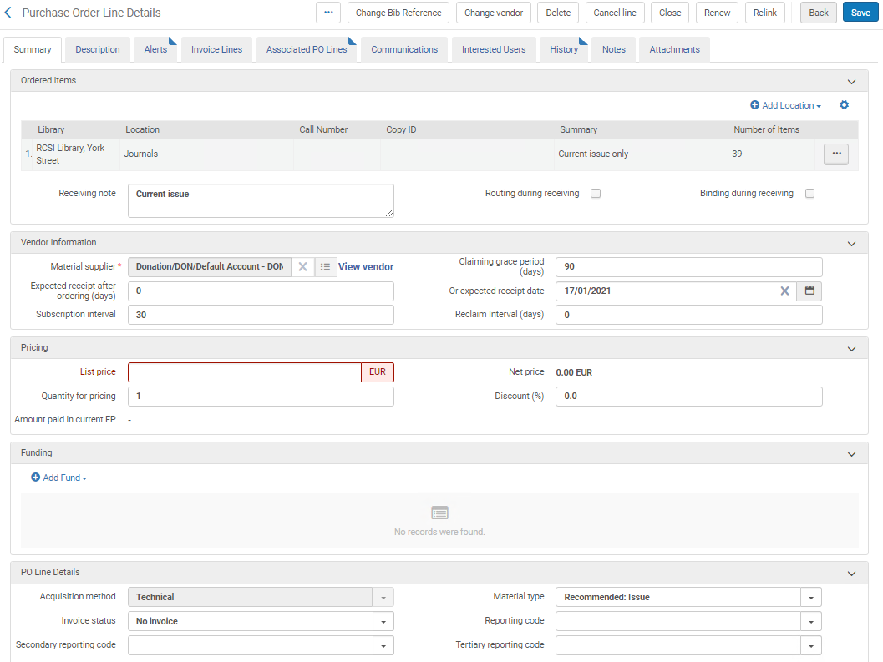

Configuration options can be found here https://knowledge.exlibrisgroup.com/Alma/Product_Documentation/010Alma_Online_Help_(English)/020Acquisitions/110Configuring_Acquisitions/020Configuring_Reporting_Codes

Local parameters (BIB and HOLs)
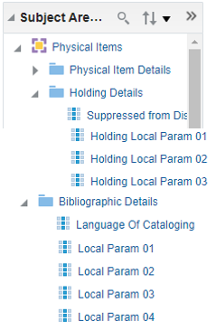

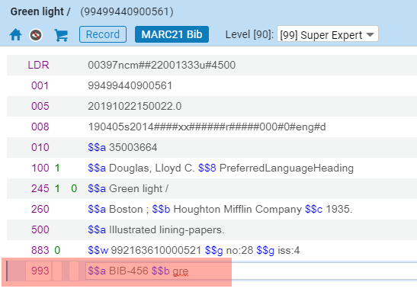

Information can be found here https://knowledge.exlibrisgroup.com/Alma/Knowledge_Articles/Add_bibliographic_fields_to_Alma_Analytics

