|  |  |
| --- | --- |
| **How to filter in an Analytics report for fields which contain a semicolon** |  |
|  | |

**Yoel Kortick**

**Senior Librarian**

**Question:**

I would like to filter by the field “Internal Note 1” in the “Physical Item Details” folder of the “Fulfillment” subject area for all notes which have a semicolon.

The problem is that when I filter “contains any” and use a semicolon I get a message “The operator 'contains any' requires at least 1 value(s).”

I put in a semicolon:

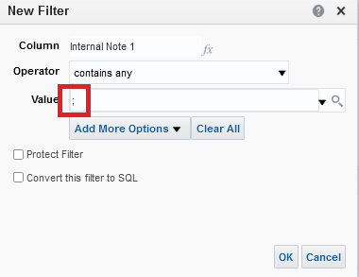

Then after I click OK I get this:

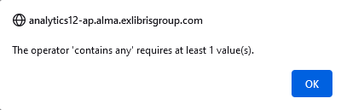

**Answer:**

We will do this using an SQL query

**ONE**

Do the filter with “Contains Any” and instead of using a semicolon use any other character such as the letter “a” and check the box “Convert this filter to SQL”. Click “OK”

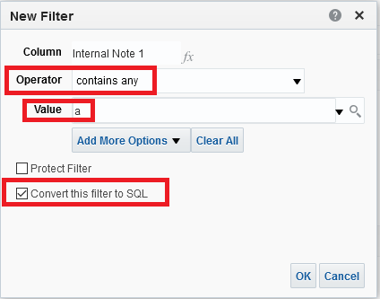

**TWO**

Edit the SQL filter

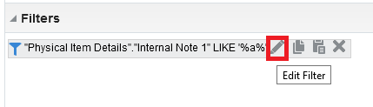

**THREE**

Replace the “a” with a semicolon.

Instead of this:

"Physical Item Details"."Internal Note 1" LIKE '%a%'

Have this:

"Physical Item Details"."Internal Note 1" LIKE '%;%'

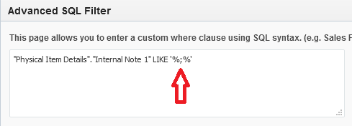

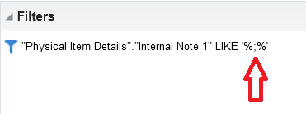

**FOUR**

Run the report and see that all fields retrieved have a semicolon.

