|  |  |
| --- | --- |
| **Bibliographic IDs in the "Titles" subject area of Alma Analytics** |  |



**Yoel Kortick**

**Senior Librarian**

In the "Titles" subject area the following fields were added to a new folder called "Bibliographic IDs":

1. ISBN valid single (normalized)
2. ISSN valid single (normalized)
3. OCLC Control Number single (035a).

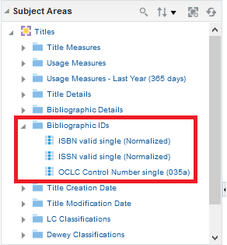

These fields are described in the [Titles Subject Area Field Descriptions](https://knowledge.exlibrisgroup.com/Alma/Product_Documentation/010Alma_Online_Help_(English)/080Analytics/Alma_Analytics_Subject_Areas/Titles#Field_Descriptions):

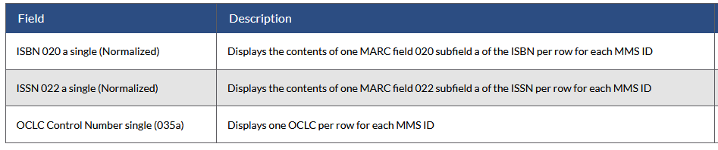

These fields differ from the corresponding fields which are present in the "Bibliographic Details" folder.

In the "Bibliographic Details" folder if the MMSID and the ISBN (for example) are displayed then there will be one MMSID per row with multiple ISBNs of that MMSID semicolon delimited.

For example, MMSID 9941857401891 has four ISBNs: 041590191X; 9780415901918; 0415901928; 9780415901925

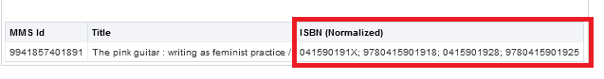

There are four in Alma Analytics because there are two in Alma, and they are also transformed to ISBN-13 in Alma Analytics (so we have the two originals and the two 13 character length versions)

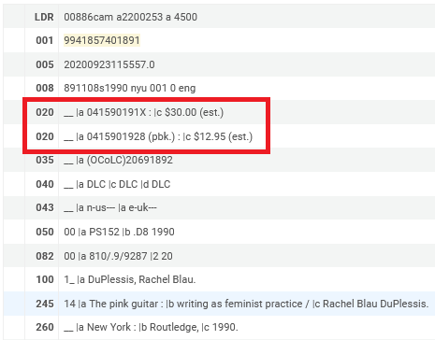

The ISBN single (normalized), however, will display one per row for each MMSID.

For example, here we add “ISBN valid single (normalized)” and we get one ISBN per line

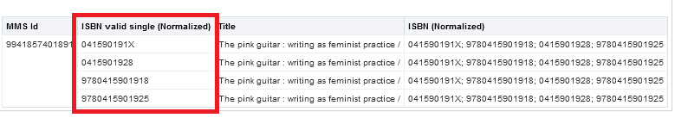

And we can filter by a specific ISBN

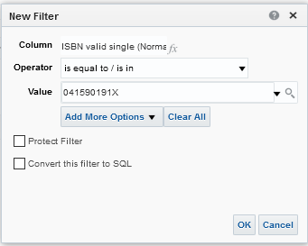

And then we get the one record which has this ISBN

