|  |  |
| --- | --- |
| **How to create a report of all loans which are overdue by 30 or more days** |  |



**Yoel Kortick**

**Senior Librarian**

**ONE**

From Alma do menu “General > Analytics > Design Analytics”

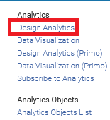

**TWO**

From Analytics do “New > Analysis” and choose subject area “Fulfillment”

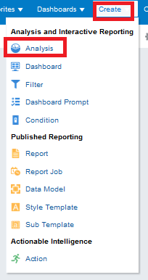 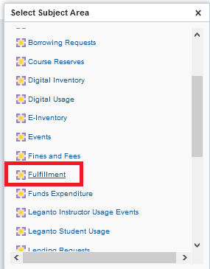

**THREE**

From left pane drag desired fields to right pane

For example drag these fields to the right pane:

* Due Date > Due Date
* Item Location at time of loan > Library Name
* Item Location at time of loan > Location name
* Bibliographic Details > Title
* Loan Details > Barcode
* Loan Details > Call Number
* Borrower Details > Last Name
* Borrower Details > First Name
* Borrower Details > Primary ID
* Preferred Contact Information > Preferred Email
* Preferred Contact Information > Preferred Phone Number

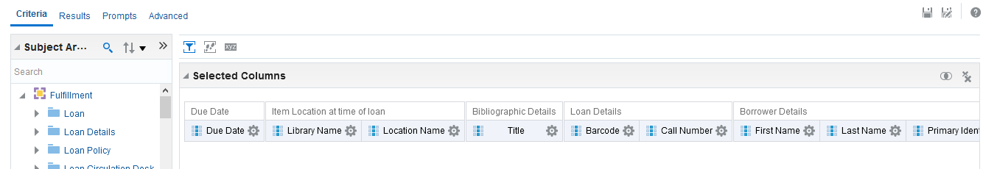

**FOUR**

We need to get only “Active” loans (not returned) so we will filter by loan status = active.

This is done by

1. Add filter > More Columns  
     
   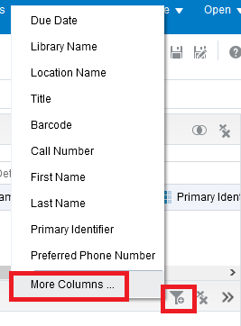
2. Choose: ”Loan Details > Loan Status”  
     
   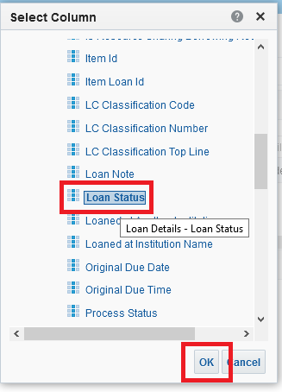
3. Filter by “Loan Status = Active”  
     
   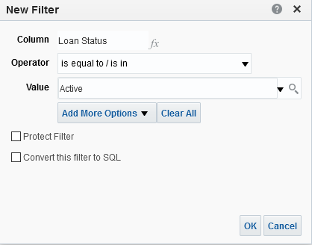

Now we will get everything with a due date 30 days or more in the past.

There are various ways to do this, we will show just one way.

This is done by

1. Add filter > More Columns



1. Choosing “Due Date > Due Date Filter” and “OK”

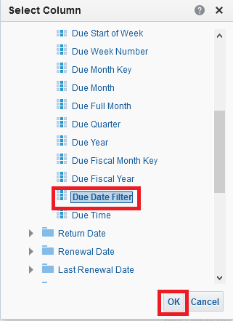

1. Choose “Is equal to “Older than 30 days”  
     
   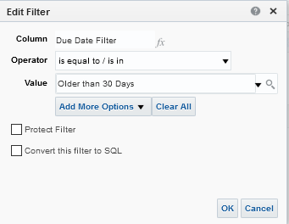

**FIVE**

Click the “Results” tab and see report

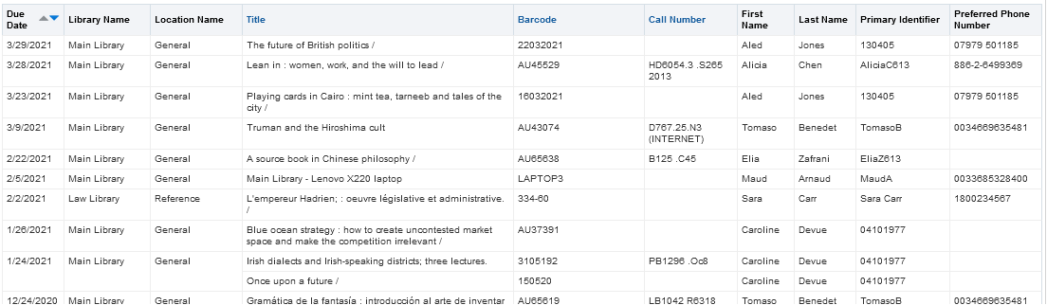

**SIX**

Save report

Click “Save As” on top right

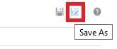

Choose location and save

