|  |  |
| --- | --- |
| **How to create an Alma Analytics report of all ordered items that have not yet been received** |  |



**Yoel Kortick**

**Senior Librarian**

**ONE**

From Alma do menu “General > Analytics > Design Analytics”

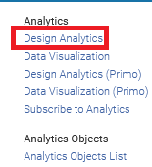

**TWO**

From Analytics do “Create > Analysis” and choose subject area “Funds Expenditure”

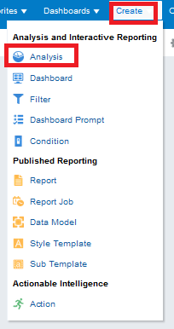 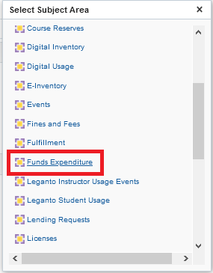

**THREE**

Add the desired fields to the report for example:

"Bibliographic Details > Author"

"Bibliographic Details > MMS Id"

"Bibliographic Details > Title"

"PO Line > Expected Receiving Date"

"PO Line > PO Line Reference"

"PO Line > Receiving Status"

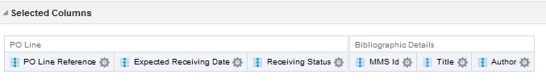

**FOUR**

Add filters on “Receiving Status” to get only “non-received” items”

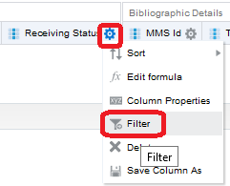

**FIVE**

Choose all the items that have not a receiving status = yes

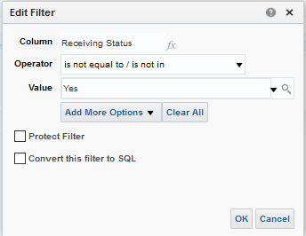

**SIX**

Filter on the “Expected Receiving date” and choose a value less than today:

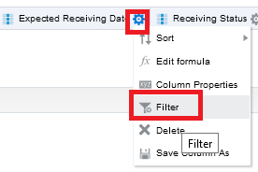

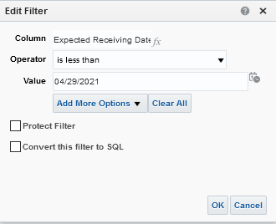

Note that instead of hard coding the expected receiving date to today it is possible to use sql to have it dynamically always use the current date. If you want to use a dynamic date via SQL:

In the filter choose to convert the filter to SQL

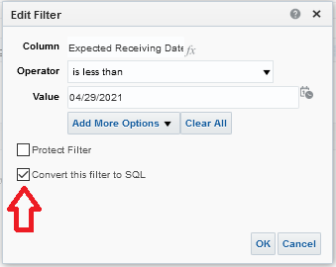

Then change the text of the filter to use current_date instead of a hard coded date

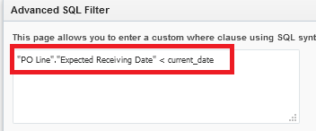

**SEVEN**

Run the report by clicking on the “Results” tab:

**EIGHT**

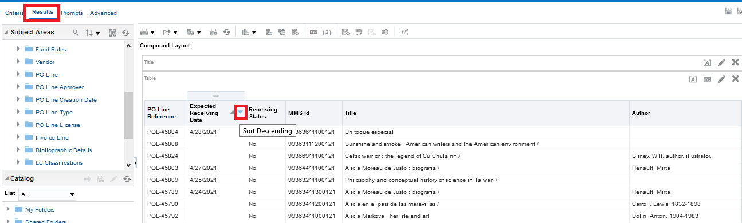

NINE

Click “Save As” on the top right and save the report in a desired location

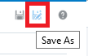

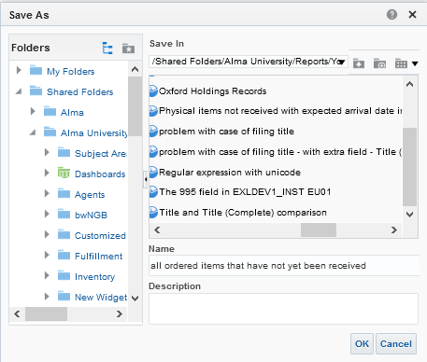

**TEN**

Let’s take a look at the first example, POL-45804

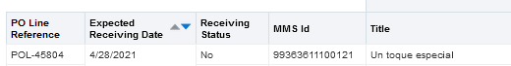

The POL is still in status “sent” and was supposed to arrive yesterday

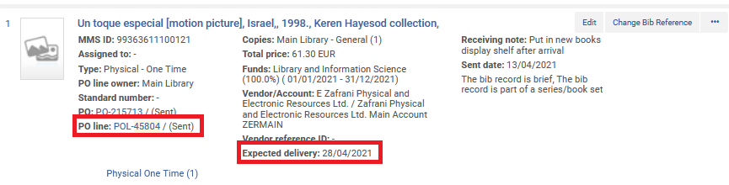

It also appears in the Receiving Workbench as having not yet arrived

