How to make the alternate rows of a table be shaded in an Alma Analytics table
Yoel Kortick
Senior Libraian

Question:
I have made a table in my Alma Analytics report but I see the whole table in white rows and therefore it is hard to read. How can I make each alternate row be shaded with a background color (like I can easily do in Microsoft Word) so that it will be easier to read? I know it is possible because I have seen other libraries do it.

Here is my table now

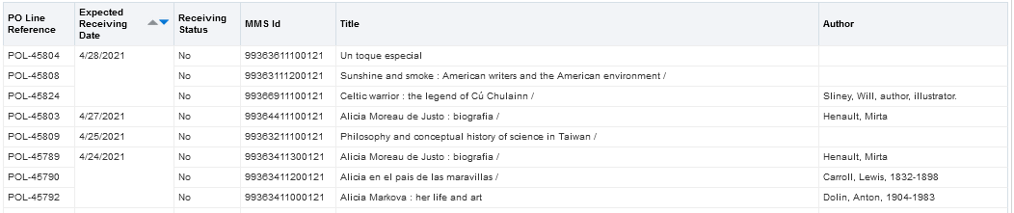

Answer:

ONE
When the table is open in the “results” tab click the “View Properties” icon on top right

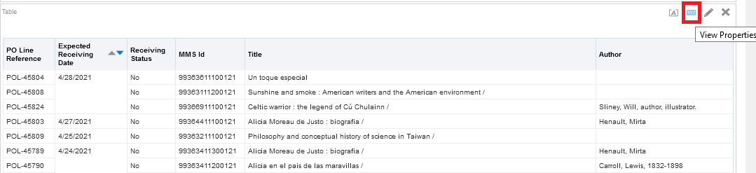

TWO
In the “Table Properties” window tab “style” check the box “Enable alternate styling”.
If you want the rows to be white and green leave it. If you want different colors click the icon after “Enable alternate styling”.

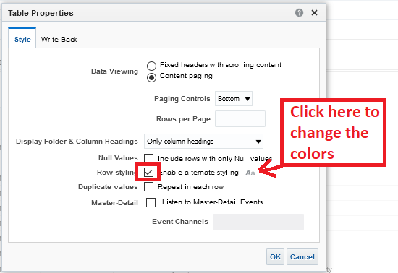

FOUR
See results

