|  |  |
| --- | --- |
| **How to make the report prompt date begin three months ago using SQL** |  |
|  | |



**Yoel Kortick**

**Senior Libraian**

**Question**

We have a report with a prompt of the loan date. We see a way to change it to by default be greater than or equal to a certain default date, but we want to make it always be three months ago from the time the user opens the report. For example today (Apr. 29 2021) I want it to default to Feb. 29, 2021. Tomorrow (Apr. 30 2021) I want it to default to Feb. 30, 2021

**Answer**

**ONE**

From the “Prompts” column of the report add a new prompt and choose “Column Prompt”.

Select the desired column if it already appears or click “More Columns”

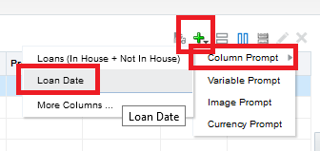

**TWO**

1. In the “Operator” field choose “is greater than or equal to”.
2. In the “User Input” field choose “Calendar”.
3. Click the triangle next to the ‘Options” section to expand it.

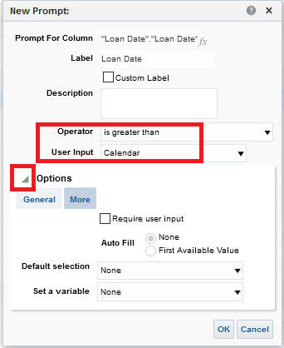

**THREE**

1. In the “Default Selection” choose “SQL Results”.
2. In section “Enter a SQL statement to generate the list of values” put as follows (and amend / edit as desired)

SELECT "Loan Date"."Loan Date" FROM "Fulfillment" WHERE "Loan Date"."Loan Date" = TIMESTAMPADD(SQL_TSI_MONTH,-3,CURRENT_DATE)

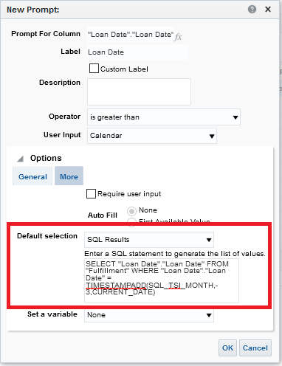

**FOUR**

Open the report and see that it defaults to three months ago (Today is Apr. 29, 2021)



