|  |  |
| --- | --- |
| **How to make the report prompt date be the current year using SQL** |  |
|  | |



**Yoel Kortick**

**Senior Librarian**

**Question**

We have a report with a prompt of the loan date. We see a way to change it to by default be greater than or equal to a certain default date, but we want to make it always be the current year of when the user opens the report. For example today (Apr. 29 2021) I want it to default to 2021. Next year at this time I want it to default to 2022.

**Answer**

We are using a report like this and will prompt by loan year:

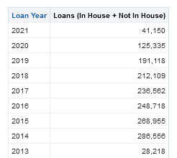

**ONE**

From the “Prompts” column of the report add a new prompt and choose “Column Prompt”.

Select the desired column if it already appears or click “More Columns”

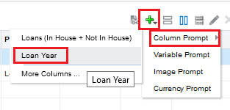

**TWO**

1. In the “Operator” field choose “is equal to / is in”.
2. In the “User Input” field choose “Choice List”.
3. Click the triangle next to the “Options” section to expand it.

(note you could choose something other than “Choice List”. That would depend on your ultimate goal)

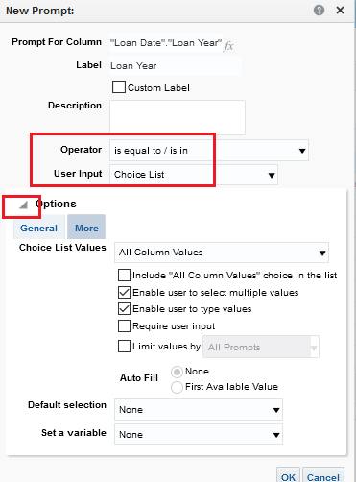

**THREE**

1. In the “Choice List Values” choose “SQL Results”.
2. In section “Enter a SQL statement to generate the list of values” of the Choice List values leave the default which is:  
     
   **SELECT "Loan Date"."Loan Year" FROM "Fulfillment" FETCH FIRST 65001 ROWS ONLY**
3. In the “Default Selection” choose “SQL Results”.
4. In section “Enter a SQL statement to generate the list of values” put as follows (and amend / edit as desired – this will give current year)  
     
   **SELECT "Loan Date"."Loan Year" FROM "Fulfillment" WHERE "Loan Date"."Loan Year" = YEAR(TIMESTAMPADD(SQL_TSI_YEAR, -0, CURRENT_DATE))**

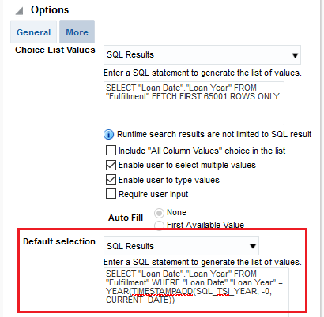

**FOUR**

Open the report and see that it defaults to the current year (Today is Apr. 29, 2021)



