|  |  |
| --- | --- |
| **How to create a report of the number of items requested per week** |  |
|  | |



**Yoel Kortick**

**Senior Librarian**

**ONE**

Create a report in the “Requests” subject area

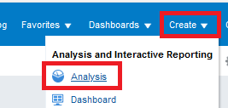 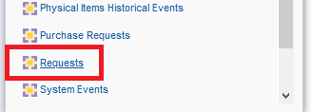

**TWO**

Display the following fields:

1. "Request Measures > # of requests"
2. "Request Date > Request Date Start of Week"

**THREE**

Decide how far back you want the report to include.

Add this field to filter by and then remove it from display after making the filter

* "Request Date > Request Date Filter"

Here we filter by the last 3 months

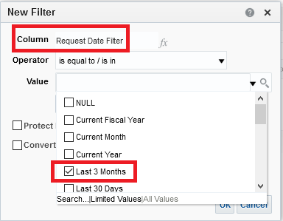

Then we remove it from display

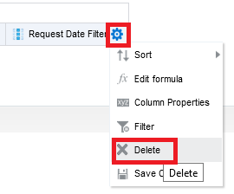

And we still have it in the filter

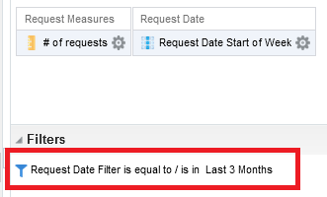

**FOUR**

Sort the “Request date start of week” descending so that the most recent will be in top:

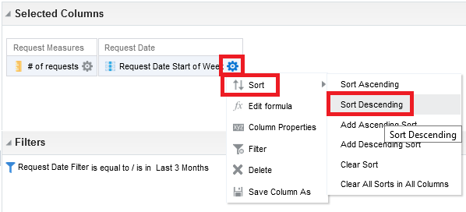

**FIVE**

Switch to criteria tab and drag the “Request date start of week” column to the left (if it is not already in the left)

Now we have the number of requests per week with the first day of the week

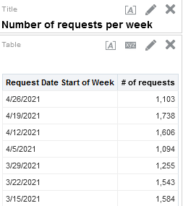

**SIX**

If you also want the request type then from the results tab drag the following field

* "Request Type > Request Type Description"

To the middle column

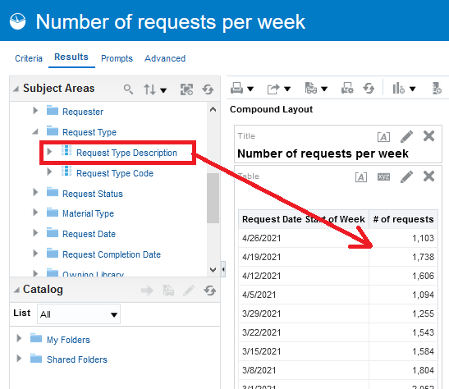

**SEVEN**

We see all types but we want only “Patron Physical Item Requests”

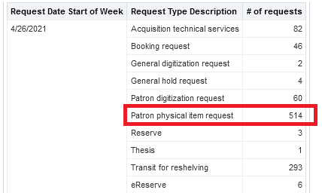

**EIGHT**

In the criteria tab filter by “Request Type Description = Patron Physical Item Request” then remove it from display

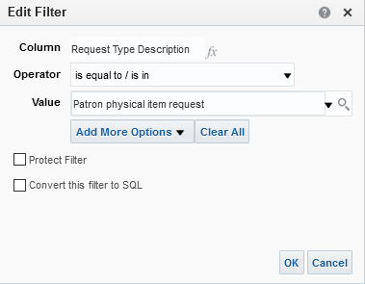

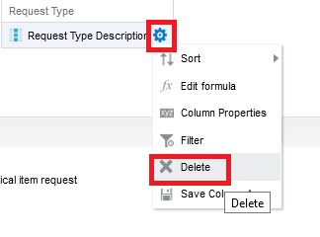

**NINE**

Now we have number of patron physical item requests per week with the most recent week on top.

