|  |  |
| --- | --- |
| **How to create a report of the number of courses created per year** |  |
|  | |



**Yoel Kortick**

**Senior Librarian**

**ONE**

Create a report in the “Course Reserves” subject area

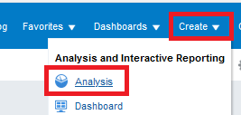 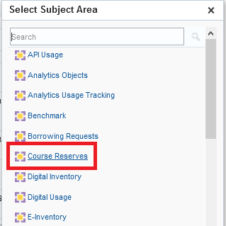

**TWO**

Display the following fields:

* “Course”.”Course Create Date (Calendar)”
* “Course”.”Course ID

**THREE**

In the criteria tab filter by Course Create Date (Calendar) is not null (just filter by this field but do not display it)

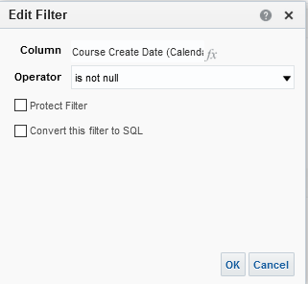

**FOUR**

Do “Edit Formula” on “Course Create Date (Calendar)”.

We will change the full date to just the year.

change

"Course"."Course Create Date (Calendar)"

To

YEAR("Course"."Course Create Date (Calendar)")

Make the Name be “Course Create Date Year”

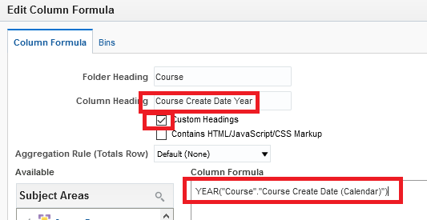

**FIVE**

Do “Edit Formula” on “Course ID”

Change

"Course"."Course Id"

To

COUNT(DISTINCT "Course"."Course ID")

Make name be “Number of Courses”

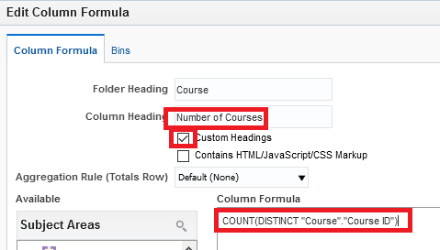

**SIX**

Switch to “Results” tab and drag “Course Create Date Year” to the left (if it is not there already):

