|  |  |
| --- | --- |
| **How to create a report of the number of reading lists citations created per year** |  |
|  | |



**Yoel Kortick**

**Senior Librarian**

**ONE**

Create a report in the “Course Reserves” subject area

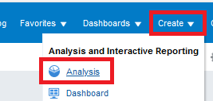 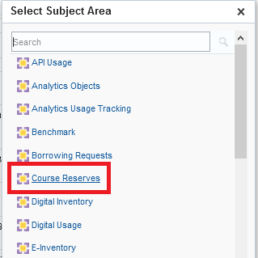

**TWO**

Display the following fields:

* "Reading List Citation Create Date > Citation Create Year")
* "Reading List Citation > Number Of Citations"

**THREE**

In the criteria tab filter by Course Create Date (Calendar) is not null (just filter by this field but do not display it)

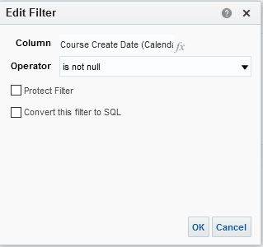

In the criteria tab filter by Citation Create Date Year is not null

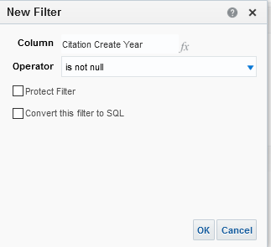

**FOUR**

Switch to “Results” tab and drag “Citation Create Year” to the left (if it is not there already):

