|  |  |
| --- | --- |
| **How to create an Alma Analytics report of all ordered items that have been received in the last 30 days** |  |



**Yoel Kortick**

**Senior Librarian**

**ONE**

From Alma do menu “General > Analytics > Design Analytics”

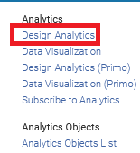

**TWO**

From Analytics do “Create > Analysis” and choose subject area “Funds Expenditure”

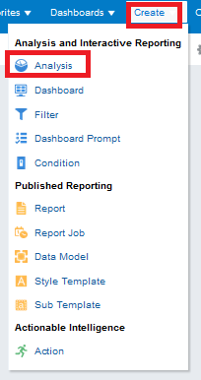 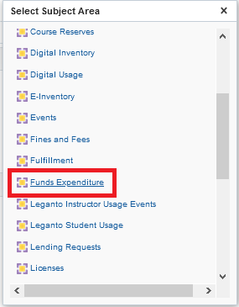

**THREE**

Add the desired fields to the report.

In the example below the section before the period is the folder and the section after the period is the field:

* "Bibliographic Details"."Author"
* “Bibliographic Details"."MMS Id"
* “Bibliographic Details"."Title"
* “PO Line"."PO Line Reference"
* “PO Line"."Receiving Date (Latest in POL)"
* “PO Line"."Receiving Status"

Filter by “PO Line"."Receiving Status" = Yes

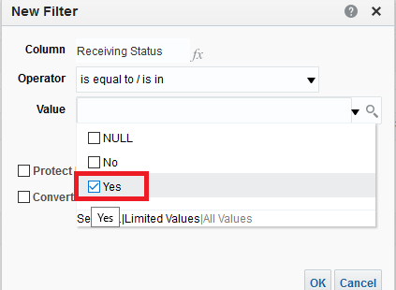

Remove field “PO Line"."Receiving Status" because now that we made the filter it will always be “Yes”

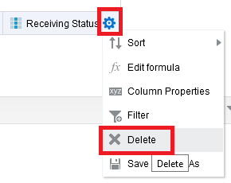

Now it looks like this in the criteria tab

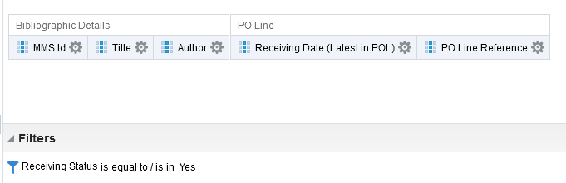

**FOUR**

Save the report as it is continued to be worked on (“just in case”). For example, save as “All ordered items that have been received in the last 30 days”

Click “Save As” on the top right and save the report in a desired location

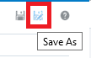

**FIVE**

Add a filter on "Receiving Date (Latest in POL)" to get only those with a date in the last 30 days.

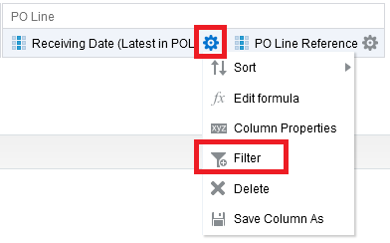

Note that instead of hard coding the "Receiving Date (Latest in POL)" to be 30 days ago it is possible to use sql to have it dynamically always use the current date. If you want to use a dynamic date via SQL:

In the filter choose to convert the filter to SQL

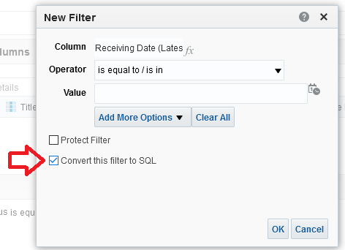

Then change the text of the filter to be as follows instead of a hard coded date

"PO Line"."Receiving Date (Latest in POL)" >= TIMESTAMPADD(SQL_TSI_DAY,-30,CURRENT_DATE)

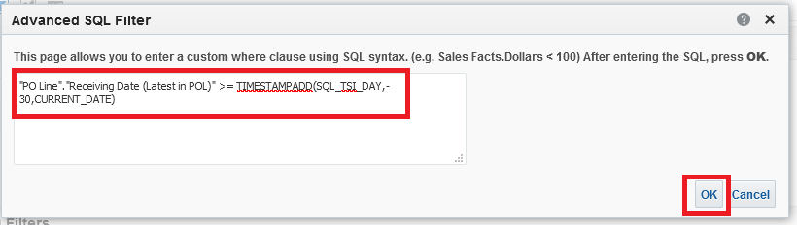

This part of the SQL here

>= TIMESTAMPADD(SQL_TSI_DAY,-30,CURRENT_DATE)

means:

The date will be equal to or greater than any date which is the current date minus 30 days (which is 30 days ago).

**SIX**

Run the report by clicking on the “Results” tab.

Note that all items have been received in the last 30 days

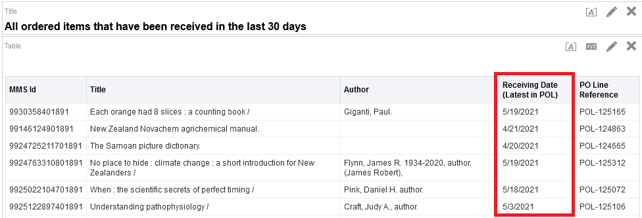

**SEVEN**

Save all changes

