|  |  |
| --- | --- |
| **How to identify records not linked to the Network Zone** |  |
|  | |

**Yoel Kortick**

**Senior Librarian**

**Question:**

How can we make an Alma Analytics report of all records which are not (and also which are) linked to the NZ from our member institution?

**Note:**

This topic is relevant for member institutions which are part of a network zone consortia.

**ONE**

In the “titles” subject area make a new report.

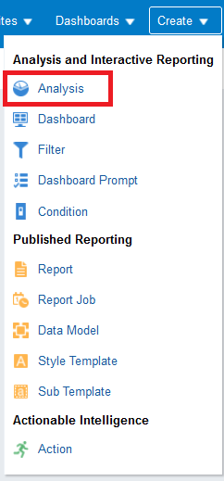 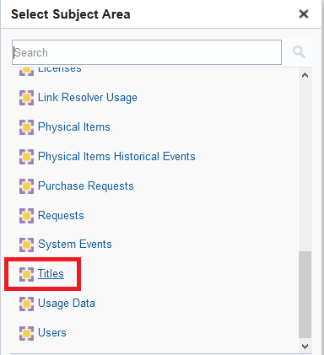

**TWO**

In the “criteria” tab select whichever fields you want to display.

Display whatever fields you want.

Here we are displaying the “Num Titles (Active)”, the “MMs ID” and the “Title”.

We have chosen to display the “Num Titles (Active)” because this will aid us later in getting the total number of titles.

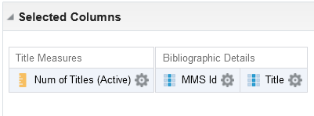

**THREE**

Filter by “Lifecycle” = “In repository”.

The “Lifecycle” field comes from the “Bibliographic details” folder. This will ensure that we will not be including deleted records.

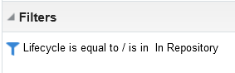

**FOUR**

Filter by “Linked to NZ” = “No”.

The “Linked to NZ” field comes from the “Bibliographic details” folder. This will ensure that we will be including only records which are not linked to the Network Zone. (Conversely, if you wanted only records which **are** linked to the NZ you could choose here “Yes”).

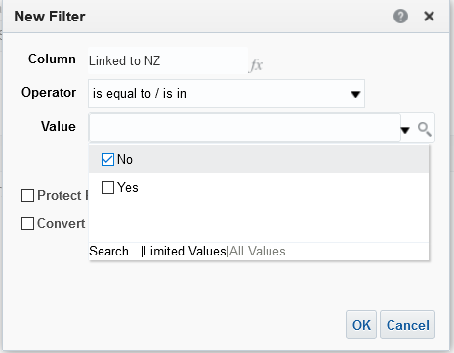

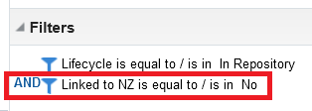

**FIVE**

View results.

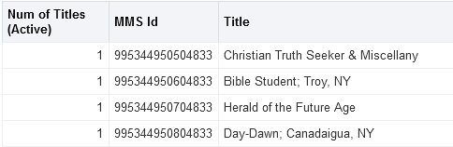

**SIX**

Check one or more of the results in Alma and see that it is not linked to the NZ. Here is the first record which appears in the report: title “Christian Truth Seeker & Miscellany”:

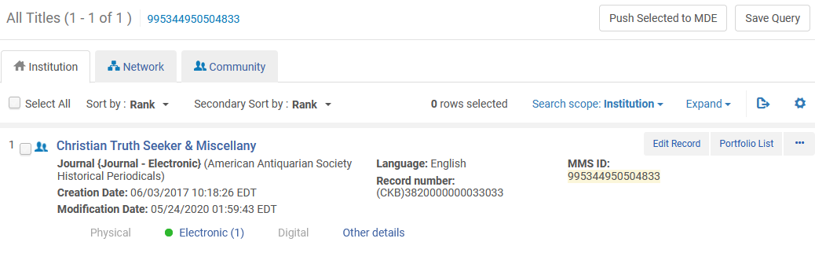

We know that the first record which appears in the report (title “Christian Truth Seeker & Miscellany”) is not linked to the Network Zone because if it was then it would have an icon like this:

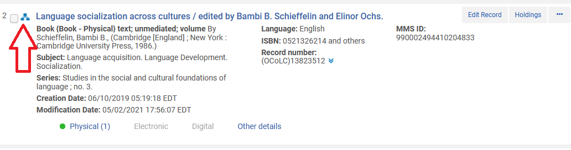

**SEVEN**

Add to the report the total number of titles. There are multiple ways to do this.

We will do this by getting the count of the number of rows (because each row has one title).

In the “criteria” tab do “edit formula” on the field:

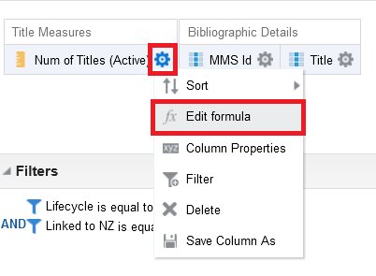

Change the contents of the formula to:

MAX(RCOUNT(1))

This means “get the count of each row and display the maximum (largest)”

Change the title of the column to whatever you want:

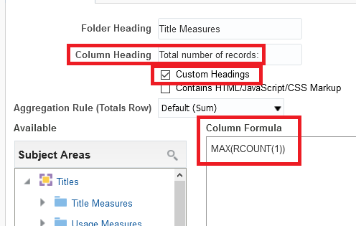

**EIGHT**

See results in “Results” tab. Here we have 665,594 records.

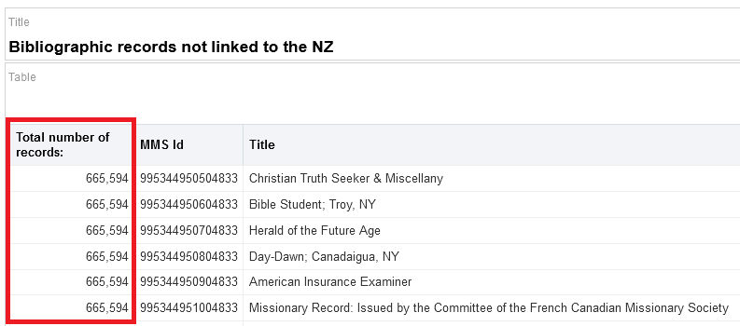

**NINE**

Move this column to the “sections” so it appears before the table instead of as a column in the table. Right click the column header and choose to move it to the sections:

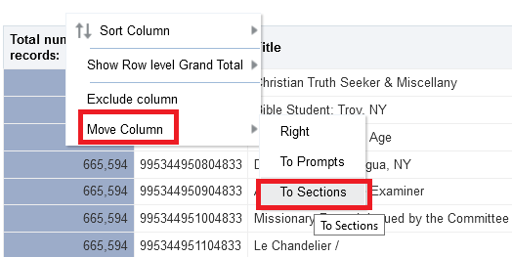

**TEN**

Now we have the total on top.

