|  |  |
| --- | --- |
| **How to obtain the number of physical items held by institutions within the consortium by LC classification** |  |
|  | |

**Yoel Kortick**

**Senior Librarian**

**Question:**

How can we make an Alma Analytics report of the number of physical items held by institutions within the consortium by LC classification?

**Note:**

This topic is relevant for a network zone institution.

**ONE**

In the network zone institution create a new report in the “titles” subject area.

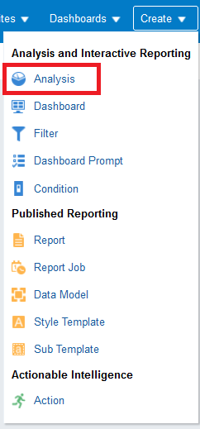 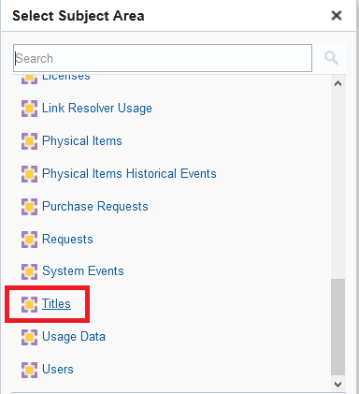

**TWO**

First we will make a report of each institution and how many items they have.

Later we will filter by and display the LC classifications.

In the “criteria” tab select the institution name, Institution Code, and the Number of active items:

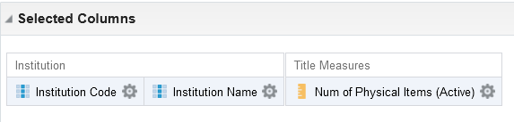

**THREE**

Check results

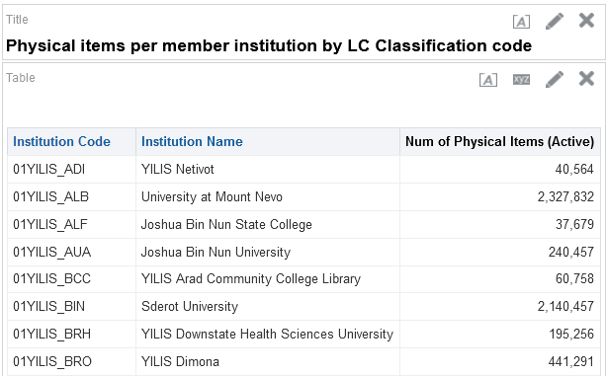

**FOUR**

Now we can add the desired field form the folder “LC Classifications” and add it for filtering and id desired also for display.

In the criteria tab we will add the “Group 1” from the “LC Classifications” folder.

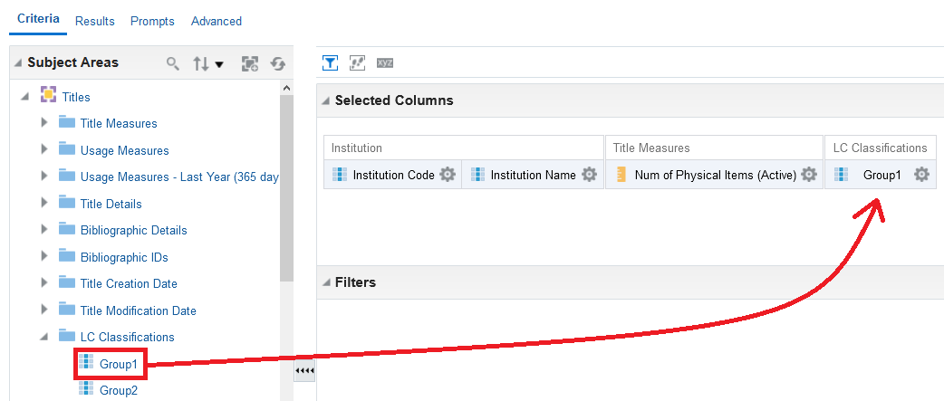

**FIVE**

Filter by whatever Group 1 you want. We will choose here “Libraries”

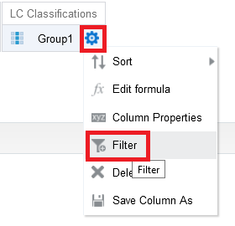

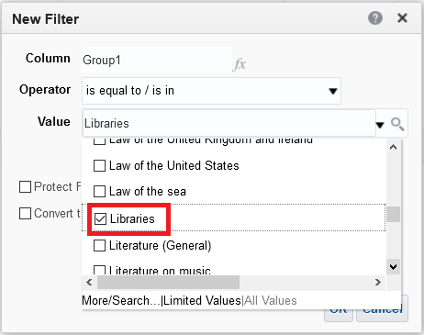

**SIX**

Check results

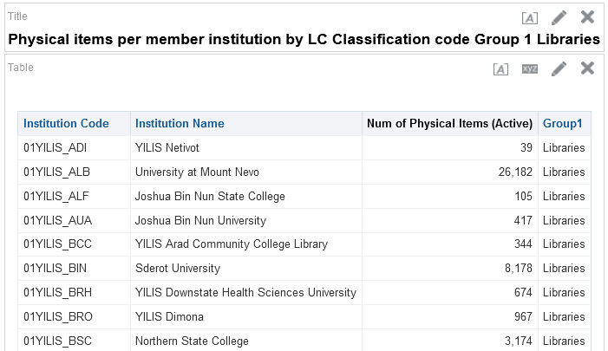

**SEVEN**

If desired we can now remove the “Group 1” from the display but leave it in the filter.

The name of the report states that it is for “Group 1 Libraries”

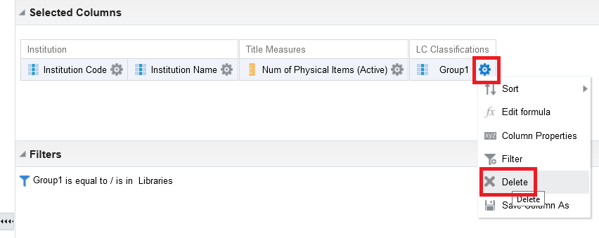

Now we have the filter but no display

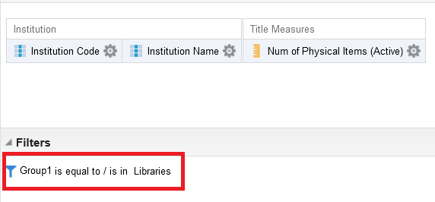

**EIGHT**

See final report

