Understanding Instructor Engagement
You’re probably wondering how instructors are engaging with Leganto, which departments are making use of Leganto reading lists, and which departments are not using Leganto. There are several reports available in the Alma Analytics Community Folder which can help you monitor instructor engagement. These reports are a great way to review your progress and determine next steps regarding outreach and adoption.
(Shared Folders/Community/Reports/Shared Reports/Reports/Leganto Course Reading Lists/Instructor Usage)
How Many Instructors Use Leganto?
This is a count of the number of unique instructors engaged with Leganto in any way, broken down by academic department. The total number of unique instructor users is visible at the bottom. Note the option to change to prompt to view a different year.
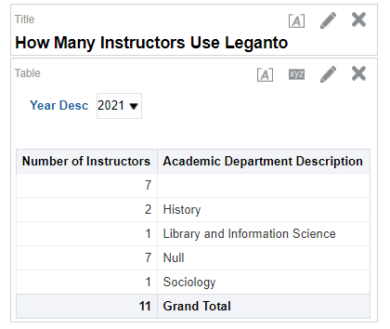

How Many Instructors Per Academic Department Use Leganto Each Year?
This report shows how many unique instructors use Leganto in any way, year over year, broken down by academic department. The total at the bottom shows you the number of unique instructors who have ever used Leganto. Includes a graph to help visualize trends.
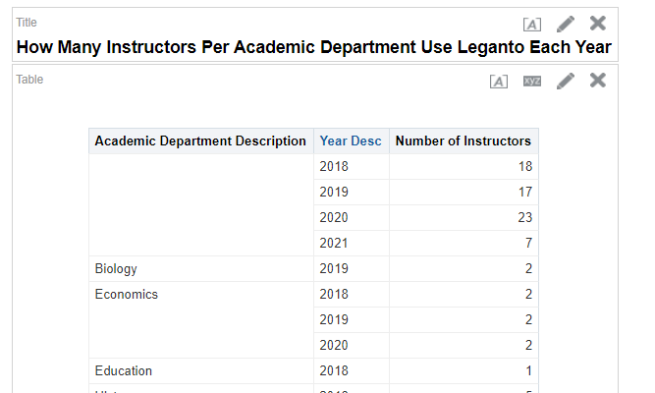
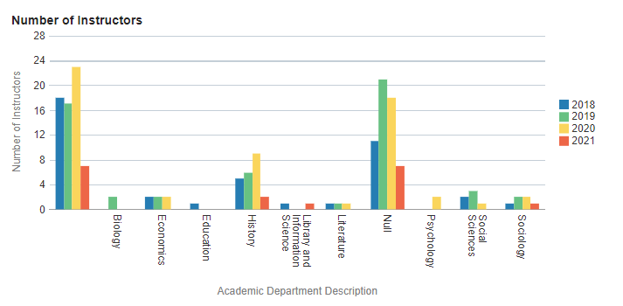

How Much Do Instructors Use Leganto?
For tracking instructor engagement. This report shows how many unique events each instructor has in Leganto, broken down by Academic Department and with a prompt for course year.
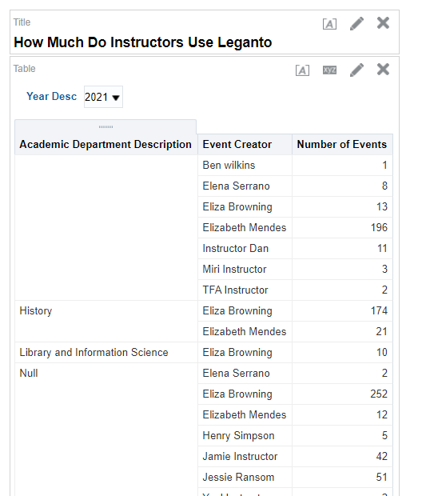

What Do Instructors in Each Academic Department Do in Leganto, by Year?
Tracks how many unique instructors perform each action in Leganto (create list, etc), broken down by year and with a prompt for academic department.
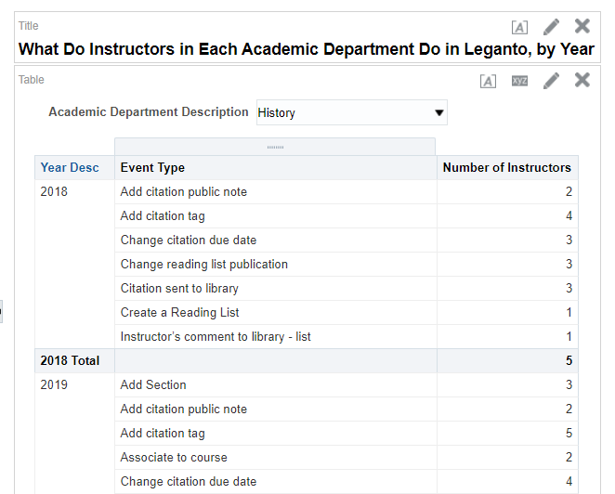

How Many Instructors Create Lists or Add Citations Each Year?
Tracks how many unique instructors create a reading list, add a citation, and/or roll over a reading list per year. Includes a graph for analyzing trends
