|  |  |
| --- | --- |
| **How to save a customized Alma Analytics column to be used in future reports** |  |
|  | |

**Yoel Kortick**

**Senior Librarian**

**Question:**

I have edited the field “Network Number” from the “Bibliographic details” folder. I did “edit formula” on the field and then made two changes (which follow here). I do not want to have to make these same changes every time I create a new report. How can I save my edited column to reuse in the future in other reports?

Here are the changes I made:

**First change:**

I changed

"Bibliographic Details"."Network Number"

to

evaluate('regexp_substr(%1,''[^\;]+'', 1,1)',REPLACE("Bibliographic Details"."Network Number",';','\;'))

**Second change:**

I changed the Column Heading from

Network Number

To

Network Number (first occurrence).

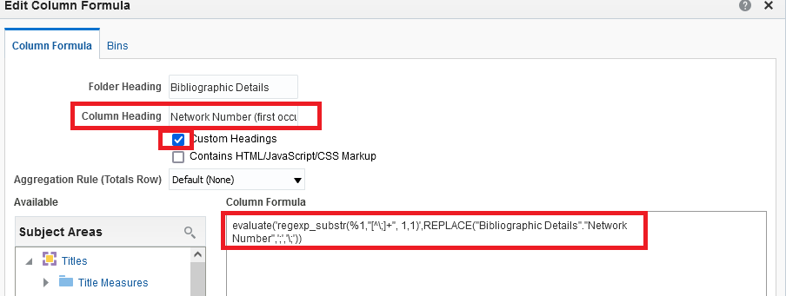

**Answer:**

**ONE**

After you make the changes choose “Save Column As”:

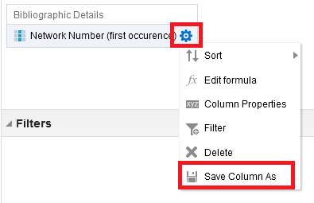

**TWO**

Save the column in one of the suggested folders. If you want other people to be able to access the column then do not save in “My Folders” because that is private to you.

Below we save it in folder “/Shared Folders/Alma University/Subject Area Contents/Titles”

In this case “Alma University” is the name of the institution, and “Titles” is the subject area from which the new column was saved.

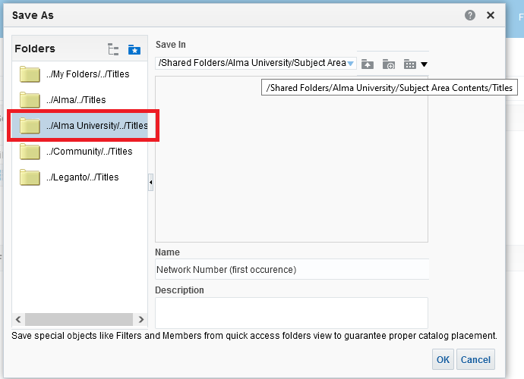

**THREE**

You can see now that the column exists in the folder where we saved it

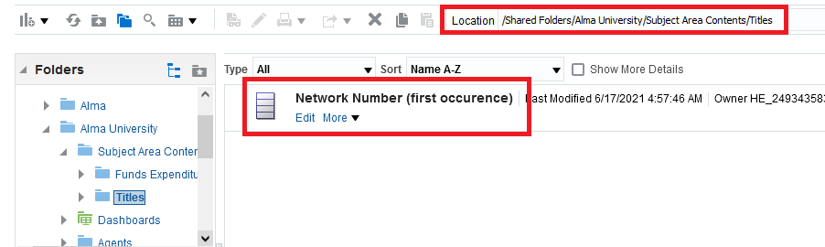

**FOUR**

Create a new report in the “Titles” subject area and access the saved column as follows:

1. On bottom left in the “Catalog” section navigate to where the column was saved.
2. Drag the column into the “selected columns” section as you would for any other column.

