|  |  |
| --- | --- |
| **How to identify mismatches between bibliographic material type and physical item material type via Alma Analytics** |  |
|  | |



**Yoel Kortick**

**Senior Librarian**

**Introduction**

There may be cases in which either

* A bibliographic record has an incorrect material type due to cataloging errors
* A physical item has an incorrect material type due to cataloging errors.

For example

We should not expect that a bibliographic record with format “Book” will have a physical item with material type “issue”.

We would expect that all bibliographic records which have a physical item of type “Audio Cassette” will have a format “Music” (and not for example “Book”).

Regarding how the bibliographic material type is determined see the [Scope of the Bibliographic Format](https://knowledge.exlibrisgroup.com/Alma/Product_Documentation/010Alma_Online_Help_(English)/010Getting_Started/050Alma_User_Interface_%E2%80%93_General_Information/Searching_in_Alma#Scope_of_the_Bibliographic_Format) table and the [Fields that Identify the Bibliographic Material Type](https://knowledge.exlibrisgroup.com/Alma/Product_Documentation/010Alma_Online_Help_(English)/010Getting_Started/050Alma_User_Interface_%E2%80%93_General_Information/Searching_in_Alma#Fields_that_Identify_the_Bibliographic_Material_Type) table

**ONE**

In the “Physical Items” subject area create a report with

1. “Material Type” from the bibliographic details folder
2. “Material Type” from the physical item details folder
3. "Num of Items (In Repository)" from the physical item details folder

**TWO**

To make the columns clear change the name of

1. “Material Type” from the bibliographic details folder to “Bibliographic Material Type”
2. “Material Type” from the physical item details folder to “Physical Item Material Type”

Edit the Bibliographic material type field

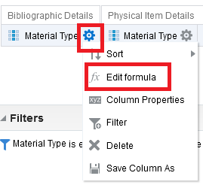

Rename the field

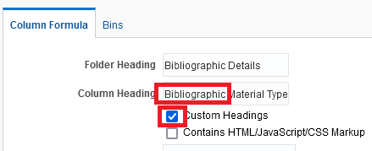

Edit the Physical item details material type field

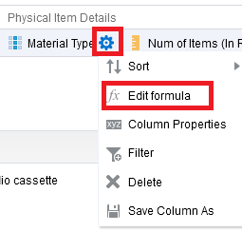

Rename the field

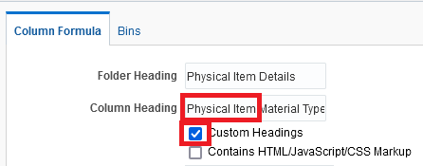

**THREE**

Filter by “Material Type” from the physical item details folder = Audio cassette

**FOUR**

Filter by “Lifecycle” from the physical item details folder = “Active”

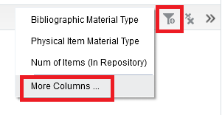  
  
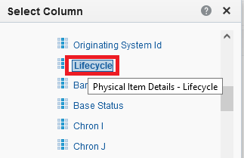

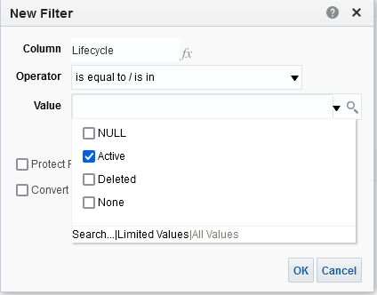

If desired filter by a specific physical item material type, for example ‘Book” and “Bound Issue”.

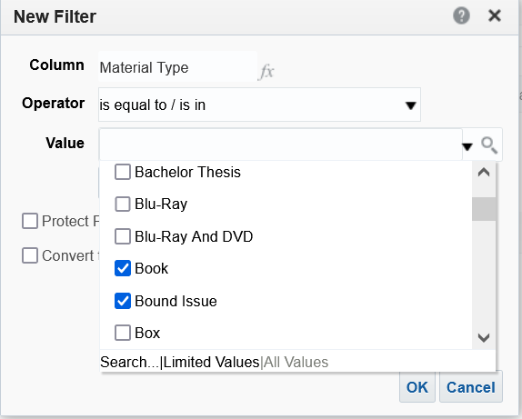

**FIVE**

The criteria tab of the report now looks like this:

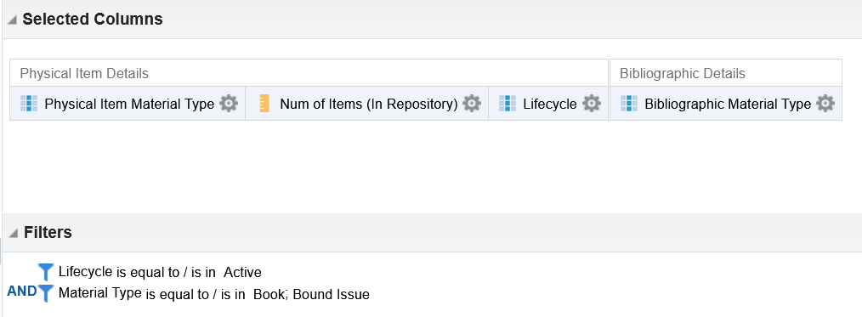

**SIX**

Save report as “Mismatches between bibliographic material type and physical item material type – Book and Bound Issue”

**SEVEN**

See results. The vast majority are correct, but there are errors.

We can see that tyhere are

Items with material type “Book” and they are part of a bibliographic record with material type “Journal”.

Items with material type “Bound Issue” and they are part of a bibliographic record with material type “Book”.

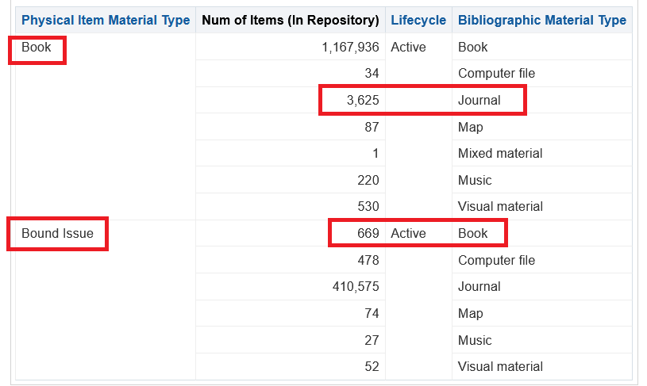

**EIGHT**

It is worth checking the mismatches to see why they have what appears to be conflicting values.

Return to the criteria tab and filter by “Bibliographic Material Type” = “Journal” and “Physical Item Material Type” = “Book”

This way we will get only a subset of the ones we want to check.

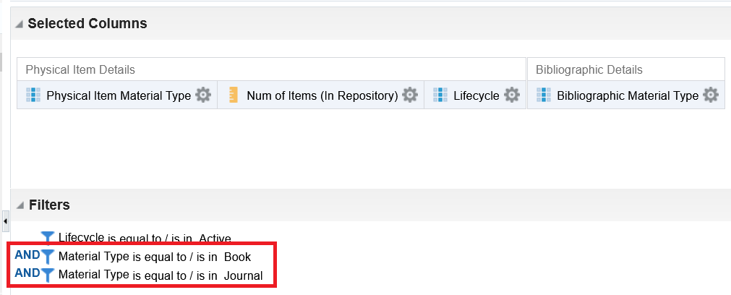

**NINE**

Return to results tab

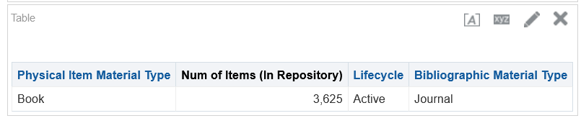

**TEN**

In the results tab add the MMSID so that a cataloger can check the records. Just drag it in to the first column

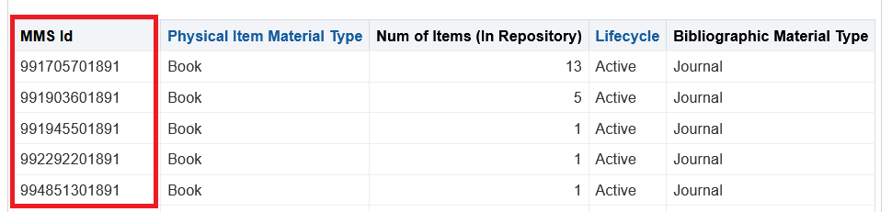

**ELEVEN**

Here is an example of one of the results in Alma

