|  |  |
| --- | --- |
| **How to create a report of all items which have been declared “Missing” longer than 6 months ago** |  |
|  | |



**Yoel Kortick**

**Senior Librarian**

1. The status “Missing” may be attributed to an item for example
   1. Doing the “toggle missing status” in the list of items
   2. Via a job “Change physical items”
2. Create a new analysis in the physical items subject area
3. Display the following fields (you can display other fields according to specific needs, this is just a recommendation)
   1. "Modification Date" from the "Physical Item Details" folder
   2. "Barcode" from the "Physical Item Details" folder
   3. "Title" from the "Bibliographic Details" folder
   4. "Location Name" from the "Location" folder
   5. "Permanent Call Number" from the "Holding Details" folder
4. Filter by the following fields
   1. "Process Type" from the "Physical Item Details" folder = 'Missing'
   2. "Physical Item Details"."Life Cycle" from the "Physical Item Details" folder does not equal 'Deleted'
   3. "Physical Item Details"."Modification Date" from the "Physical Item Details" folder is older than or equal to 6 months ago
   4. Here is the text of the sql filter:  
      "Physical Item Details"."Modification Date" <= TIMESTAMPADD(SQL_TSI_MONTH, -6, CURRENT_DATE)
   5. Here is how to do the filter:  
        
      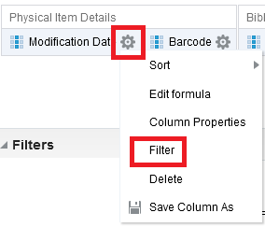  
        
      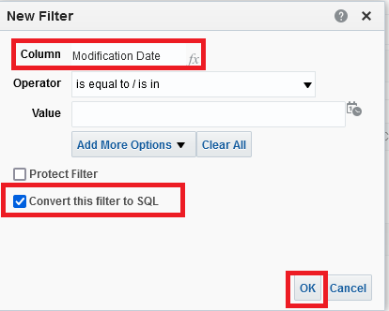  
        
        
      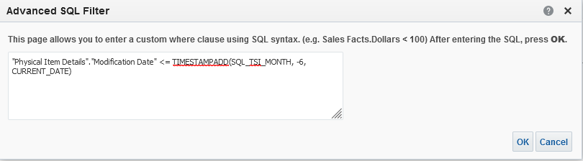
5. Here is the criteria tab:  
     
   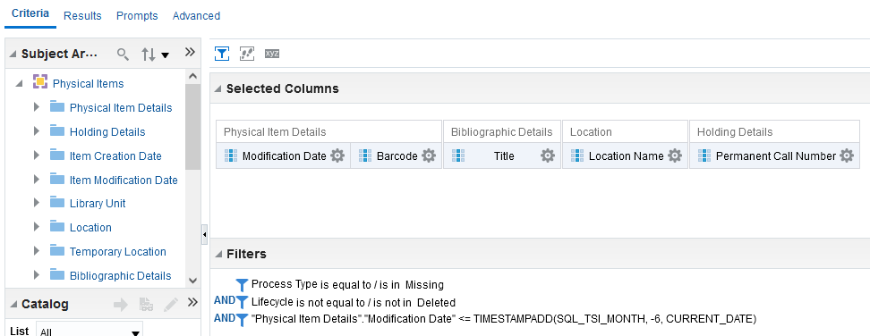
6. Here are sample results  
     
   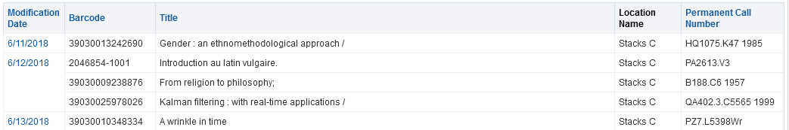
7. We will check the first example from the result
   1. It is missing  
        
      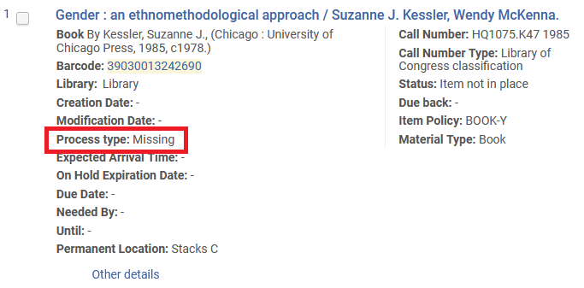
   2. It was changed to “Missing” more than six months ago  
        
      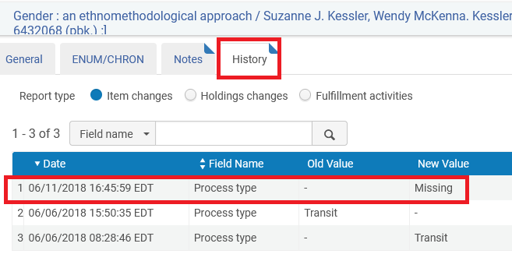
8. You can also from here make a report of of all items which have been declared lost longer than 6 months ago
   1. This is the “lost” in the list of loans for a patron, or via a job “Loans - Overdue and Lost Item” which uses the “Overdue and Lost Loan Profile”)
   2. Make just like above report but instead of  
      "Physical Item Details"."Process Type" = 'Missing'  
      Use  
      "Physical Item Details"."Process Type" = 'Lost'