|  |  |
| --- | --- |
| **How to create an Alma Analytics report of portfolios activated for the electronic collection “Ebook Central Perpetual DDA and Subscription Titles”** |  |



**Question**

We run the “Upload Electronic Holdings” integration for ProQuest Ebook Central. How can we get a report of which portfolios have been added to the electronic collection “Ebook Central Perpetual, DDA and Subscription Titles” (which is used with the integration profile)?

**Answer**

The reports created below may be found in the “Community” folder at /shared/Community/Reports/Shared Reports/Reports/Ebook Central

1. First let’s get a report of how many portfolios have been activated for this electronic collection for each year / month combination. Later we will get the actual portfolios, but for now we will get the amounts.
   1. Create a report in the e-inventory subject area and include the following fields (the text before the period is the folder, the text after the period is the field name)
      1. "Electronic Collection"."Electronic Collection Public Name",
      2. "Portfolio Activation Date"."Portfolio Activation Month Key"
      3. "Portfolio Activation Date"."Portfolio Activation Year"
      4. "Portfolio"."No. of Available Portfolio"
   2. Filter by "Electronic Collection"."Electronic Collection Public Name" = Ebook Central Perpetual, DDA and Subscription Titles
   3. The criteria tab now looks like this:  
        
      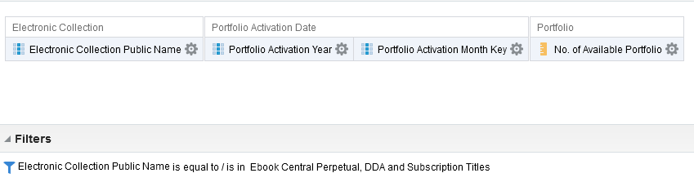
   4. The results tab now looks like this. We see for example that in April 2018 303 portfolios were activated in the collection, and in May 2018 5 portfolios were activated in the collection (this is the beginning of report)  
        
      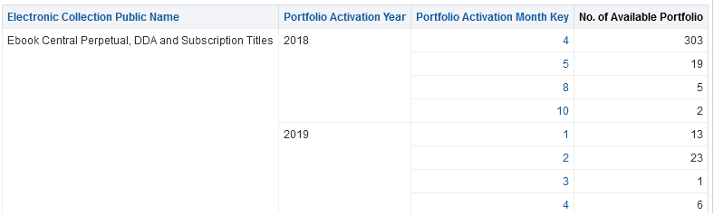
   5. If you want the Year and month columns to be more narrow (to appear more aesthetic):
      1. In criteria tab to “edit formula” on field “Portfolio Activation Year”
      2. Change the column heading from   
         "Portfolio Activation Year"  
         to  
         "Activation<br>Year"
      3. Check the box “Custom Headings”
      4. Check the box “Contains HTML/JavaScript/CSS Markup”  
           
         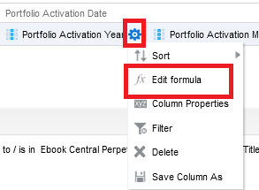  
           
         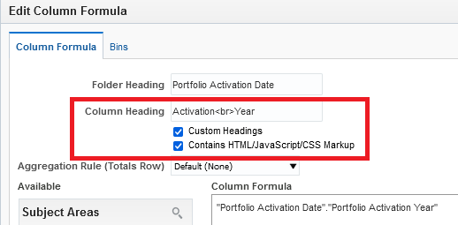
      5. In criteria tab to “edit formula” on field “Portfolio Activation Month Key”
      6. Change the column heading from   
         "Portfolio Activation Month Key"  
         to  
         "Activation<br>Month"
      7. Check the box “Custom Headings”
      8. Check the box “Contains HTML/JavaScript/CSS Markup”
   6. Save the report as “Ebook Central Number of Portfolios Activated per Year Month”
   7. See it now (with narrower more aesthetic columns) (this is the beginning of report)  
        
      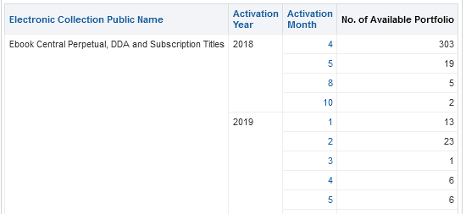
2. Now let’s get the actual titles (and not just numbers) of which portfolios were activated during the periods.
   1. In the above report
      1. Remove field "Portfolio"."No. of Available Portfolio"
      2. Add field "Portfolio"."Portfolio Id"
      3. Add field "Bibliographic Details"."Title"
      4. Add a filter on the activation date so that you do not get all the titles in the collection (which can be a lot). For example: "Portfolio Activation Date"."Portfolio Activation Date Filter" = 'Last 365 Days'
   2. Save the report as “Ebook Central Portfolios Activated in Last 365 Days”
   3. Here is the criteria tab:  
        
      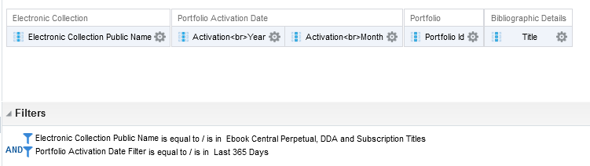
   4. Here are the results (beginning of report):  
        
      