|  |  |
| --- | --- |
| **How to create an Alma Analytics report of users with a patron role and a role expiry date which will expire in the next 30 days** |  |
|  | |



These ten steps will show how to create a simple report of users with patron role which will expire before a certain date.

For details on saving the report query and adding to a dashboard see separate document.

**ONE**

In Alma access the Alma Analytics via Alma Menu > General > Analytics > Design Analytics

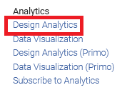

**TWO**

“Alma Analytics” will open in a new browser tab.

Choose “New > Analysis” and then select “Subject Area” “Users”

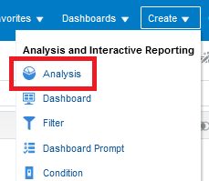

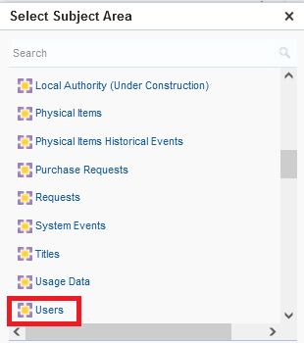

**THREE**

Drag in the fields you want to include in the report, for example Primary Identifier, First Name and Last Name:

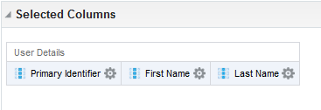

**FOUR**

In the lower pane “Filters” section click the “Create a filter for the current Subject Area” icon (note that there are other ways to do this as well)

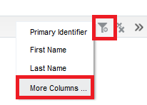

**FIVE**

Choose the “Role Type” from the “Role” folder and make it equal to “Patron”

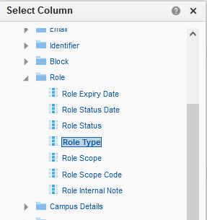

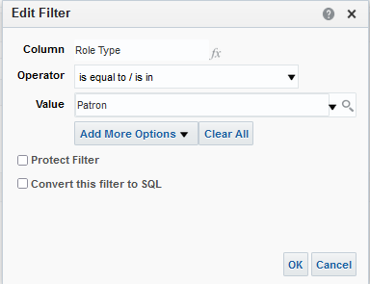

**SIX**

Add another filter the same way and make it for the field “Role Expiry Date” in the “Role” folder.

Make a filter and click the “Convert this filter to SQL” box

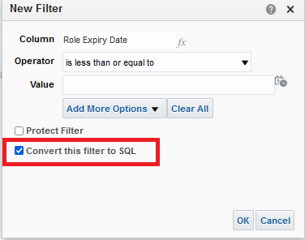

**SEVEN**

Make the filter be as follows. This means that the expiry date of the patron role will be between today and 30 days from now

"Role"."Role Expiry Date" between timestampadd(sql_tsi_day,+0,current_date) AND timestampadd(sql_tsi_day,+30,current_date)

See [How to use the TIMESTAMPADD parameter to retrieve by today - X time in an Alma Analytics report](https://knowledge.exlibrisgroup.com/@api/deki/files/48630/Analytics_-_How_to_use_the_TIMESTAMPADD_parameter_to_retrieve_by_today_-_X_time_in_an_Alma_Analytics_report.pptx) for more information on the syntax.

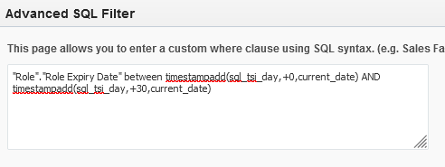

**EIGHT**

Here are our results

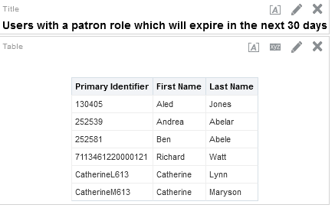

**NINE**

Let’s check for example the first line, Primary identifier 130405

We see that the expiration date is for August 29, 2021.

That is between today and 30 days from now.

