|  |  |
| --- | --- |
| **Understanding the fields "Link ID", "Linked to CZ" and "Linked to NZ" in the “Bibliographic Details” folder** |  |
|  | |

**Yoel Kortick**

**Senior Librarian**

**Introduction**

This document concerns itself with the following three fields found in the shared folder “Bibliographic Details”:

1. Link ID
2. Linked to CZ
3. Linked to NZ

The "Link ID" is an internal unique identifier of the link between the bibliographic record and the network zone record or community zone record to which it is connected.

* When a report is run in the network zone the "Linked to NZ" will always be "No" because a record is not linked to the NZ from the NZ, it is already in the NZ.
* When a report is run in a member institution the record may be linked to nothing, or linked to the NZ or linked to the CZ.
* When a report is run in a standalone institution the record may be linked to nothing, or linked to the CZ.

We will now see examples of this, looking at reports run

1. In a network zone
2. In a member institution of a network zone
3. In a standalone institution

**Example of report run in the network zone**

In the example below the report is run in the network zone.

Therefore, all cases of "Linked to NZ" are no.

When both the “Linked to NZ” and the “Linked to CZ” are “No” then the “Link ID” is empty (as in the last two lines here). This is because if the record is not linked then there cannot be a link ID.

In the first two cases the “Linked to CZ” field is “Yes” and therefore there is a link ID.

The Link ID has a value if either the “Linked to CZ” or the “Linked to NZ” is filled in.

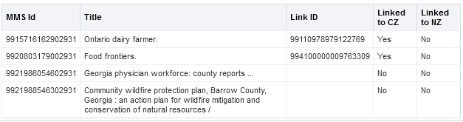

Let’s look at the first example, MMS ID 9915716162902931 “Ontario dairy farmer” in Alma. It states here in analytics that it is linked to the CZ.

We see in Alma that it is linked to the CZ, as signified by the “people icon” next to the record:

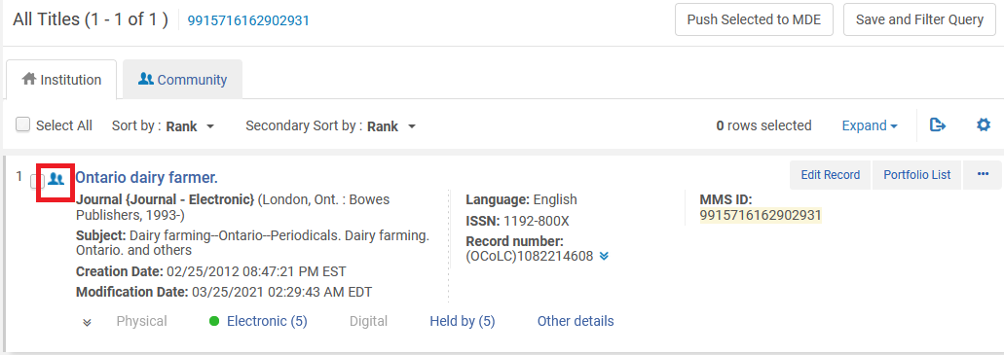

Let’s look at the third example, MMS ID 9921986054602931 “Georgia physician workforce: county reports” in Alma. It states here in analytics that it is not linked to the CZ.

We see in Alma that it is not linked to the CZ, as signified by the lack of a “people icon” next to the record:

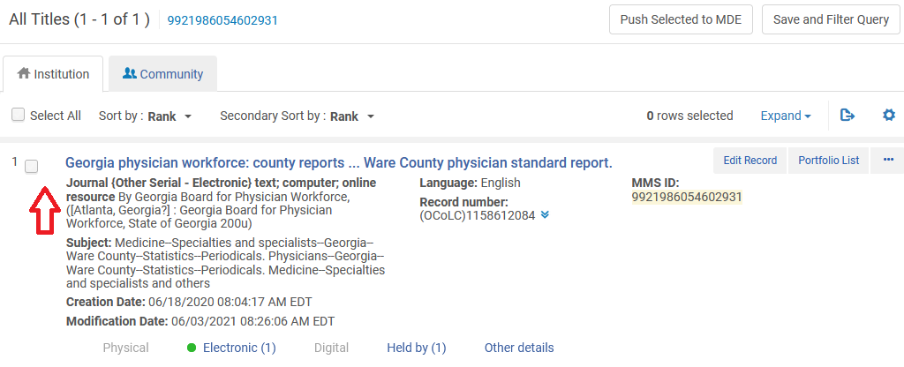

**Example of a report run in a member institution of a network zone**

In the member institution a record may be

* Either “Linked to CZ” or “Linked to NZ” but not both simultaneously.
* Not linked to either the CZ or the NZ

In the example below the records in the member institution are linked to the NZ.

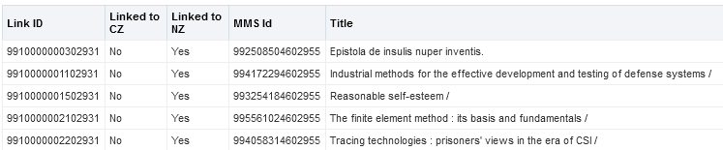

Let’s look at the first example, MMS ID 992508504602955 , title “Epistola de insulis nuper inventis.”

We see it is linked to the NZ according to the icon next to the record:

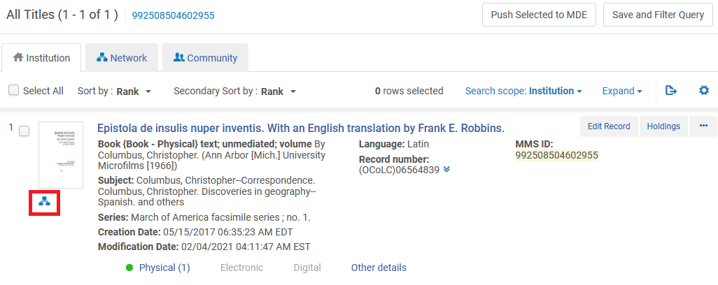

In the example below the records in the member institution are linked to the CZ.

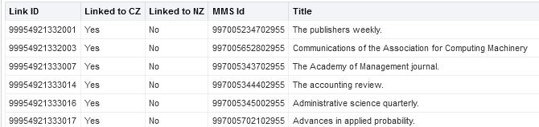

Let’s look at the first example, MMS ID 997005234702955, title “The publishers weekly.”

We see it is linked to the CZ according to the icon next to the record:

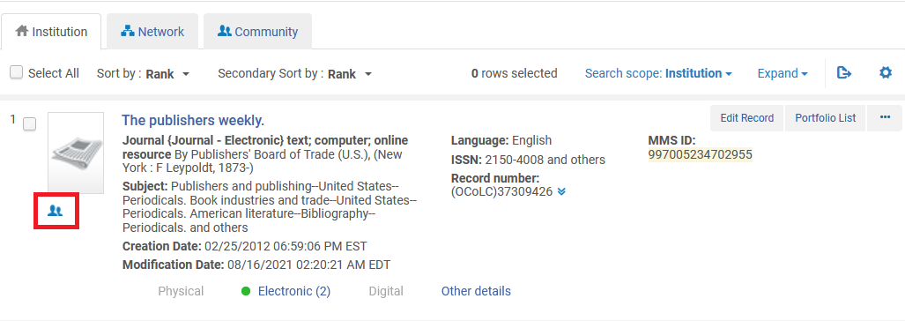

**Example of report run in a standalone institution**

In a standalone institution no records will ever be “Linked to NZ” because there is no NZ.

Records will either be

* Not linked to anywhere
* Linked to the CZ.

In the example below the records in the standalone institution are linked to the CZ.

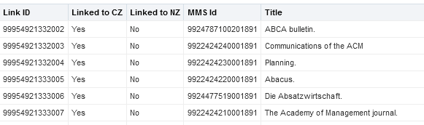

Let’s look in Alma at the first example, MMS ID 9924787100201891, title “ABCA Bulletin”.

We see in Alma that it is linked to the CZ, as signified by the “people icon” next to the record:

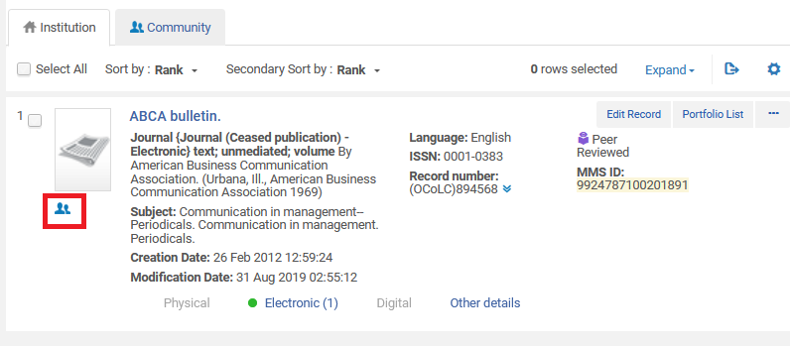

In the example below the records in the standalone institution are not linked to anywhere.

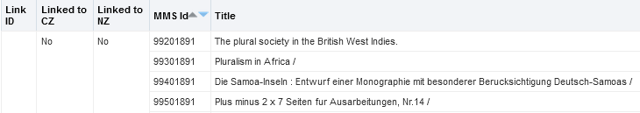

Let’s look at the first example, MMS ID 99201891, title “The plural society in the British West Indies”.

We see in Alma that it is not linked to anywhere, as is evidenced from the lack of an icon:

