|  |  |
| --- | --- |
| **How change a date field which contains date and time to only contain date** |  |
|  | |

**Yoel Kortick**

**Senior Librarian**

**Question:**

When we create a report including the “Invoice-Approval-Date” from the “Invoice Line” folder of the Funds Expenditures subject area we get the date and the time.

For a specific situation we only want the date. How can we change the field to have only the date and not the time?

For example, in the first line below

We do not want it to state “8/10/2021 11:10:13 AM”

We want it to state “8/10/2021”

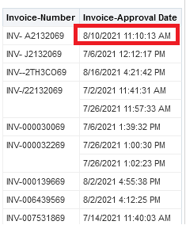

**Short answer:**

Use a function to CAST the field as a date

**Full detailed answer:**

**ONE**

First choose ‘edit formula’ on the desired field from the criteria tab. Here we do it on Invoice-Approval-Date.

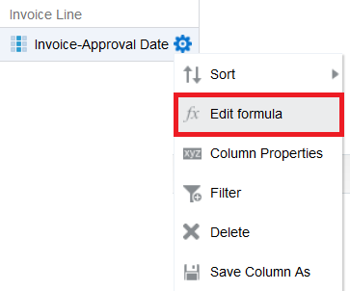

**TWO**

With field selected and click ‘Insert Function’

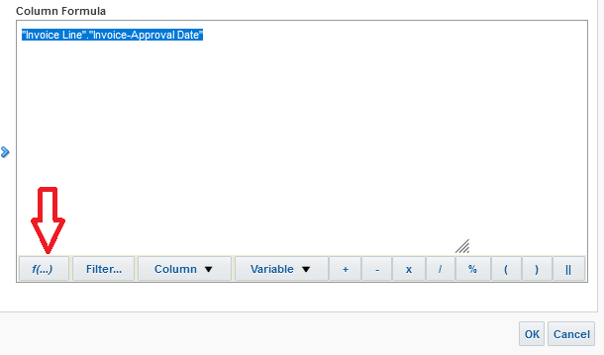

**THREE**

Choose “Conversion > Cast’ and click OK

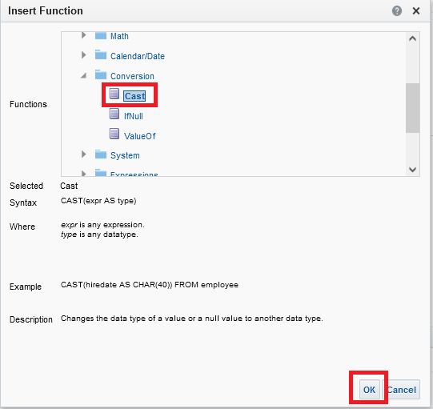

**FOUR**

Get this:

CAST("Invoice Line"."Invoice-Approval Date" AS type)

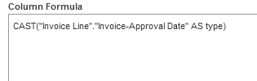

**FIVE**

You now have this text in the ‘column formula’:

CAST("Invoice Line"."Invoice-Approval Date" AS type)

Change it to

CAST("Invoice Line"."Invoice-Approval Date" AS date)

And if desired change header (custom heading)

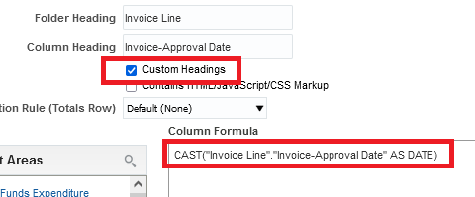

**SIX**

Now in the results tab it appears as follows:

