Providers guide for accessing Ex Libris MFT
To access the service, make sure your network can reach the following IPs in the required ports:
IPs
216.147.214.21 | HTTPS (80,443)  SFTP (10022)
216.147.218.23

MFT access
Access to Ex Libris MFT for providers require username and SSH key, these will be provided to you by Ex Libris Provider Relations team.

How to retrieve the user and key?
Note! – the steps described in this section should be executed once in order to retrieve the SSH key. Uploading data to MFT required different steps and will be described in the next section.
- An email will be sent to your address, the email contains the following information:
  - Hostname: this will be the server name used for uploading data
  - Port and protocol: data uploads to MFT are done with SFTP over port 10022
  - Username: this is the user you’ll use for the data uploads
Document the above information for later use.
- In addition to the above the email contains a link to a file, this is the SSH key file you’ll use when uploading data. Click the link to download the key file.
- A browser window will be launched, and you’ll be prompted for a secondary password. The password should be sent to your email after the link was clicked. Copy the password and paste it in the ‘Enter OTP’ prompt:
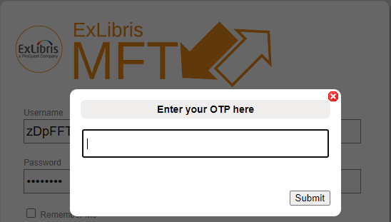
- You should now be connected and see the key file that was shared with you:
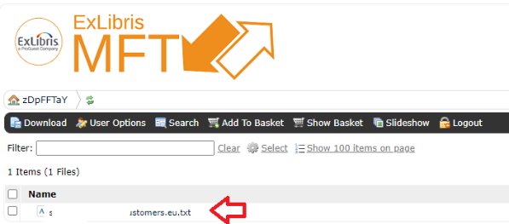
- Right-click the file and download it, keep this file in a secure location.
- This completes the ssh key download which is a one-time step.

Connecting to MFT and uploading data
After completing the above steps you should have the following info:
- Hostname
- Port and protocol
- Username (<user>@customers.<region>)
- SSH key: the key downloaded previously
Using this info to connect to MFT, you can connect directly from CLI or use SFTP client line WinSCP/ FileZilla/etc…

Using SFTP Clinet - WinSCP
Note – the key is provided in standard format, some Windows SFTP clients like WinSCP require that the key will first be converted to ppk. Here is a guide on who this can be done.
Connect with any SFTP client using the following parameters provided in the email you received:
- File protocol = SFTP
- Hostname = <HOSTNAME>
- Port number = 10022
- Username = <USERNAME>
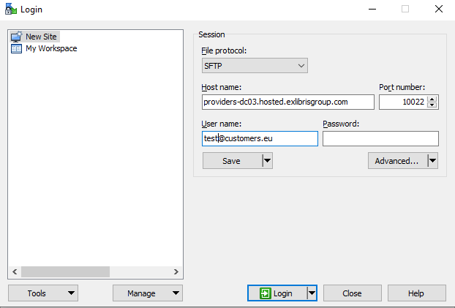
- Click the ‘Advanced’ button, on the right-pane menu select SSH > Authentication
- Click the ‘Private key file’ browse button to select the ‘.ppk’ key:
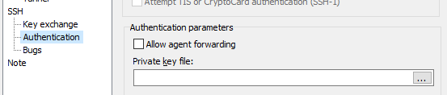
- Click ‘ok’
- Click ‘Login’
- You should now be connected and can upload files

Connecting from bash shell using sftp command

Use the following command to connect to MFT, replace the variables with the info gathered above:
sftp -o Port=10022 -o IdentityFile=<Private_Key_Path> -o User=<User_Name> <MFT_Server>
Example:
sftp -o Port=10022 -o IdentityFile=/tmp/test@customers.eu.txt -o User=test@customers.eu providers-dc03.hosted.exlibrisgroup.com

