|  |  |
| --- | --- |
| **How to add the letter name to the bottom of the letter in small print** |  |



**Question**

Hi. We are trying to add the letter name to the letters that get printed out in Alma. We want to have it print in small print on the bottom of the letter. That way when we want to edit the letter, we will know exactly which letter it is by looking at the letter name. This will save us time. Is this possible? If so how?

**Answer**

This is possible. The first step is to get the name and path of the letter name from the xml of the printed letter.

To do this there are two options:

1. Hard code the name of the letter in a text and just write it into the xsl of the letter.
2. Take the letter name from the field in the xml and make it appear from the field.

We will do option 2, because that is the “safer” way. If the letter name ever changes it will automatically be updated.

**ONE**

Get the name and path of the field of the letter name as follows. We will use the Borrowing Activty Letter as an example

1. Go to “Configuration > General > Letters > Letters Configuration
2. Edit the desired letter (in this case the Borrowing Activity Letter)
3. Switch to the “Letter Examples” tab
4. Edit one of the letter examples
5. Get the name and path of the letter name field

Here we see that the field name and path is **/notification_data/general_data/letter_name**

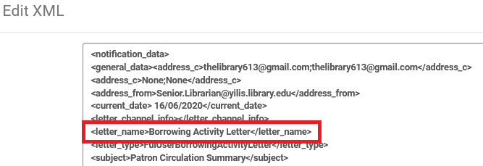

**TWO**

Switch to the “Template” tab and edit the xsl.

Before the call to the footer add the following text.

Change “h6” to whatever size you want and change the comments to whatever you want.

|  |
| --- |
| <!-- Begin Yoel's addition to add the letter name -->  <h6>Letter name: <xsl:value-of select="/notification_data/general_data/letter_name" /></h6>  <!-- End Yoel's addition to add the letter name --> |

So now the end of the xsl looks like this:

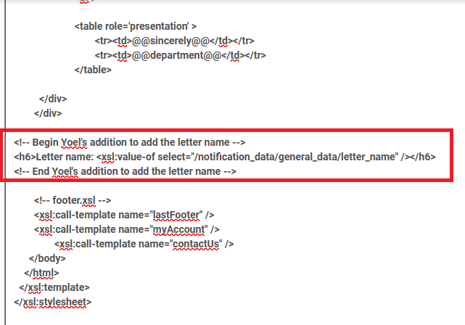

**THREE**

Print the letter and see that now you have the letter name on the bottom:

