Manual Ordering Workflow
If ordering a title already in the repository, do a search and choose the title to order.
  - Search for title in Alma via repository search, if it exists, order it by clicking on Action button (3 dots) then clicking the Order option.
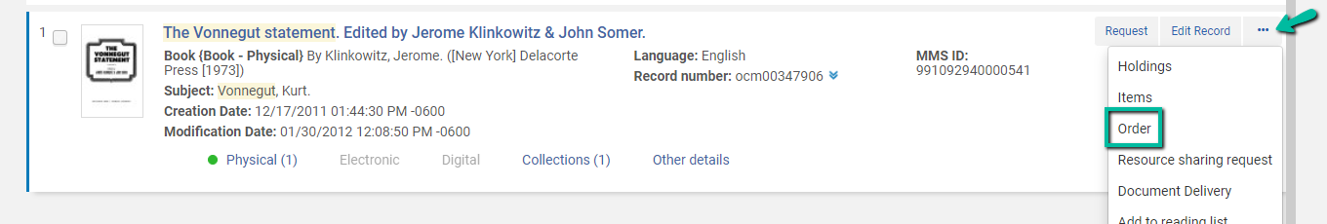
  - If title not found via repository search, search in Connexion or “external sources” and import the title
If using Connexion, export the record from OCLC Connexion and import it in to Alma or Import the title via external search
Record is imported via Connexion or External search. You will be in the metadata editor on the bib record. Click on the order button (the button with the shopping cart)
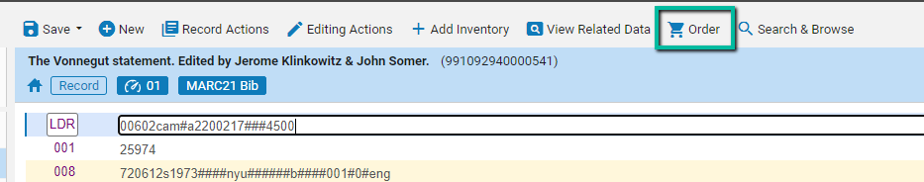
The PO Line Owner and Type will appear –
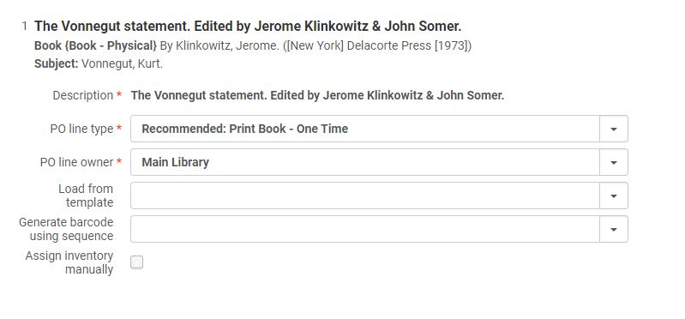
Select the Purchase Type. This is important as it determines purchasing workflow and inventory. See below for an explanation of purchase types:
One-time – Used for one-time or infrequent orders, such as a printed book, an e-book, or a musical score that is not published repetitively. Physical material is received via the One Time tab on the Receive New Material page. Holdings and items are created automatically, with one holdings being created for each unique location, and one item for each copy. Electronic material goes through the standard activation process and remains activated indefinitely. Once the PO line is invoiced and received/activated, it is closed.
Continuous – Used for orders that are repeated on a regular basis—for example, monthly subscriptions to physical or electronic material such as journals. Physical material is received via the Continuous tab on the Receive New Material page. Holdings are created upon PO line creation (for each run of the series in a location) and items are created upon receipt (for each issue or bound volume). Electronic material goes through the standard activation process and may be deactivated during the evaluation process. The PO line remains open once it is invoiced and received/activated (although it can be closed manually).

Standing order – Used for orders that are not repeated on a frequent or regular basis. Physical monograph material is not received on the Receive New Material page. Rather, it is created manually by creating or choosing a bibliographic record, creating a holdings record, and then creating an item record, which you associate with the standing order PO line. You set a receipt date for the item in the Physical Item Editor. Non-monograph material is processed in the same manner as physical continuous material, although without a fixed sequence or frequency. Electronic material goes through the standard activation process and may be deactivated during the evaluation process. The PO line remains open once it is invoiced and received/activated (although it can be closed manually).

Select the PO Line Owner: The list of available libraries (or library) is determined by the Purchasing Operator or Purchasing Manager’s scope.
If you have a template, select it to save time on entering vendor and fund information.
Click on Create PO Line
You will be taken to the PO Line Summary page. In the Summary tab, under Ordered Items, you will see that Alma has automatically ordered for the library and location. You can edit the library and/or location by clicking on Actions>Edit.
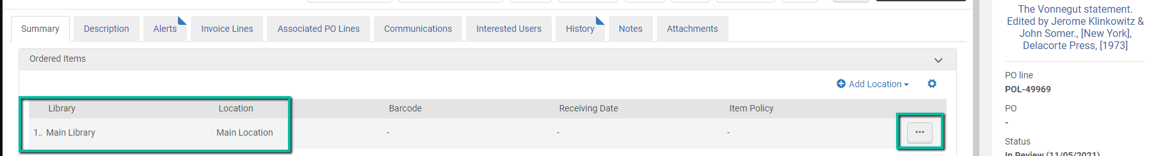
If you didn’t use a template, enter the Material Supplier in the Vendor Information section, Price (if required), Funding. Click on Add Fund.
In the PO Line Details area, you can select a Reporting Code (but it is not required). Enter the Acquisition Method. If you select Purchase, an email will be sent to the vendor. Price and fund is not required if the Acquisition Method is Gift, Repository or Technical.
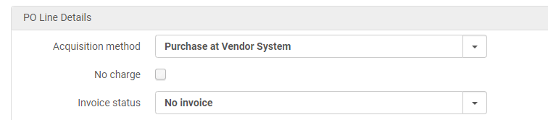
You can also mark the POL as Manual Packaging. When you click on Save and Continue, the POL will go to manual packaging instead of auto-packaging.
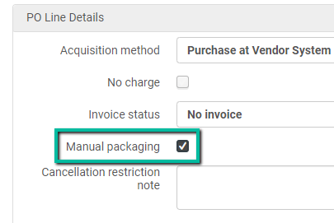
Once the information is entered in the POL, you have the option to -
- Save and Continue: If the POL is not marked as Manual Packaging –The POL goes to Auto Packaging. A job is run automatically to package POLs into a PO. See online Help’s “Packaging Purchase Order Lines” for details on packaging rules. If the POL is marked as Manual Packaging, the POL goes to manual packaging.
- Save: The POL will be in the Review status. You can work on it later or assign to another user.
- Order Now: Creates the PO (skips auto-packaging and creates the PO)

If clicked on Manual Packaging, go to your Task list and click on “Order Lines – Packaging,” select the POLs to package in a PO, then click on the Create New PO button.
End of purchasing workflow.
The next step would be to invoice and receive the physical items or activate the electronic resource.

