How to set up and test a Fulfillment Network (FN) and an Automated Fulfillment Network (AFN)

1. Objective 2
2. Setting up the Network 2
Shared password 2
Network Members 2
Non NZ members 2
NZ Members 3
Testing Your Setup 3
3. Setting up the Sharing of Users 3
Linked Account Rules 3
Linked Account Shared Fields 4
Restricted Users 4
Searchable Identifiers 4
Consortially Unique Identifiers 4
Testing Your Setup 5
4. Setting up the Fulfillment Attributes 6
Walk in Loans 6
Institution Relations 6
Setting up Libraries 6
Testing Your Setup 7
Requesting 7
Pickup Anywhere 7
Testing your Setup 8
5. Other Configurations 8
Primo 8
Consortially Unique item Barcodes 9
6. Setting up AFN 9

Objective
This document is a quick set up list that will guide through the process of setting up and testing a fulfillment network. The process will follow through setting up a FN and a AFN workflow between two specific institutions. The process will normally be done between multiple institutions.
While having a Network Zone (NZ) is not mandatory for a functioning FN, some elements of the FN configuration may be done in NZ where relevant. This will be referred to within the document.
The basic configuration of a FN is made up of two elements:
- Setting up the network
- Setting up the sharing of users
- Setting up the fulfillment relations between institutions
The AFN setup is an additional configuration and workflow layer that allows automating the FN requesting process.
It is recommended to follow through the setup process in the order it is defined in this document.
Note that the different models of shared user management (such as Centralized User Management and use of Consortial IDs) are not discussed in this document.

Setting up the Network

Shared password
Note : This step is required only when no NZ is in place. Where a shared NZ is used the password is shared via the NZ setup.
In order for Alma institutions to communicate the must share a password. The password is set up using the Resources config menu >General>Other Settings option and setting up the networkSearchPassword parameter. All participants of the network must have the same password.

Network Members

Non NZ members
Setting up which institutions your institution will share fulfillment network services with is done by listing them using the General>Network Groups>Fulfillment Member configuration menu.
More information is here.

NZ Members
In an NZ, all members of the NZ are considered potential members of fulfillment networks within the NZ. Configuring the members of the network is therefore done by setting up Fulfillment Groups in the General>Network Groups>Fulfillment Network Groups option at the NZ. Using the mapping in this table you define which institutions are part of a fulfillment network. While this allows the flexibility of creating multiple fulfillment networks within the same NZ, the classic configuration is to list all of the NZ members in one fulfillment group, creating a single network of all of the NZ members.
More information is here.

Testing Your Setup
Once the above elements have been configured, you should be able to see an option to Find user in other institution’ when using the Manage Fulfillment Services (a.k.a. circulation desk) page, and see a list of the institutions you have configured.
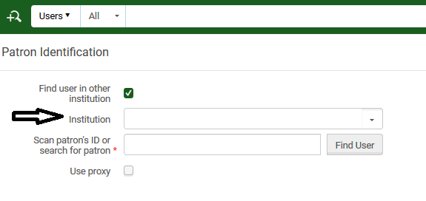
Being able to actually pull a user record from another institution depends on the setup in the next section – ‘Setting up the sharing of users’.

Setting up the Sharing of Users

Linked Account Rules
Linked account rules determine how accounts will be copied to your institution from another institution. This configuration option maps the values that the linked account that is created in your institution will get, for example:
- The user group the account will be set to
- When the record will expire
- When the record will be purged
- Will source institution blocks affect the linked account created in your institution.
Linked accounts rules are configured using the User Management config menu>Collaborative Networks>Linked Account Rules option.
These rules affect how accounts are created at your institution from other isntitutions’ user records.
More information is here.

Linked Account Shared Fields
Linked Account Shared Fields setup enables you to control what fields from your patron records will be copied over to another institution. It enables you to protect the privacy of your patrons, for example by setting this configuration to allow other institutions to pull only the patron name and email.
Linked accounts rules are configured using the User Management config menu>Collaborative Networks> Linked Account Shared Fields option.
These rules affect how accounts are pulled from your institution by other institutions.
More information is here.

Restricted Users
Restricted Users setup enables you to determine which user groups to be hidden from other institutions in a fulfillment network. Effectively, this excludes these user groups from being able to receive services at another institution, since their user record will not be shared with another institution. This can be configured for a number of reasons, such as:
- Some user groups may not be eligible for fulfilment network services because of institutional fulfillment policies.
- Some users records may be considered private and not allowed for sharing because of privacy concerns.
Restricted Users rules are configured using the User Management config menu>Collaborative Networks>Restricted Users.
These rules affect how accounts are pulled from your institution by other institutions.
More information is here.

Searchable Identifiers
Searchable Identifiers define which user identifiers are searchable via the fulfillment network process for fetching patron information. A typical use case is where not all patrons are eligible for fulfillment network services. Only patrons that are granted the ID types configured in this table will be able to get fulfillment network services, and only by using the IDs of the types configured here when identifying at the circulation desk of a remote library.
Searchable Identifiers are configured using the User Management config menu>Collaborative Networks> Searchable Identifiers.
These rules affect how accounts are pulled from your institution by other institutions.
More information is here.

Consortially Unique Identifiers
If the user IDs in the network are fully unique, i.e. the same ID is not used for identifying two different patrons in two different institutions, then you may set up the network_users_unique_identifiers parameter to FULL. This way, when patrons approache a desk in your library there will not be a need to first select their source institution before scanning in their ID. By only scanning in their ID, Alma will find the correct record in whatever institution in the network and pull the user record.
This option is configured using the User Management config menu>General> Other Settings option, by configuring the network_users_unique_identifiers parameter to FULL.
These rules affect how accounts are pulled to your institution from other institutions.
More information is here.
Note – this option should only be used if you can guarantee that user IDs are 100% unique across the network. If user IDs are not 100% unique across the network then consult Ex Libris staff. In cases where there is a high level of uniqueness a setup may still be done such that unique records will be automatically identified without requiring to select the source institution, and where a non unique ID is scanned in a select option will pop up allowing to select the correct record.

Testing Your Setup
Once the above listed steps have been configured it is recommended to verify the setup. Note that the setup needs to be done at two institutions before a test is done – the institution from which the user record will be pulled (institution A in the below example) and the institution to which it will be pulled (institution B in the below example).
- Identify a user record in institution A which you want to be able to receive fulfillment services at institution B.
- In institution B, access the Manage Patron Services page
- Select ‘Find user in another institution’. Form the drop down, select institution A
- Scan the ID of the record you identified in step 1.
The expected result is a user edit form, prepopulated with the data that institution A allowed to be shared with other institutions (see above), and populated according to the rules you have set up (see above).
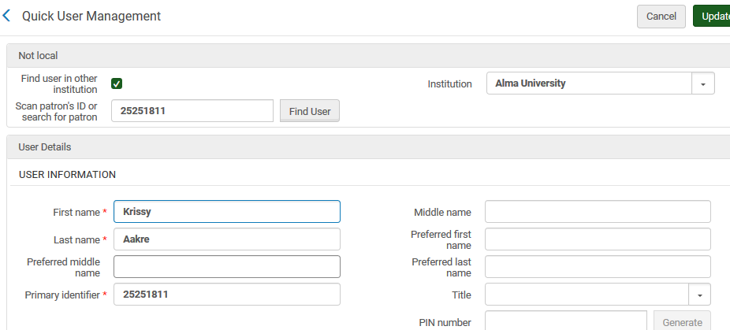
After the user record has been pulled once, the next time it is identified at the circulation desk the manage Patron Services screen will open up skipping over the step of confirming the user information.

Setting up the Fulfillment Attributes

Walk in Loans

Institution Relations
Institution relations determine:
- Which institution can potentially deliver items to which other institution.
- Which institution can potentially circulate (check in\out) items of another institution.
General>Network Groups>Institution Relations
More information is here.

Setting up Libraries
Libraries can check out\in items from libraries of other institutions only if the have been set as libraries that serve other institutions.
When configuring a library (General Config > General > Add a Library or Edit Library Information), select the ‘Serves Other Institutions’ check box for libraries that should be able to process items from other institutions at their primary desks.
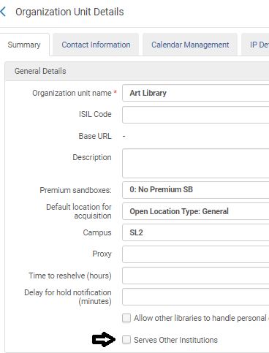

Testing Your Setup
You should now be able to use the Manage Patron Services page to scan in item barcodes from institutions that your institution has Circulate For relations with (see above). This will be possible only at primary desks of libraries that have been set to service other institutions (see above).
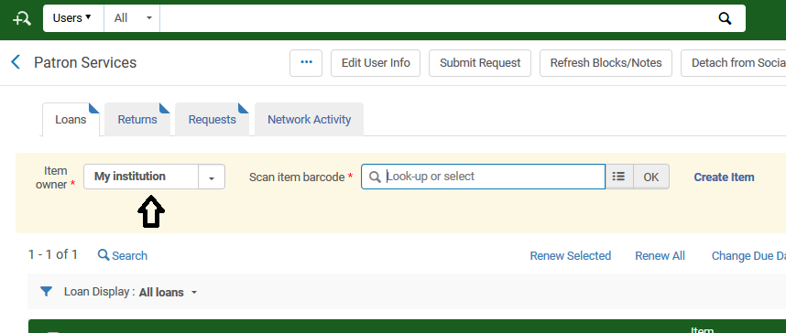
The same option should be available in all scan in interfaces – the Scan In page, the Return Items page and the Returns tab of this page.

Requesting

Pickup Anywhere
In order to be able to request an item for pickup at another institution, the item’s request policy must have the Pickup Location Policy set to ‘At Any Institution’.
- Make sure you have defined such a pickup policy

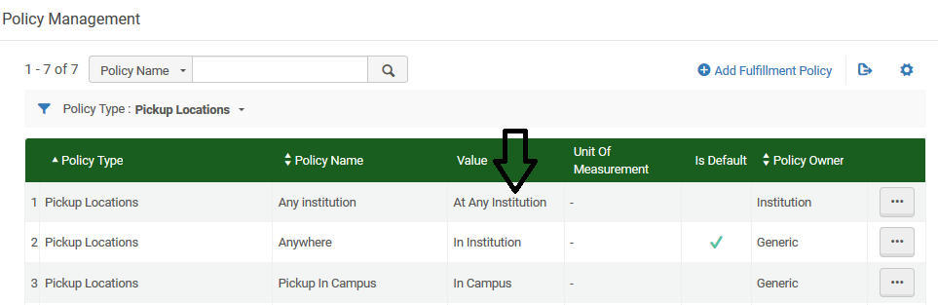
- Make sure to use it at a TOU that you want to apply to items that should be requestable for pickup at other institutions.

Testing your Setup
You should now be able to use the Alma request form to request an item for pickup at another institution. Find an item that a known patron should be able to request for pickup at any institution as per your rules (use the Fulfillment Configuration Utility to verify the item is indeed requestable for this patron for pickup anywhere), and open up its request form.
The request form should enable requesting for pickup at institutions that your institution is set up to have Deliver To relations with (see above). Only libraries that serve other institutions (see above) show up.
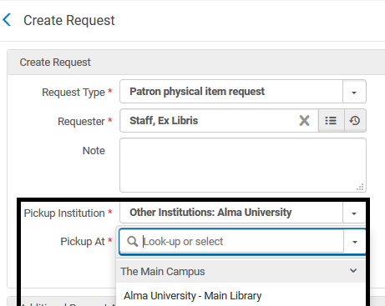

Other Configurations

Primo
Primo can be set up so that opening the GetIt tab of another institution will not automatically create a linked account at that institution, unless the patron has explicitly agreed to that. Use the Fulfillment Config menu>General>Other Settings menu to set the uresolver_remote_register parameter to Manual. If set to Auto then the linked account will be created without requiring any action from the patron.

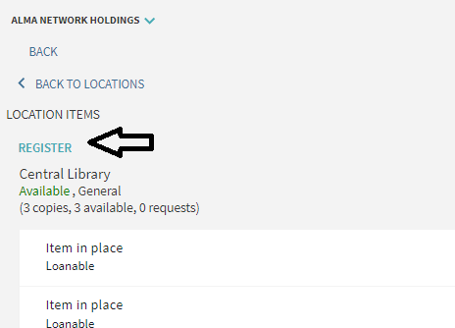

Consortially Unique item Barcodes

If the item barcodes IDs in the network are fully unique, i.e. the same barcode is not used for identifying two different items in two different institutions, then you may set up the fulfillment_network_unique_barcodes parameter to FULL. This way, when and item barcode is scanned in at a desk in your library there will not be a need to first select their source institution before scanning in the item barcode. By only scanning in the item barcode, Alma will find the correct item in whatever institution in the network.
This is configured by using the Fulfillment config menu>General> Other Settings option, by configuring the fulfillment_network_unique_barcodes parameter to FULL.
More information is here and here.

Setting up AFN
The Automated Fulfillment Network (AFN) is based on a functioning Fulfillment Network. Once the above steps have been successfully configured, the library can set up its resource sharing process so that the resource sharing rota will create FN requests at peer institutions instead of resource sharing lending requests.
The AFN setup is practically a regular resource sharing setup, with the only difference being that:
- The profile type of the partner records is ‘Fulfillment Network’
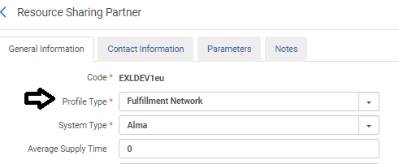
- The locate profiles are set up with the type ‘Fulfillment Network’
