Defining Library Open Hours on the Library Level Calendar

Yoel Kortick
Senior Librarian

Regarding Library Open Hours, they must be defined on the library level

As stated in the On Line Help for Configuring Institution/Library Open Hours:

Libraries inherit events and exceptions from the institution. However, libraries do not inherit institution opening hours; opening hours must be defined for each library.

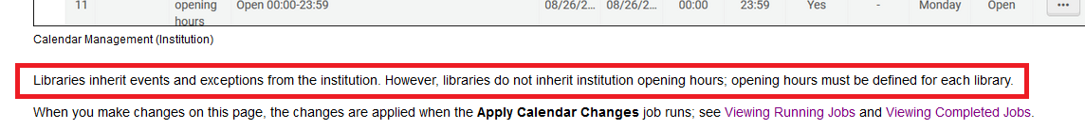

Here is an example of this:

ONE

At institution level “Configuration > Fulfillment > Physical Fulfillment > Advanced Policy Configuration” we have a Policy of type “Due Date” called “1 day loan due at closing time”.
It is defined to be a loan for 1 day.
The due time hour will be the library’s closing time because the field “At (HH:MM)” is empty

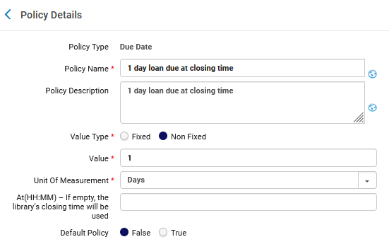

TWO

At institution level “Configuration > Fulfillment > Physical Fulfillment > Terms of Use and Policies” we have a Terms of Use of type Loan which uses the above policy of type “Due Date” called “1 day loan due at closing time”.

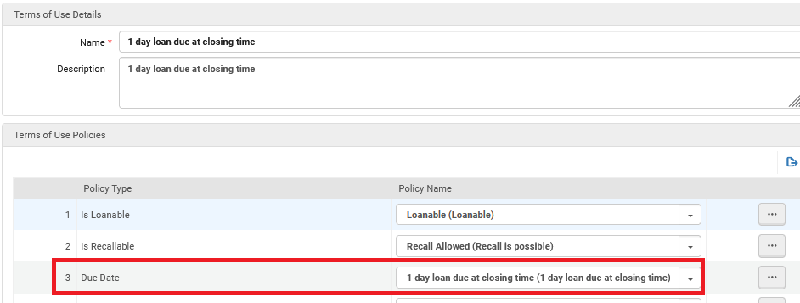

Note also that in this terms of use the “Closed Library due Date Management” is defined as “No Change to Due Date”

THREE

The institution level fulfillment unit “regular” includes the location code BAL (Ballet Music Collection) which is in the Art Library.

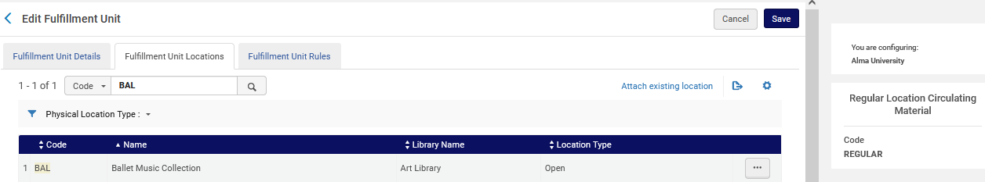

FOUR

The first rule of type loan for the institution level fulfillment unit “regular” is called “Art Library Ballet 1 day loan due at closing time” and it states “If Location = Art Library Ballet Music Collection then use the Terms of Use ‘1 day loan due at closing time’”
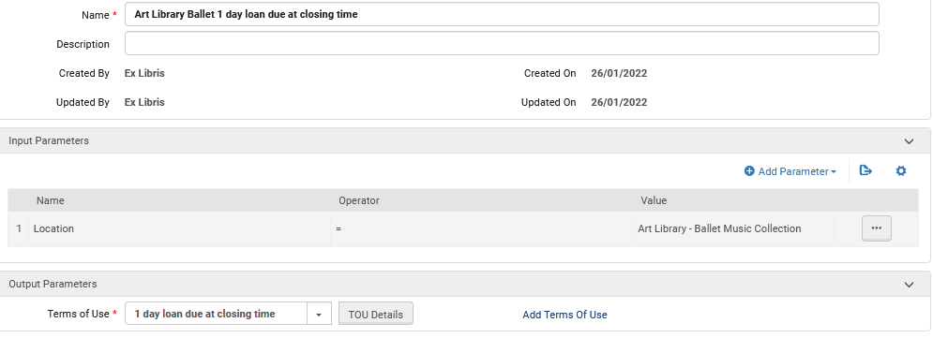

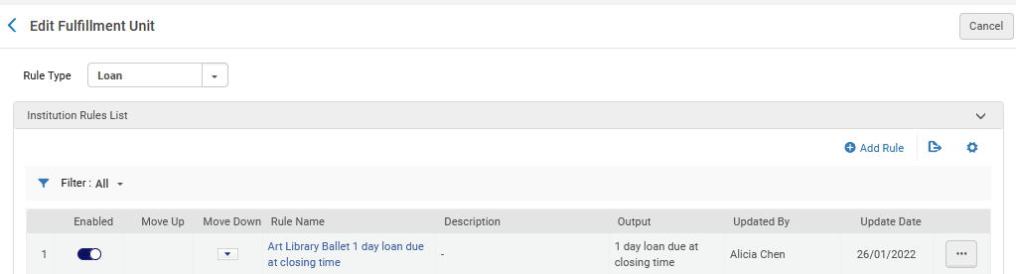

FIVE

Item barcode AU45159 is in the Art Library Ballet Music Collection, and therefore it will use the Loan rule “Art Library Ballet 1 day loan due at closing time”. This will allow us to see how the closing time of the Art Library is being determined.

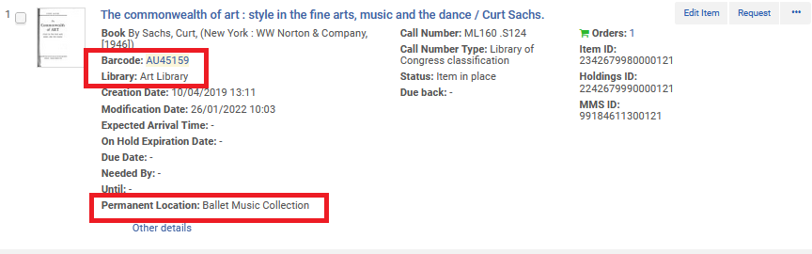

SIX

If we try to loan this barcode via the “Fulfillment Configuration Utility” at “Fulfillment > Advanced Tools – Loans” we see that it does in fact use our fulfillment unit rule “Art Library Ballet 1 day loan due at closing time” and terms of use “1 day loan due at closing time”.
Loaning the item on Wed. 26 Jan. 2022 gives it a dues date of Thu. 27 Jan. 2022 at 23:00.

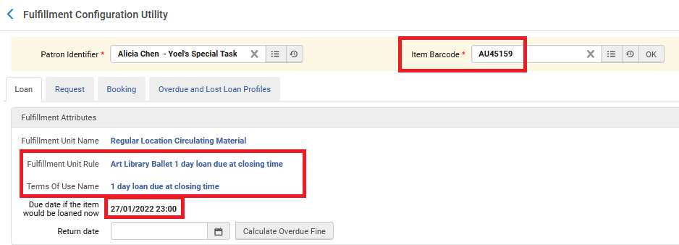

SEVEN

Let’s see why the closing time (and therefore the due hour) is 23:00 for the Art Library.
We will go to “Configuration > General > Libraries > Add a Library or Edit Library Information”

If we look on the institution level, we see that the closing time for Thursday is 22:00

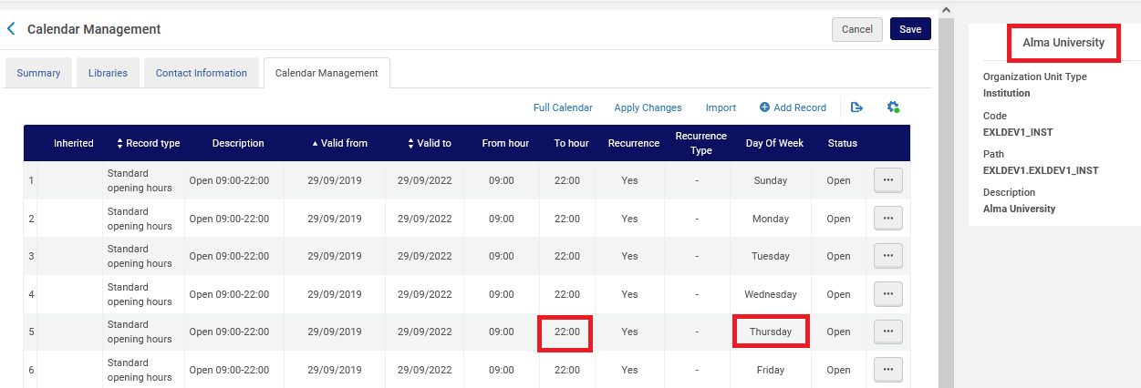

EIGHT

If we look on the Art Library level, we see that the closing time for Thursday is 23:00.
The times are not inherited from the institution.

This is why the item is due at 23:00

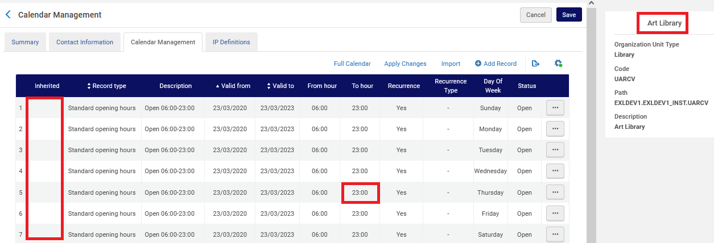

NINE

Now we will remove the calendar from the Art Library and see if the times will be inherited from the institution.

We remove all the dates and click “Apply Changes”

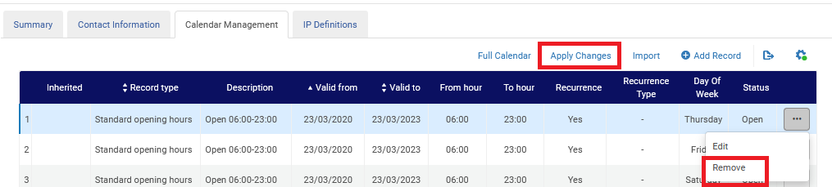

TEN

Now nothing appears in the calendar for the Art Library

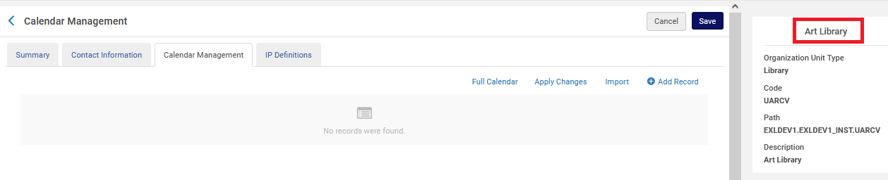

On the institution level the closing time is 22:00

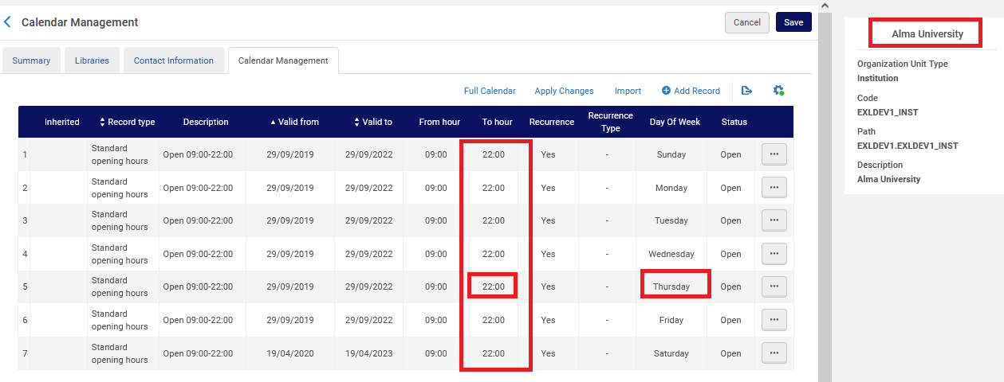

ELEVEN

Now again we will check the due date and due hour for item barcode AU45159 is in the Art Library Ballet Music Collection, loaning it on Wed. 26 Jan. 2022. Again, we will use the “Fulfillment Configuration Utility” at “Fulfillment > Advanced Tools – Loans”

It does not inherit the closing hour from the institution (which would be 22:00).
Instead, it gives a due time of 1 day from the loan day, with the hour being the hour the loan was made.
It does not have a closing time so it makes the due time be the time the loan was made (in this case 10:49)

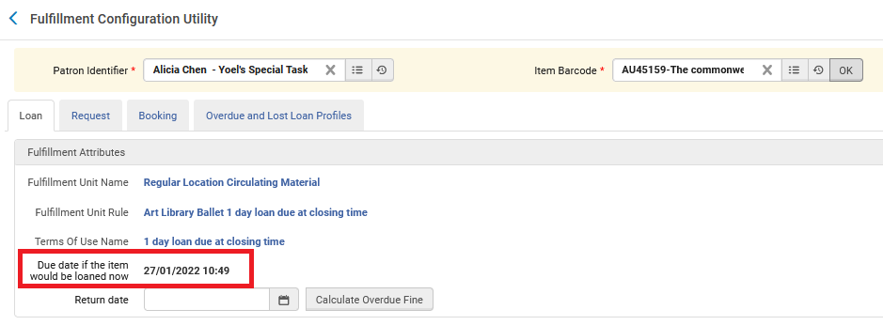

TWELVE

If now we define the Art Library to have closing time at 21:00 …

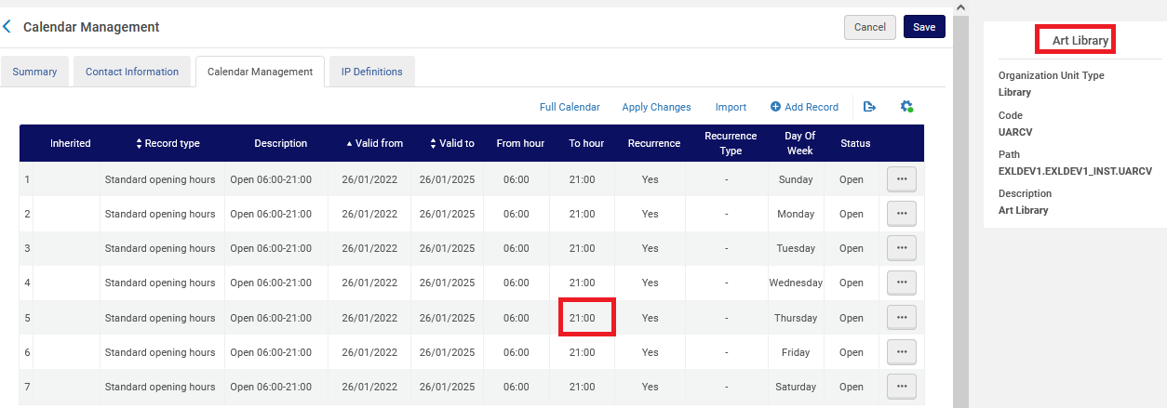

Then barcode AU45159 will be due the next day at 21:00

