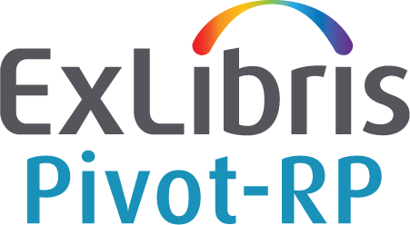

Accelerate your Research Funding

Start Guide and Search Tips
Licensed under a Creative Commons Attribution 4.0 International license.

What is Pivot-RP?
Pivot-RP is the most comprehensive resource for finding global funding opportunities. Coupled with a database of scholarly profiles and conferences seeking proposals, Pivot-RP helps automate the process of matching financial support to researchers and partners. Pivot-RP includes billions of dollars in funding opportunities from the broadest scope of sources including from public institutions, non-profit organisations, corporations and multinational organisations – all in one easy to search tool.

To access Pivot-RP, navigate here: https://pivot.proquest.com

You can use the links below to navigate to specific topics in this guide.

What is Pivot-RP?
Creating an Account
Claiming a Profile
Searching
Browsing and Searching with Keywords
Using Advanced Search - Tools for Narrowing a Search
Working with Results
Results: Related opportunities
Results: Limited Submission opportunities
Results: Sharing Opportunities
Results: Tracking Opportunities
Saved Searches and Email updates
Getting Help
General Search Tips

Creating an Account
As a new Pivot-RP user, you may want to start out by giving yourself an account. This will allow you to save searches, track opportunities, create regular email updates, and send emails about individual grant opportunities to yourself or others.

You will also be able to manage a personal profile which allows you to get personalised funding recommendations and will make you more visible to potential collaborators.

Having an account will allow you to access Pivot-RP when outside of your institution’s IP range – which means you can use Pivot-RP from anywhere you have internet access.

Note that when creating a Pivot-RP account, you must sign up with your institutional/university email address and create a password, or, use institutional SSO credentials (and then validate with your email address). Pivot-RP will not allow you to use a personal email.

To sign up for an account, select the Create Account link from the login screen or from the home dashboard page which you will see if you are IP authenticated. | 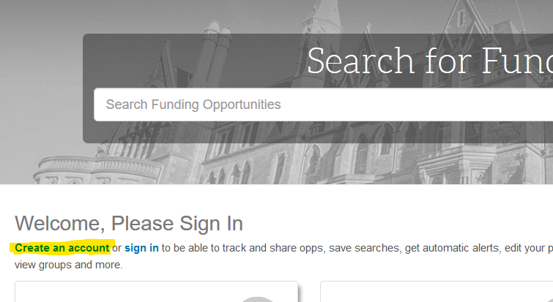
Note that the Sign in link is just next to it. You do not need to login to search if you are in an institutionally recognised IP range, but you will be required to login to use any of the save or email functions.
The sign-up page asks for your name, email, and prompts you to create a password.  Your email address will serve as your userID.  Find and select our university/institution from the institution pull down menu.  The system will send you an email with a link that serves as a confirmation, and will lead you to a website where you may log in.  If the confirmation email does not arrive in a short amount of time, you may want to check your email account’s spam folder. | 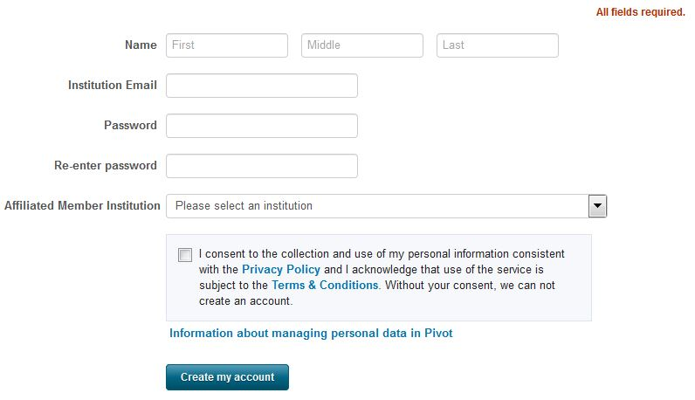

Claiming a Profile
All Pivot-RP users can claim and manage a personal profile. For most users Pivot-RP comes pre-populated with a profile that has been set up by the Pivot-RP editors on behalf of your institution. You will just need to Claim your Profile to be able to manage and edit its contents. Your profile can contain biographical information about your role and research interests, as well as lists of publications and grants awarded.

While you do not need to maintain a profile to use Pivot-RP, the profile information is used to provide you with automatic Funding Advisor Alerts which are weekly recommendations of funding opportunities that may be of interest to you. You can opt out of receiving such recommendations in your personal Preferences settings.

Once you have created an account, choose My Profile and you will be prompted to Claim your Profile. | 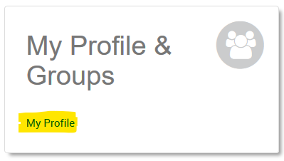
Next you will see a Select your profile page which should display your profile. If you have a common name, you may be prompted to select from a list of potential matches. Find your profile and select “This is me” to claim it.  The system will send you an email with a link that serves as a confirmation that you have claimed your profile. | 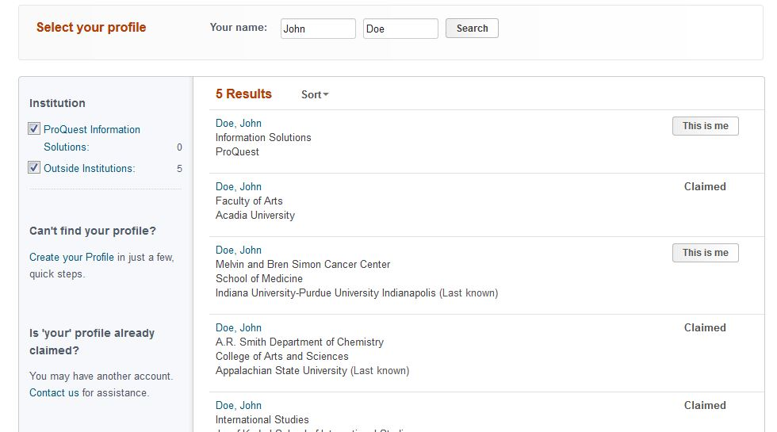
The next time you log in to Pivot-RP you will find a link to My profile on the home page, or, in the drop-down menu under your name. It is a good idea to view and update the contents of your profile. | 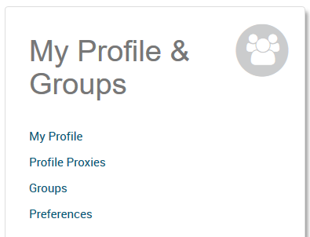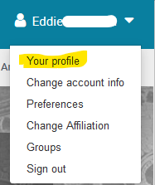
From your profile page you can select Edit Profile at any time to add, delete or update any of the information that is visible.

Linking a CV or publication page to your profile, or, adding a few Keywords that match your research interest, will improve the automated funding adviser recommendations you receive.

Searching
The best place to start a Pivot-RP search is from the Funding tab. Pivot-RP offers several ways to quickly perform a search and get relevant results related to your research interests.

Pivot-RP also allows you to search researcher profiles from the Profiles tab. All profiles provide links to funding opportunities that would be recommended for each researcher based on the contents of their profile.
Choose the Funding tab to see all your search options. You can choose to search  - by entering Free-Text terms  - by Funder name  - by Keywords  or  - you can browse and select keywords using the graphical browse by keyword wheel  or  - choose Advanced Search for more precise searching options | 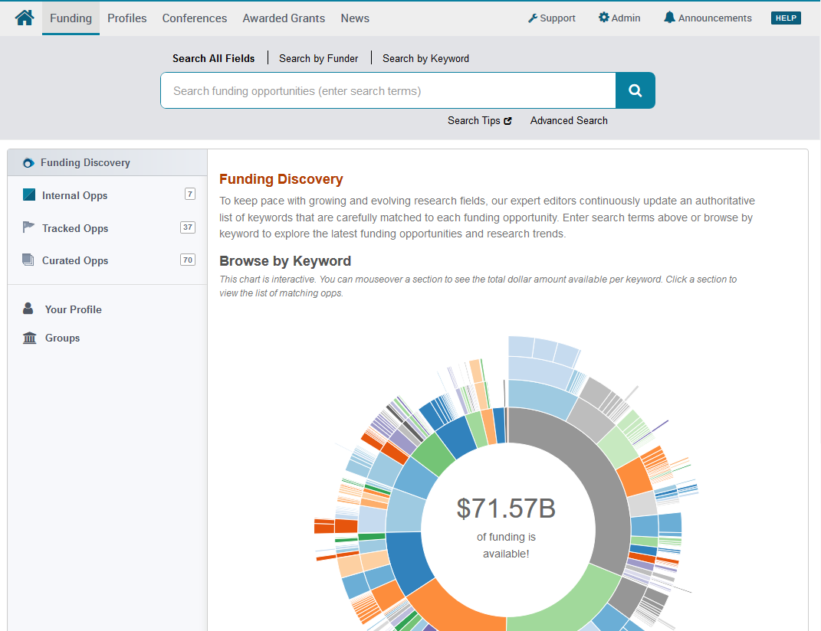

Browsing and Searching with Keywords

Because the titles and descriptions of the grant opportunities are often written in very general terms or are summarised from the full text of the opportunity, simple free-text searches may not yield the most precise or comprehensive results. One of the best ways to overcome this is to use the pre-defined keyword search options since Pivot-RP editors carefully map one or more of those keywords to each entry in the database. Searches using pre-defined keywords can be more precise.

One way to search by keyword is to use the interactive Browse by Keyword wheel. Hovering over different parts of the wheel will give you a sense of approximately how much funding is available by topic.  Note: not all funders specify exactly how much funding is available so there is usually even more funding available at any given time than what the wheel displays. | 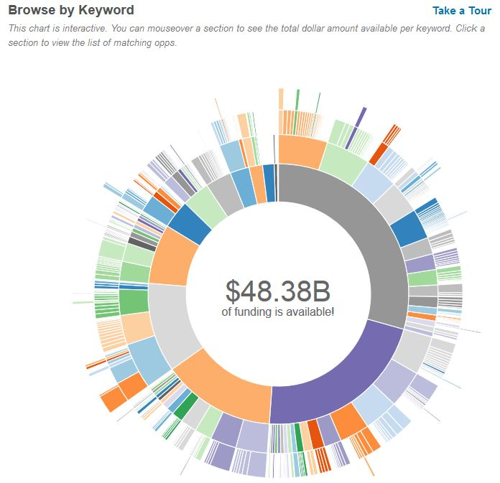
If you find a Keyword that matches your research interest when hovering over the wheel, just click that part of the wheel to view all results in Pivot-RP currently associated with that term. | 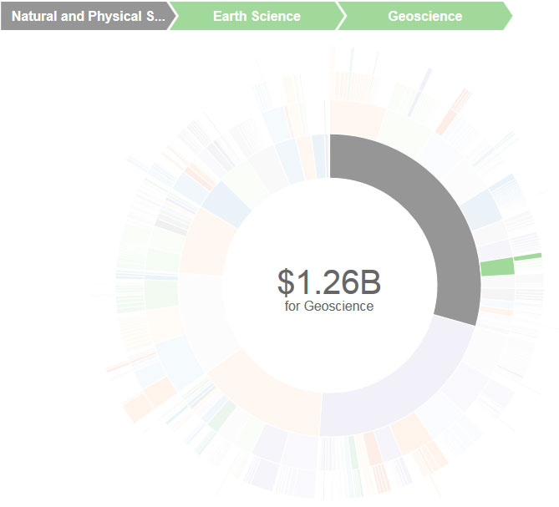
Choose Search by Keyword to browse the Pivot-RP keyword hierarchy. You can also type terms in the search box and Pivot-RP will match them to the keyword hierarchy.  This allows you to build a query that uses one or more keyword terms and may lead you to discover related keyword terms you had not yet thought of.  Note that when using multiple keywords, they are automatically combined with an OR, which means that your results will contain at least one of the keywords that you selected. | 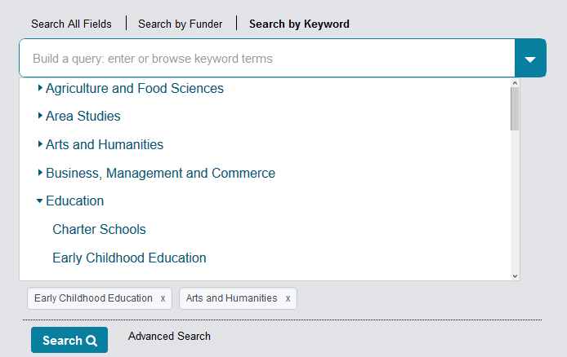
Keywords can also be found and included in searches (along with other search parameters) when using the Advanced Search form | 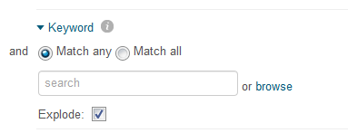

Using Advanced Search - Tools for Narrowing a Search

One of the most effective ways to search Pivot-RP is to use the Advanced Search form which allows you to set very specific search criteria for a more precise, narrow results set.

The Advanced Search page has many tools for pre-scoping and limiting your search results.  You can search all or just specific fields within funding opportunity records by using the All Fields pull down menu.  You can also pre-filter results by funding type, by dollar amount, by upcoming deadline, or by a handful of other useful parameters related to eligibility or applicant type. | 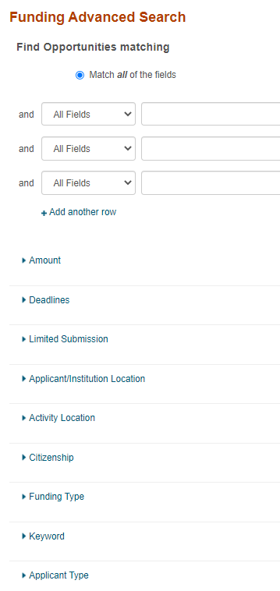
Placing search terms on two separate lines will cause the ideas to be combined with an AND, meaning each resulting item will contain both topics.  Items on the same line are automatically combined with an OR, which means that your results will contain at least one of the keywords that you selected. | 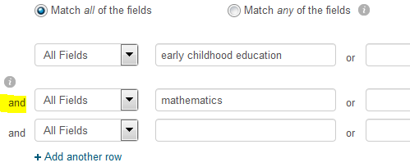
Choose Funding Type to limit to opportunities of a particular type or for a particular activity, such as postdoctoral awards or travel. | 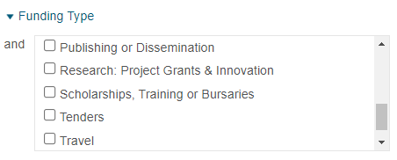
Choose Funder Type to limit to opportunities from a particular type of funder, such as the US or international governments, a private foundation, or a commercial entity. | 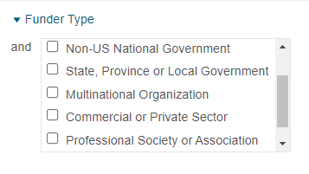
Choose Applicant/Institution Location to limit where the applicant can be based to apply from.  Choose Activity Location to limit by where the activity may take place.  Choose Citizenship to limit results based on citizenship requirements stipulated by the funder.  Note: In some cases, you may see these filters enabled by default by your Institution’s Pivot-RP administrator | 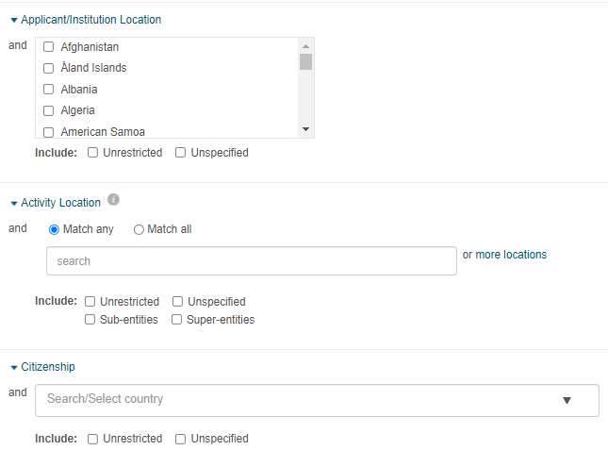
You can also exclude opportunities that meet certain criteria in the Exclude Opportunities matching section.  This is useful to eliminate opportunities that might contain requirements you know do not meet your needs, or, that are related to research areas you are not interested in. | 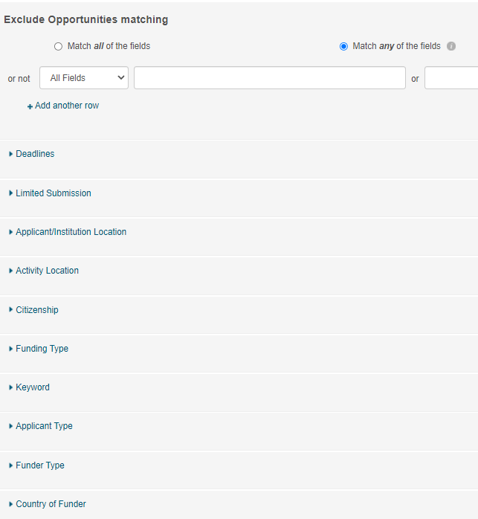

Working with Results
Your search in Pivot-RP will result in a list of possible opportunities.  By scanning the list, you can see deadlines, dollar amounts and funders  The list may be narrowed further by any of the terms in the categories listed to the left, including:  - Funding Type  - Funder Type  - Keywords  - and more | 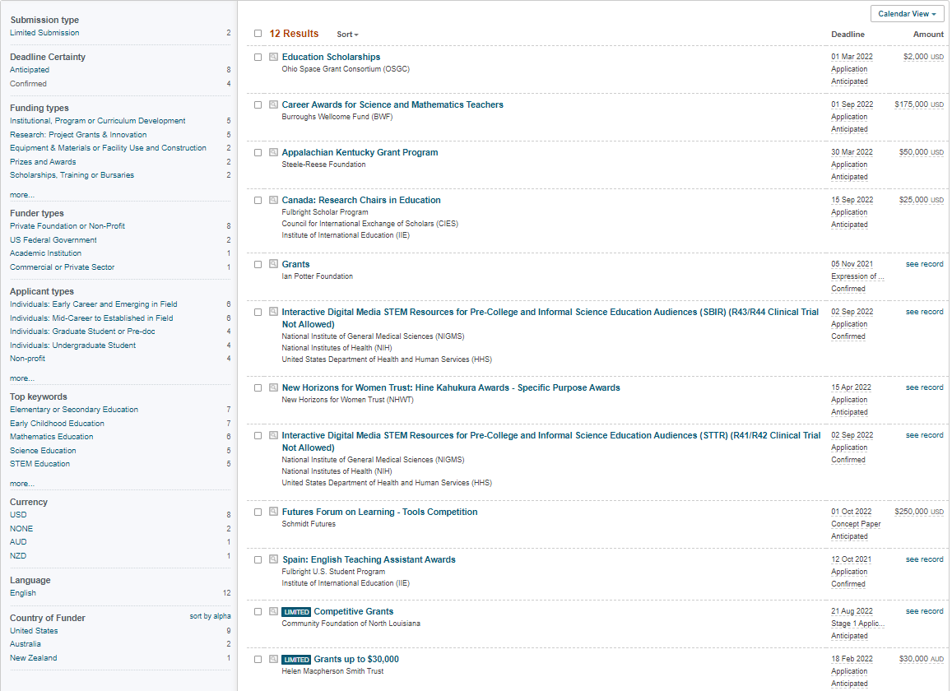
Choose Sort to order the list of opportunities by:  - Relevance  - Title  - Deadline  - Amount | 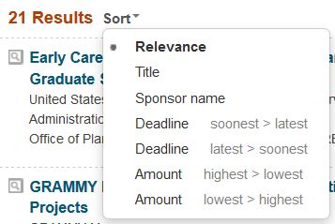
Choose the magnifying glass icon to quickly view a brief description of the opportunity and its eligibility requirements | 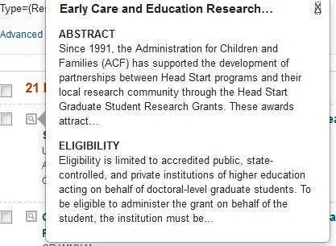
To view the full details of a grant opportunity, choose the title of the opportunity to be brought to a full details page for that opportunity.
Each Full details display gives you information about:  - Deadlines  - A detailed description  - Contact information  - A link to the funding agency’s website  - Eligibility requirements  - and more | 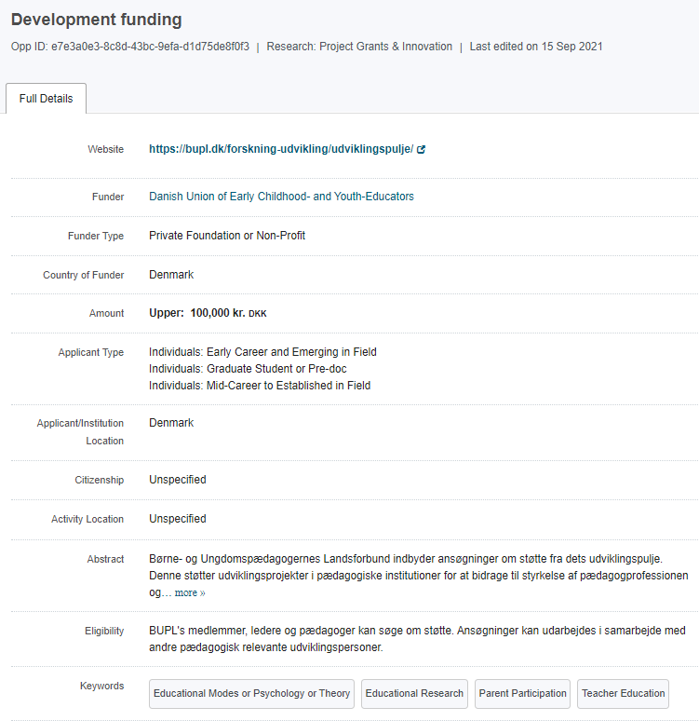
Check the Keywords to see if there are any that could be used to further enhance your search.
View the funder’s website to check the full information from the agency.

This is always an important step, since the material in Pivot-RP has been edited for brevity.
The funding contact person may also be a valuable resource, and if you are serious about an application, it may be wise to email or call them directly to discuss how well your idea matches the parameters of the grant.

Results: Related opportunities

As you are looking at individual opportunities, if you are signed in, select the “see more opps like this” link.  This is a quick way to get a list of opportunities closely related to the one you are looking at, without an elaborate search.  The list of results can be quite lengthy, but it is organised in a relevancy rank, which should help. | 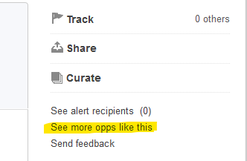
Choosing a funder name will run a new search in Pivot-RP and return results for all the opportunities that are available from that funder.

Depending on the funder this can be another way to see related opportunities.

Results: Limited Submission opportunities

Note that some results in Pivot-RP are marked as “Limited”. This generally means that a limited amount of applications may be submitted from one institution. You should coordinate with the research office before applying. | 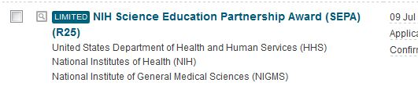

Results: Sharing Opportunities

Use Share to send opportunities to colleagues or yourself. | 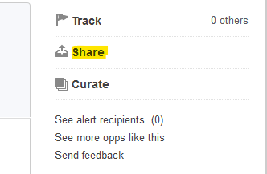
When sharing an opportunity, type the name of a recipient and Pivot-RP will autocomplete the emails for members of your institution. You can send to multiple colleagues at once.  Pivot-RP allows you to share with anyone within or outside of your organisation. If you share an opportunity with someone who does not have access to Pivot, they will only be able to view the opportunity details for 14 days. | 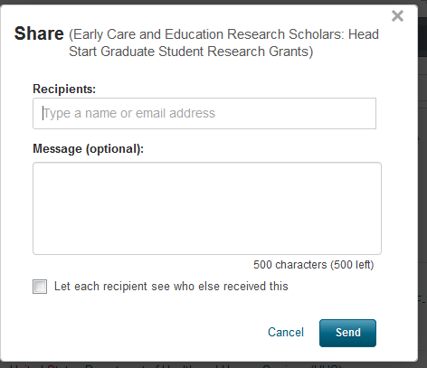
You can create and save Groups of colleagues that you regularly wish to share opportunities with. Choose Groups from the pull-down menu under your name (or from the home page) and follow the prompts to create unlimited numbers of groups.  If you have created a group(s), whenever you share an opportunity you will have the ability to share it with individuals or a group. | 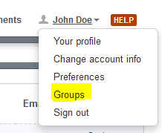
You can share multiple results directly from the results list. Click the check box next to each of the opportunities you want to share, or, check the box at the top of the list to share the entire list.  You can also use this method to track or export multiple opportunities. | 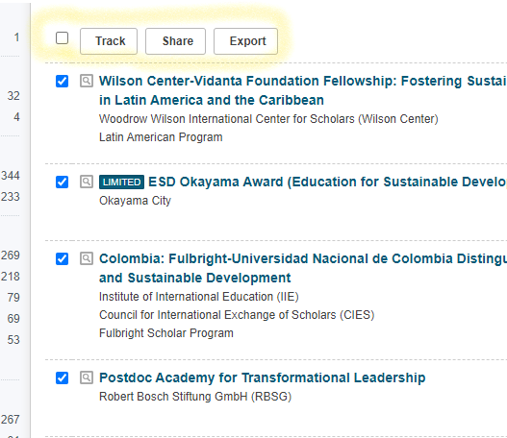

Results: Tracking Opportunities

The ability to track opportunities is one of the biggest benefits of Pivot-RP. If you are tracking an opportunity, you can schedule Pivot-RP to send you a personal deadline reminder or add deadlines to your personal calendar. Pivot-RP will also email you with updates if there are any changes made by the funder to the opportunity.

You may designate any individual opportunity to be put on a “tracked” or “active” list by using the Track link on the right.
The list of items on your tracked list, as well as your recent activity, is listed on the Pivot-RP home menu, if you are signed in.  Select the Home icon on the navigation bar. | 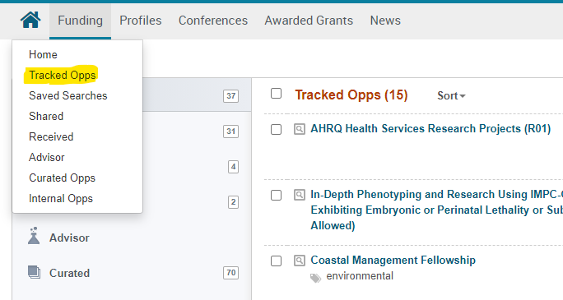
Choose Options to enable Alert emails.  You will receive a notification if an opportunity is updated in any way. | 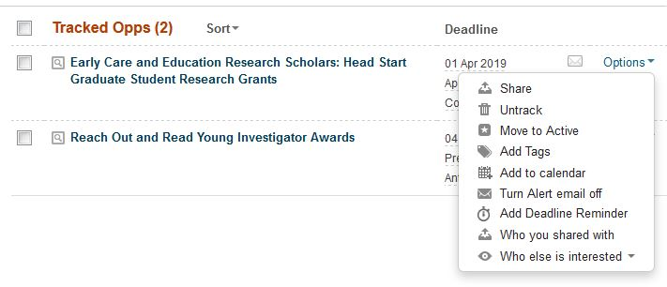

Saved Searches and Email updates
Once you have a search with which you are satisfied, you may save it and receive updates via email each time a new grant opportunity matching your search is added to the database. You may also save a search and choose not to get email updates, but instead run the search manually at any time in the future.

You can try multiple search strategies and can save multiple searches. No matter how many saved searches you have, you will only get one single weekly email that features results for each of your searches.

On your search results page, choose Save Search.
Give the search a name, decide if you want weekly email updates or not, and select Save. | 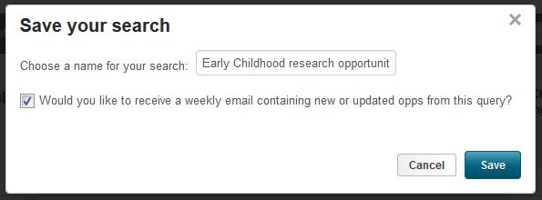
A link to your saved searches will also appear on the Pivot-RP homepage (if you are signed in).  Follow the Saved Searches link to work with your searches | 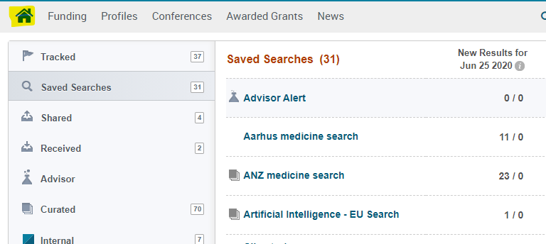
Select the title of your saved search to view the current results in Pivot-RP that match your saved search criteria.  You can limit your view to only the results that were newly added in the past week, or, you can view the complete list of results | 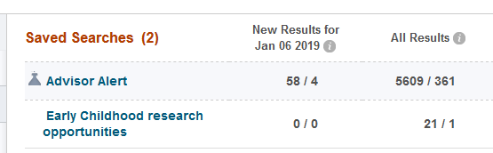
Choose Options to edit or delete searches or to change the email alert options.  You may also share searches with colleagues. They will receive a unique URL allowing them to view the full results of the search within Pivot-RP. | 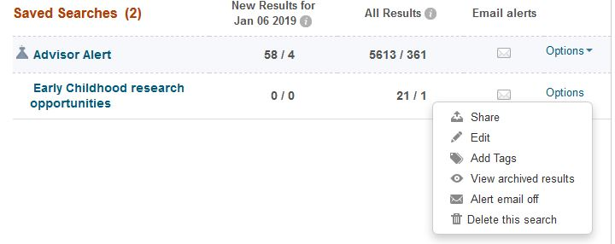

Getting Help

Pivot-RP provides short and useful “tutorial videos” and “inline help” for most features in the database. Select the “info” icon to get tips.

Selecting the “Help” link from any page will take you to detailed, searchable product documentation and other resources.

Detailed documentation and other resources: https://knowledge.exlibrisgroup.com/Pivot
Pivot-RP tutorial videos can be found on YouTube: https://www.youtube.com/user/ProQuestPivot

General Search Tips
Pivot-RP is a powerful tool, but for a variety of reasons it is not as forgiving as a search engine like Google. We recommend trying a few different approaches and search strategies to get the most relevant results. In some cases, you will find more success searching broad subject terms and then using the filters and refinement techniques to zoom in on opportunities of interest. In other cases, you may have better luck building a sophisticated query using the Advanced Search features.

Many grant funders do not mention specific kinds of research they will fund. Instead, they state broader disciplines within which they will consider applications. Some research topics may not get any results in searching, but that does not necessarily mean there are no grants for which your project may be eligible. If this happens, try searching for grants in the broader field(s) within which your project falls. For example, a project to study zebra mussels may be eligible under a grant looking to fund projects in the broader fields of Biological Sciences, Marine Biology, or Environmental Biology, etc.

Remember that you can save multiple searches and search strategies. In addition, the Pivot-RP database is updated daily, and new sponsors and funding opportunities are added frequently. So, it is always possible that a search that did not result in any opportunities one day, may have relevant results another day.

Use Truncation (Asterisk), Proximity Operators (pre/#, w/#), Exact Phrase Searching (Double Quotes), and Precedence (Parentheses) to give your search more flexibility.

Quotes: Searches for exact phrases. Example:
- “childhood obesity” searches for opportunities that contain the exact phrase “childhood obesity”

Proximity: Searches for opportunities containing words that lie within a specified maximum distance of each other.
Example:
- (childhood w/5 obesity) - Finds opportunities where the words “childhood” and “obesity” lie within 5 words of each other

Truncated: Inserting an asterisk allows you to search for multiple variations of a word or partial word. Example:
- child*- Finds opportunities containing the words “child,” “children,” “childhood,” etc.

- Searches are case insensitive. Using either upper-case or lower-case letters will yield the same result set. Also do not use the articles a, an, or the since the search engine does not search for these.

- With the exception of the hyphen, do not use punctuation marks (slashes, commas, etc.). Punctuation marks in most cases will retrieve erroneous results. This also applies to the Amount Field. For monetary amounts, leave out any commas or periods. E.g.: $10,000 = 10000.

