  - Pivot-RP Funding Database: Start Guide
To get started go to: https://pivot.proquest.com

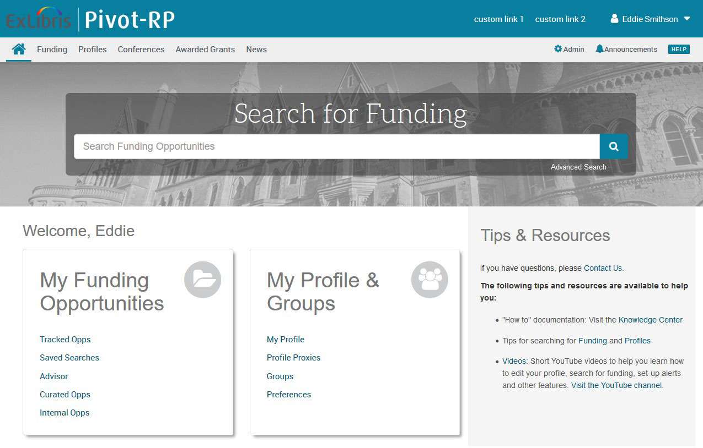

About Pivot-RP – Create an account today
Pivot-RP is a database containing active funding opportunities for all disciplines and project types. It includes a wide variety of funding types, including funding opportunities from public institutions, non-profit organisations, corporations and multinational organisations all in one easy to search tool.

With your personal account, you can:
- Sign up to receive customised funding alerts
- Save and return to previous funding searches
- Track and get updates on individual funding opportunities
- Share funding opportunities with others
- Edit your public profile

To create an account:
- Click on Create Account
- Use your institutional-assigned email address (this will be your User ID) or choose “use institutional credentials” for SSO login
- Select your institution from the Institution pull-down menu
- Fill in all required fields to validate your name and email address

To activate your account, wait for an email from Pivot-RP to validate your account. Check your spam folder if you do not see the email in your inbox.

Claim your Profile:

- Upon logging in for the first time, Pivot-RP may prompt you to claim your profile or to create a profile
- While this is optional, it is a good idea to do so, to get automated funding recommendations based on your research interests, publications, and grants
- Claiming a profile also allows you to be discovered by potential collaborators
Funding Discovery: Basic Search

Enter a search from the home dashboard or select the Funding tab for more options. You can enter free text search terms, or search by Funder or Keywords. It can be a good idea to start with keywords which are pre-defined terms that Pivot-RP editors match to funding opportunities.

By hovering over the Browse by Keyword wheel you can see approximately how much funding is available for a given term. Selecting a term from the wheel will return results for all the funding opportunities matching that term.

When running free-text searches from the main search box, you can get more precise results by:
- Using quotes for an exact phrase search (example, “childhood obesity” returns results that have that exact phrase)

- Using an asterisk to search word variants (example, using child* returns results with the terms child, childhood, children, etc.)

- Using proximity limiters (example, using childhood w/5 obesity returns results where both terms are within 5 words of each other)

The Search by Keyword feature allows you to easily find keywords that align with your research interests and quickly build a query that searches one or more keywords.

Tip: if you start with broad keywords first, then you can always narrow your results on the results screen or refine your query by adding more specific terms based on the results you receive

The Search by Funder feature allows you to search for specific funders and funding agencies, or, you can browse an A-to-Z list of all the funders that
Pivot-RP is tracking. Just click on a funder name to see all of the active funding opportunities for that funder in Pivot-RP.

Performing an Advanced Search

On the Funding tab or home dashboard select Advanced Search. You will see a variety of options for searching specific fields and for pre-scoping your search by specific criteria including by:
• Funding type
• Funder type
• Award amount
• Upcoming deadline
• Applicant type

There are also three other important parameters related to eligibility:

Applicant/Institution location – specifies where the applicant should currently be based

Activity location – specifies where the research or activity must take place.

Citizenship – specifies any citizenship requirements or restrictions

Note: These filters may already be applied by default by your institution’s Pivot-RP administrators. If this is the case, you can toggle off or modify these limiters.

Search Tip: Some research topics may not get any results in searching, but that does not necessarily mean there are no grants for which your project may be eligible. If this happens, try searching for grants in the broader field(s) within which your project falls.

For example, a project to study zebra mussels may be eligible under a grant looking to fund projects in the broader fields of Biological Sciences, Marine Biology, or Environmental Biology, etc.

Pivot-RP offers multiple ways to save searches, track results and get automated alerts for funding of interest.

Saving or Modifying a Search

After initiating your search, three links appear on the top of your search results screen: Advanced Search, Save Search, and Refine Search.

Advanced Search starts a new, blank search screen.

Save Search allows you to name and save your search. You can then choose whether you want to receive weekly funding alert emails that highlight any
new opportunities that match your search criteria. These will automatically be delivered to your inbox.

You can find and manage your saved searches by clicking on the ‘home” icon in the top left corner of the navigation bar.

Refine Search returns you to the search screen with your criteria still entered so you can easily add or modify keywords or search parameters.

You may also narrow your results using the facetted search results on the left side of the search results screen.

Tracking and Sharing Funding Opportunities

When viewing results sets or individual funding opportunities you can choose to Track or Share them or export results. You can save and share an unlimited number of opportunities.

You can choose to get alerts and deadline reminders for items on your tracked list. This list can also be organised and sorted to easily keep track of opportunities for multiple research areas at once.

Sharing an opportunity is easy. Enter the name or the email address of the person(s) that you wish to share this opportunity or search with. Pivot-RP will attempt to auto-populate names of others at your institution, so you don’t need to type in their email addresses. You can include an optional message as well and can even create groups of people you wish to share with.

Questions and Training

Note: Pivot-RP provides many self-help resources including short tutorial videos. You can also reach out to their support team directly.

Detailed documentation and other resources
https://knowledge.exlibrisgroup.com/Pivot

Pivot-RP tutorial videos can be found on YouTube:
https://www.youtube.com/user/ProQuestPivot

Any questions, contact the Pivot-RP Support team
https://supportcase.exlibrisgroup.com/s/pivot

