User Guide Overview
2022
Contents
RefWorks Quick Start Guide 1
Creating your Account 1
Navigating References 2
Viewing References 3
Content Organization 4
Search Databases 6
Advanced Search 7
Adding References 7
Create New References 8
Share 9
Exporting References 10
Projects 10
Create Citations or a Bibliography 12
Tools 13
Resources/Support 13

RefWorks Quick Start Guide
This guide will provide you with helpful tips needed to navigate RefWorks. For a comprehensive guide refer to the RefWorks User Guide.

Creating your Account
To get started with your new RefWorks account, go to https://refworks.proquest.com. Enter your institutional email address and create a password.
NOTE: RefWorks supports Shibboleth and Open Athens, which allows you to use your institutional credentials to sign into RefWorks.
Remote users accessing RefWorks from off-site or from a non-registered IP address, must either enter the unique URL provided by the institutional admin, log in via the organization’s proxy server, or log in using other institutional credentials (Athens, Shibboleth).
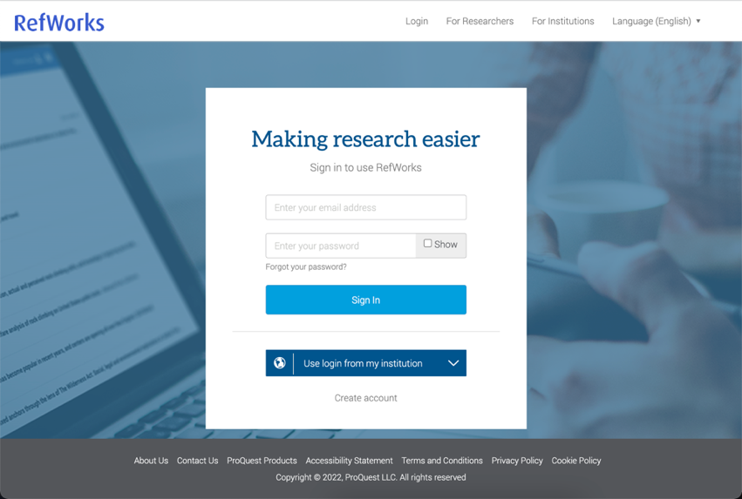

Navigating References
- Projects – Allows a user to work on separate projects with a single login account. Please refer to the Projects section below for more information.
- Utility Toolbar – Includes a drop-down for the language menu, user menu (your username), and help resources (question mark icon).
- Reference Actions – Allows you to easily and quickly: add, organize, share, cite, delete references, find tools and more.
- Reference Organization – Contains tabs that provide you with organization folders and quick access to your references.
- Reference Details/Reference Editor – Enables you to manually create a reference or to view a selected reference. This appears only if Create new reference or a specific reference is selected.
- Display Options – Provides settings for the number of references per page and reference view preferences. Reference View defaults to Normal View when you first open RefWorks and will remember your selected view the next time you open RefWorks.
- Page navigation – Previous and next button
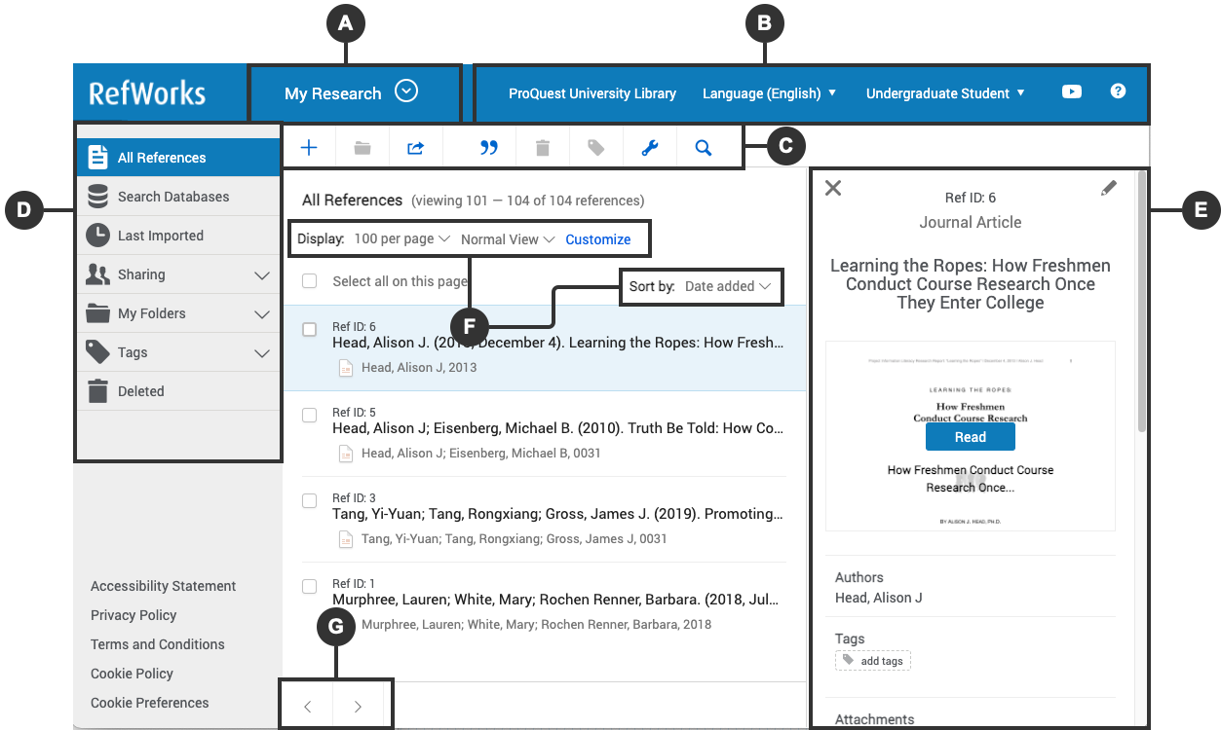

Viewing References
Sort by: On the top right use the dropdown to select how you want to display references: by date, title, author, or Ref ID. RefWorks will remember your selected sorting the next time you open RefWorks.
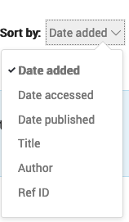
Number of references per page: On the top right, select how many references you would like to appear on the page (from 25 to 2000 references).
View type: On the top right, select which view you prefer: Normal View (default), Table View, Full View or Citation View. RefWorks will remember your selected view the next time you open RefWorks.
Using the Customize tab allows users to display Folders and Tags checkboxes when selected. Clearing the checkboxes hides the folders and tags from the list of references. This option is available in Normal View and in Full View.
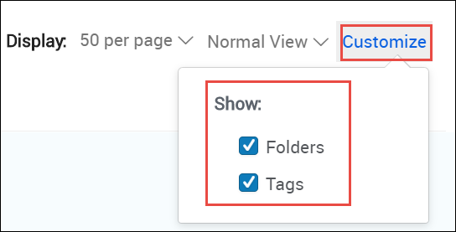

Content Organization
RefWorks supports the full research process and provides a variety of folder options to help you better organize references.
Reference Organization:
- All References – Contains all references in the project.
- Search Databases – Used to search for items in external linked databases.
- Last Imported – Displays references imported in the last 30 days.
- Sharing – Enables you to view folders that were shared with you.
- My Folders – Allows you to organize references into folders and subfolders. A single reference can be in multiple folders.
- Not in Folder – Displays references that have not yet been moved into a folder.
- Tags – includes tags assigned to references that are imported and tags created by you when adding references. A reference can have multiple tags.
- Deleted – Contains all items that have been deleted.

Creating new folders and subfolders and organizing references
To add a folder:
- Click on +Add folder
- Name your folder
- Click on Save

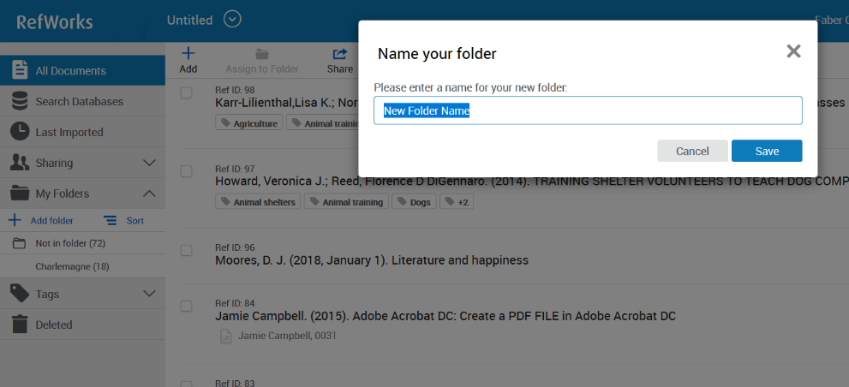
To add a subfolder:
- Click on the selected folder’s kabob icon (on the right)
- Click on Add subfolder...
- Follow prompts to name and save the subfolder.
- You can select a single or multiple reference(s) and drag and drop them into a folder or use the Assign to Folder action in the Reference Actions. More on folders in the My Folders section below.
- You can sort folders alphabetically or drag and drop in your preferred order. You can toggle between the two sorting options using the Sort option under My Folders. When choosing the custom option, your latest custom sorting is restored.

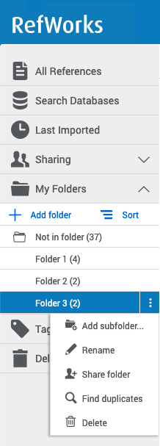

Search Databases
RefWorks provides access to hundreds of linked library catalogs and publicly available databases. Search results can be imported into your account with the click of a button.
- Select the Search Databases tab from Reference Organization.
- Open the dropdown and enter the name of the database you wish to search or select it from the list of recently used databases.
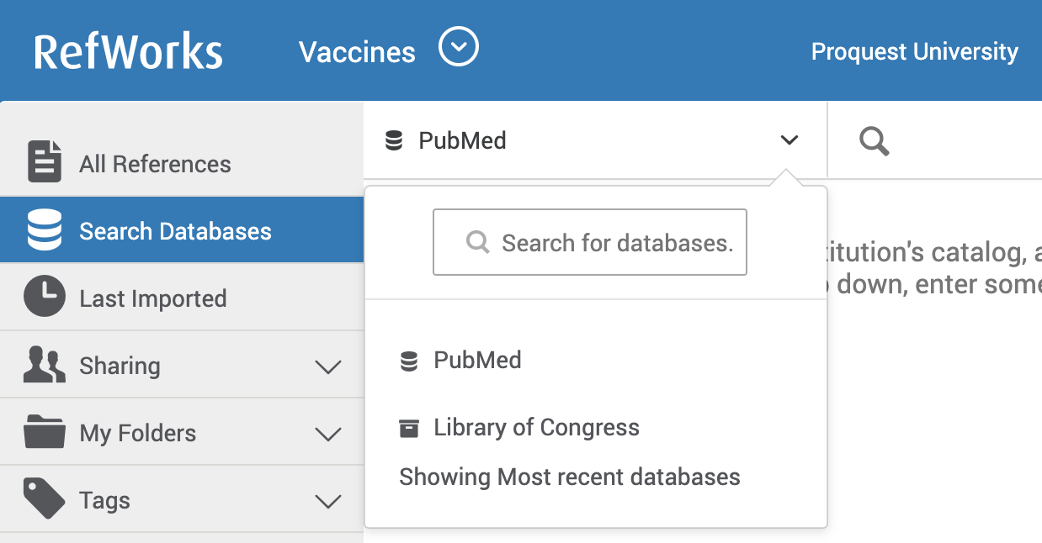
- Enter the search term in the search box and click on the Search icon
- Select the relevant items and use one of the following options to save the references:
- Click on the Folder icon to import into a specific folder. You may choose an existing folder or create a new folder.
- Click on Import. The newly imported references are placed in the Last Imported folder and can be assigned to folders by dragging and dropping or by using the Assign to Folder action in the Reference Actions.
A successful import will generate a message similar to the following:

Advanced Search
The Advanced Search capability allows you to find information in specific folders or within specific reference metadata fields.
Access the Advanced Search by clicking on the Search icon in the Reference Actions.
Click on Advanced and an options panel will open.
Advanced searches can be created by selecting a variety of fields (including custom fields), search terms and Boolean operators.
By searching for specific terms, you can better evaluate if these references are truly useful to your work.

Adding References
There are several ways to add references into Refworks. Begin in the Reference Actions and click on +Add:
Upload a Document – these are documents from your own computer files. Example: PDF, PPT, Word Doc. They can also be uploaded with drag and drop anywhere on the All Documents page or Import a Reference page.
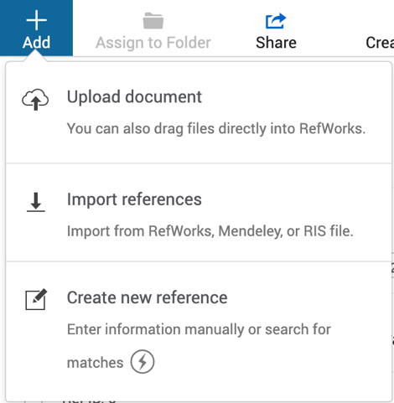
Import a Reference – allows you to import reference files from other reference managers, from legacy RefWorks and from other sources.
For more details, see Importing References

Create New References
Search for a title or DOI, review the results and save the ones you choose, or manually add all reference meta data.
When selecting Create new reference a new pane will appear on the right.
You can search for a reference or create it yourself.
- Enter a title, or as much of the title as you can.
- When available, click on the reference Find Match icon in the Title field to have RefWorks match the title with an item in the library. This button is also available after you enter a value in the DOI field, which appears for most reference types.
- RefWorks displays possible suggestions at the bottom of the pane. If you select one, RefWorks completes the title and fills the fields with information from the library. You can later review or edit fields.
- To keep the reference, click on Save. The reference will be added to your Last Imported Folder.
- If no match is found, you can create the reference by typing in the metadata yourself and clicking on Save.

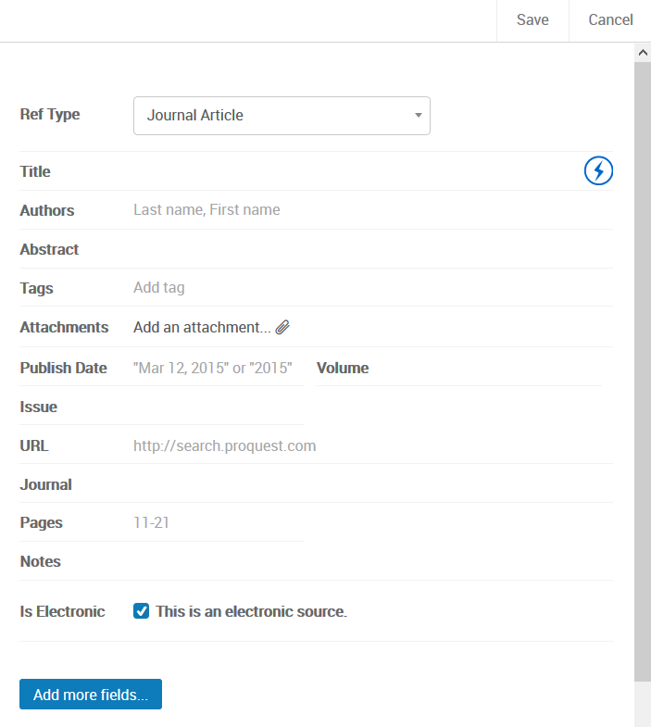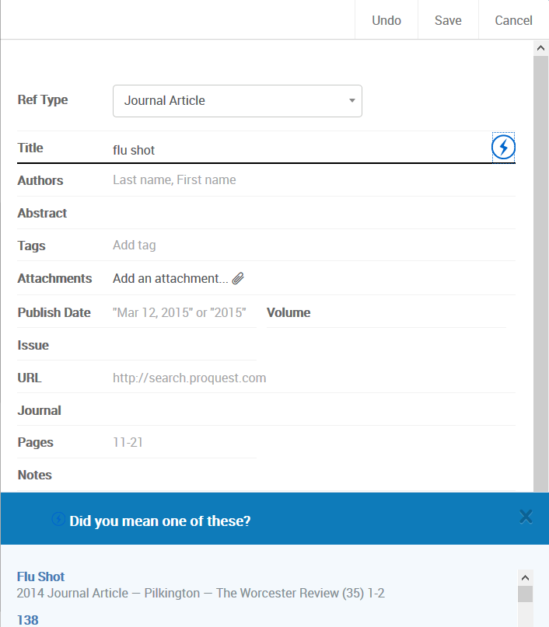

Share
RefWorks sharing capabilities allow you to share your folders with others within or outside your institution. In addition to individual sharing, users can share folders with all users at their institution. For project sharing refer to the Projects section below.
- Select the folder you choose to share in your My Folders tab.
- Click on the shortcut menu iconand select Share Folder or click on the Share icon in the Reference Actions.
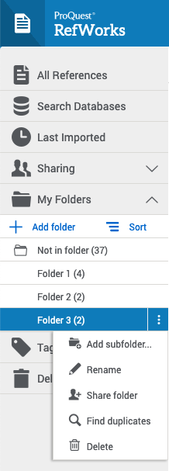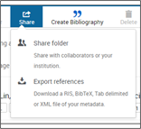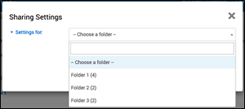
- In the Sharing Settings screen use the dropdown options to configure:
  - Settings for: Which folders to share
  - Public URL: Create a URL to provide access to people who do not have a RefWorks account. They will be able to view, sort, export references and create a bibliography.
  - Shared with: Type the email addresses, designate if the recipients can read, annotate, or modify and optionally add a message.
- Click on Done.

Exporting References
To export references:
- Navigate to the page or folder of the references you would like to export. Click on Share in the Reference Actions, then Export references. The Export references dialog box appears.
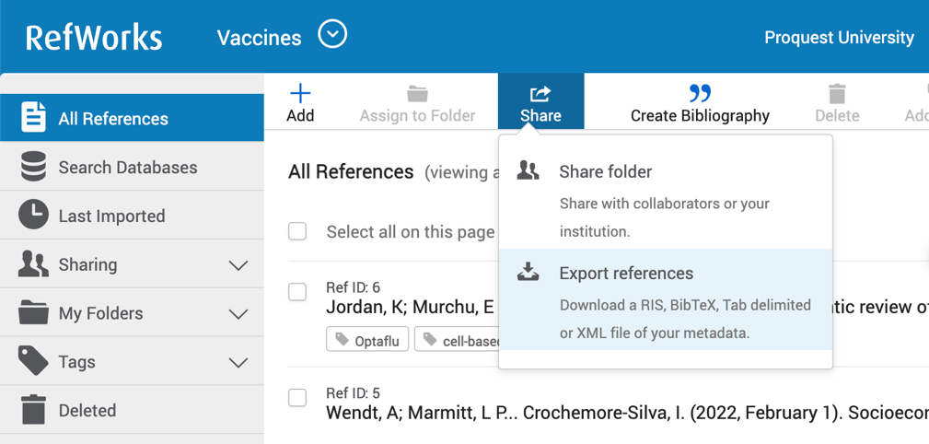
- Select whether to export all references in the current view or only selected references (you will have to select specific references for this option to be available).
- Select the output format: BibTeX, RIS, tab delimited, or XML.
- Click on Export.
For more details, see Exporting References to a File.

Projects
Projects are separate reference collections with unique folders, references, tags, etc. Most users will find they can organize their references sufficiently by using folders. For some users, especially those working on multiple research projects with different groups of people, the ability to isolate references and folders within a Project is needed.
Your RefWorks account has a default Project called Untitled Project. You can change the name and create new projects in the Manage Projects page:
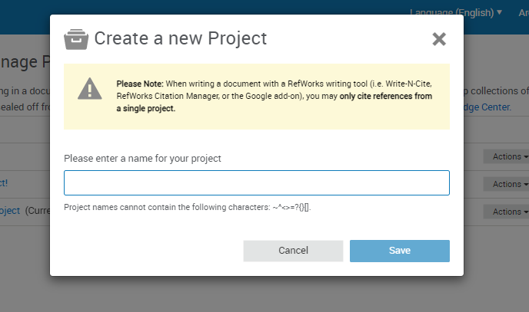

Sharing a Project
You can share a Project with other RefWorks users.
- Doing so makes them a project owner and gives them full permissions within the Project, including adding, deleting, and modifying folders and references.
- Any Project owner can delete the Project, so long as it is not the current Project of any owner.

Projects Sharing
Two Ways to Share:
- Select “Share this Project” from the Project dropdown menu:

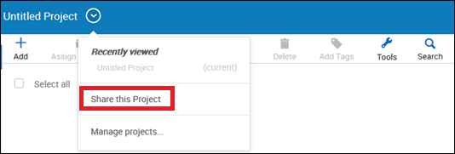

- From a Project’s “Actions” button on the My Projects page (Project Menu > Manage Projects), select Sharing settings:

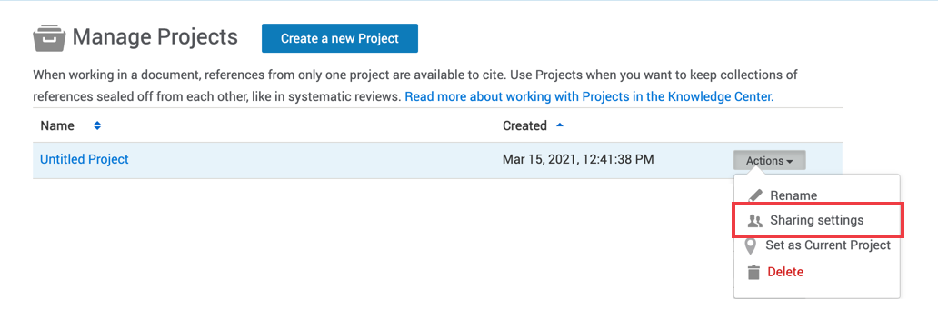

The Project Sharing Settings page appears, allowing to invite users to the project, and displaying users with whom the project was already shared.

The following actions are available from this page:
- Share the project: enter an email address in the Invite others field and click the Done button.
- Stop sharing with a specific owner: click Remove next to the owner's email address and click on Done.
- Stop sharing with all owners: click on Unshare Project

Create Citations or a Bibliography
You can create citations and a bibliography from selected references or folders.
- Navigate to the page or folder of references you want to use.
- Click on Create bibliography in the Reference Actions.
- Click on Quick Cite.
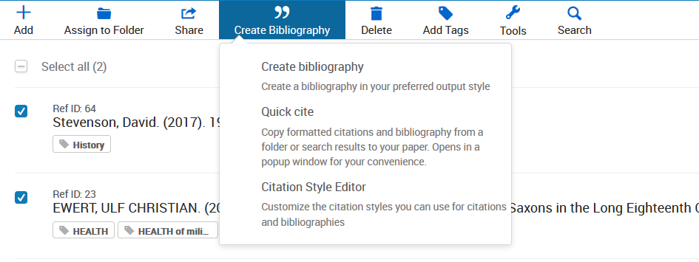

A new window will open, allowing you to choose your preferences.
- Citation Style: RefWorks will remember the last citation style you used. You can change styles by clicking on the style name and either searching for a new style or selecting from the displayed list.
- Insert Citations: Select the references for which you would like to create citations. As you select references, their corresponding citations will be displayed in the text box.
- Click on Continue to bibliography to generate a bibliography which you can copy and paste into your document.
- Click on the clipboard icon, navigate to your document and paste the formatted citations. Don’t forget to save your paper when you're done!
You can create a bibliography (without citations) from selected references or folders.
- Navigate to the page or folder of references you want to use, select references you want to include (or select none, to include all references).
- Click on Create bibliography in the Reference Actions.
- Click on Create bibliography.
RefWorks will remember the last citation style you used. You can change styles by clicking on the style name and either searching for a new style or selecting from the displayed list.
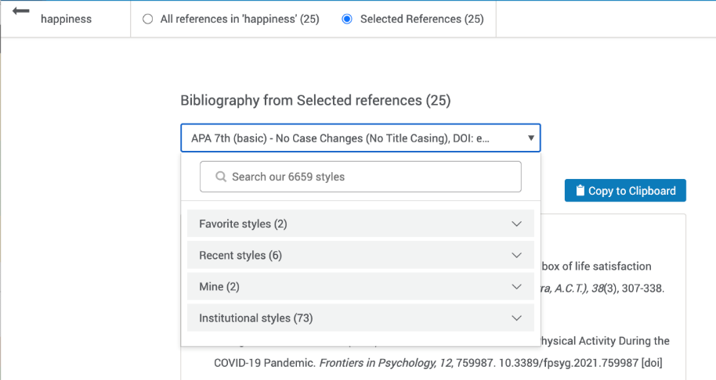
- Click on Copy to Clipboard, navigate to your document and paste the formatted bibliography. Don’t forget to save your paper when you're done!

Tools
RefWorks offers add-ons to help with your research project. To access these, click on Tools in the Reference Actions.
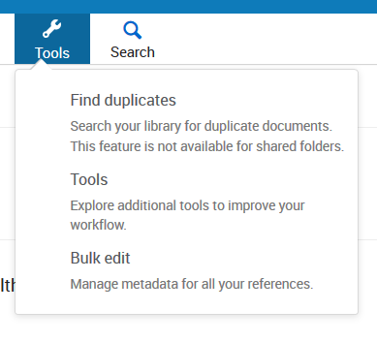
Save to RefWorks
By installing the Save to RefWorks plug-in in your browser, you will be able to save a reference or article, including full text (if available) from any website into your RefWorks account.
Add-ons for Microsoft Word and for Google Docs
These plug-ins allow you to quickly insert citations and a bibliography to your document using references from your RefWorks folders

Resources/Support
The RefWorks Knowledge Center offers resources for both Admins and users such as: user guides, support materials, training, technical support and webinar recordings. The Knowledge Center can also be accessed by clicking on the (?) symbol at the top right of the RefWorks screen.
Key Resources
- Follow us on Social Media - Facebook or Twitter
- Upgrade to RefWorks (from legacy RefWorks) guide
- RefWorks LibGuides
- Stay up to date with the release notes
Tutorials
- YouTube videos
- RefWorks training webinars
Support
The RefWorks Technical Support team, part of the larger Ex Libris Support organization, is also available to assist you with any issues that come up while using RefWorks. If the above information does not answer your questions please submit a case, or if unable to submit a case contact us by email: support@refworks.com.

