Summon Extended Training: MARC Mappings and Content Ingestion

1. MARC Mapping and Content Ingestion

1.1 MARC Mapping and Content Ingestion
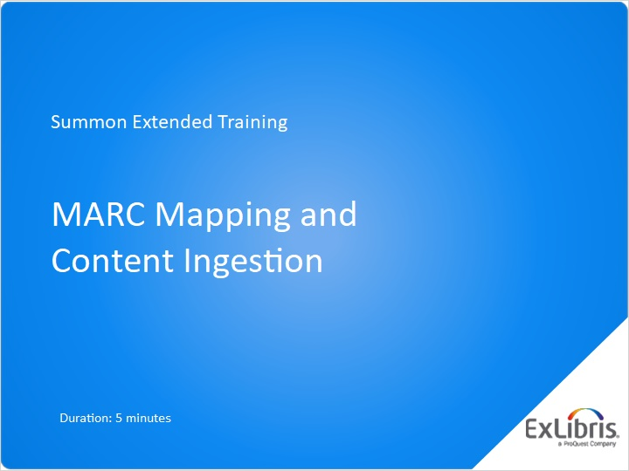
Notes:
Welcome to this Summon training session where we will investigate a couple of elements of your library’s catalog.

1.2 Agenda
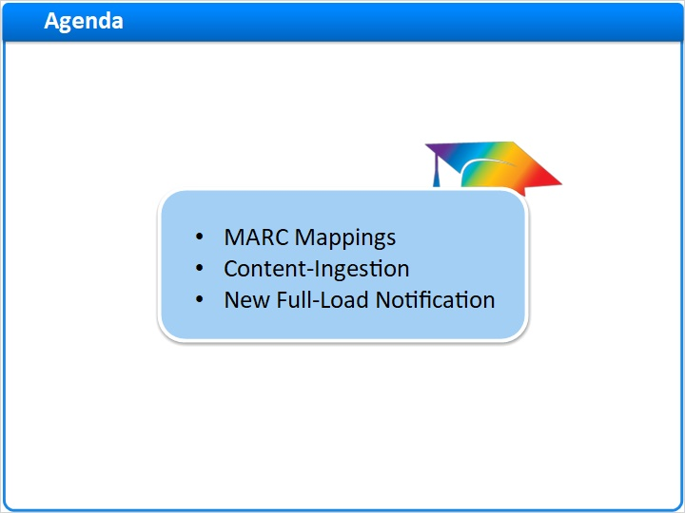
Notes:
In this short session, we’ll talk about how your catalog MARC records are mapped to the Summon Index, and how to get a report when your catalog or other content is ingested into the Summon Index. We’ll also discuss how to notify Summon that you want it to ingest a new, full load of your catalog records.

1.3 Catalog Items in Summon
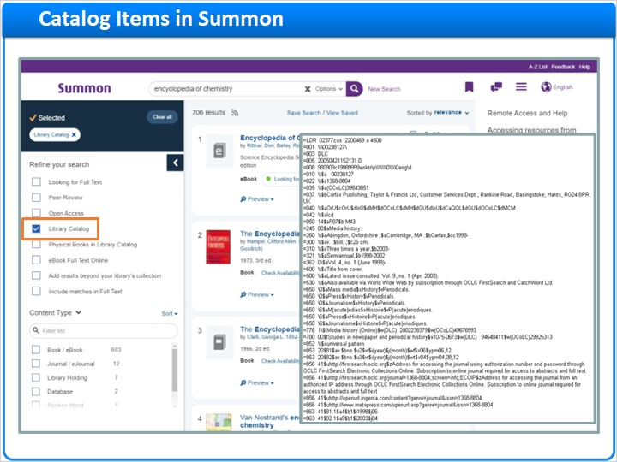
Notes:
As part of your library’s implementation of Summon, your catalog is ingested into the Summon Index.

One element of this process involves matching your catalog’s MARC record fields to various fields in the Summon Index.

You can see two elements of that matching process in the Summon Administration Console.

1.4 MARC Mappings
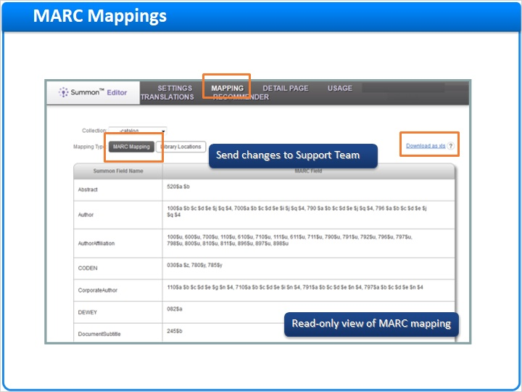
Notes:
On the Mapping tab, you can first look at the MARC Mapping page. Your catalog’s MARC Fields are sorted into groups based on which Summon Field Name they map to.

Usually there is no need to change this mapping. But if you ever do need to make a change, it cannot be done here.

Instead, download the mapping as a spreadsheet, make your changes there, highlight the changes so they are easy to find, save the spreadsheet, and then send it to the ProQuest - Ex Libris Support Team to make the changes.

1.5 Library Locations
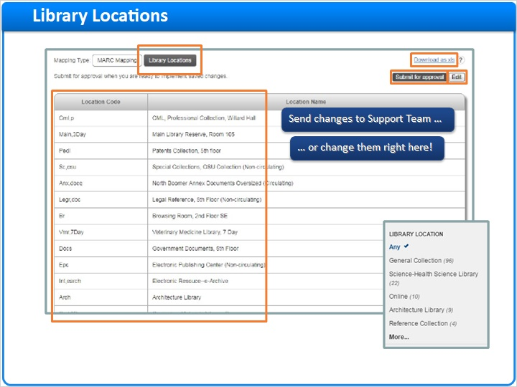
Notes:
The second mapping element you can see is the Library Locations. Click the Library Locations button to see how your library’s Location Codes map to the Location Names that will display to your Summon researchers.

Again, if you need to change anything, you can download the list as a spreadsheet, make and highlight the changes, and submit the changed spreadsheet to the Summon Support team.

However, you can change locations yourself if you prefer, right here in the Summon Administration Console. Click Edit in the upper-right corner, make the changes you want in the table, click Save, and then click Submit for approval. The requested changes will go to the Summon metadata librarians for review and implementation.

1.6 Content-Ingestion
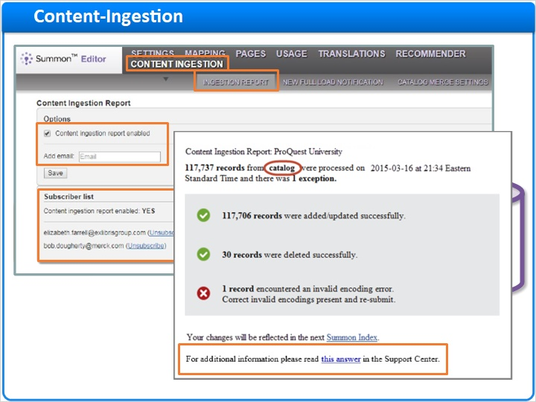
Notes:
At regular intervals, your library will send a file with your catalog’s MARC-record adds, changes, and deletes to ProQuest - Ex Libris, so the catalog updates can be processed and loaded into Summon.

There can be a delay between the time you create the file and the time the ingestion is complete, so it can be helpful to know when the ingestion is done.

In the Summon Administration Console, on the Content Ingestion tab, choose the Ingestion Report page. You can request that Summon send you a report via email. Add as many people to this request list as you want.

The Content Ingestion Report email is helpful not only to see when the ingestion was completed, but also to see if there were any errors. If errors were encountered while processing a set of records, the email will include a text file containing the relevant records. Summon documentation can help you correct the errors.

Remember, however, that just because your catalog update was processed, doesn’t mean those changes will appear in Summon immediately. There still can be a delay of several days before the changes show up for your Summon researchers.

1.7 New Full-Load Notification
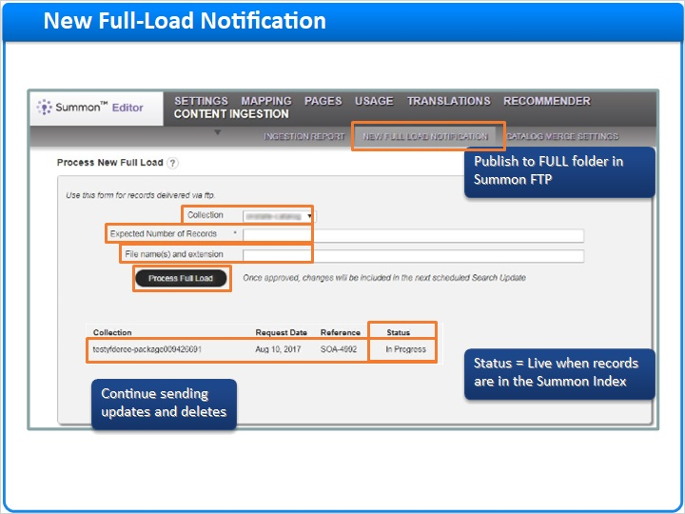
Notes:
Although your library will usually send catalog-update files with Adds, Changes, and Deletes, you can request that Summon process a new full-load.

To do this, you need to first publish the full set of records to the FULL folder in the Summon FTP, which is described elsewhere in the Summon documentation.
Then, in the Summon Administration Console, on the Content Ingestion tab, select the New Full Load Notification page.
In the Collection drop-down menu, select the source-package identifier for the record set to be loaded.
Enter the number of records to be processed.
Optionally, add the file names and extensions.
Then click the Process Full Load button.
The page will refresh with the request Status and a reference number. Full load requests for additional collections will display on separate rows. The records will be indexed as soon as possible, usually within the next three weeks.
Continue to send updates and deletes as usual, because they will be processed after the new full load has gone live.
If an issue arises during processing, the request Status will be updated with instructions.
The Status will display as Live when the records are available in the Summon Index.

1.8 Catalog Merge Settings
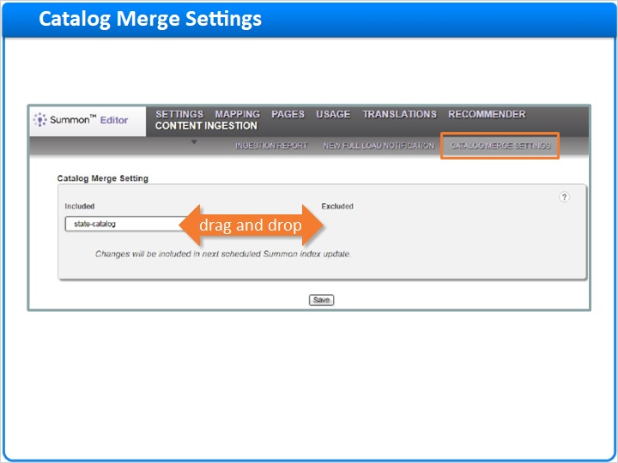
Notes:
By default, your library’s catalog records are merged with records of the same items from other providers and libraries, to create the richest possible metadata. However, sometimes this merging causes results to include metadata that is not as helpful for particular patrons, such as subject terms in a different language or incorrect date or language information.

You can turn off the Match and Merge system for all your local Library Catalog records on the Catalog Merge Settings page.
Use your cursor to drag and drop the source-package identifiers of the collections that you do not want merged to the Excluded list on the right, then click Save.
You changes will be reflected in the next Summon Index update.

1.9 Thank You!

Notes:
And that’s it for this session. Thank you for joining!

1.10 About this Training
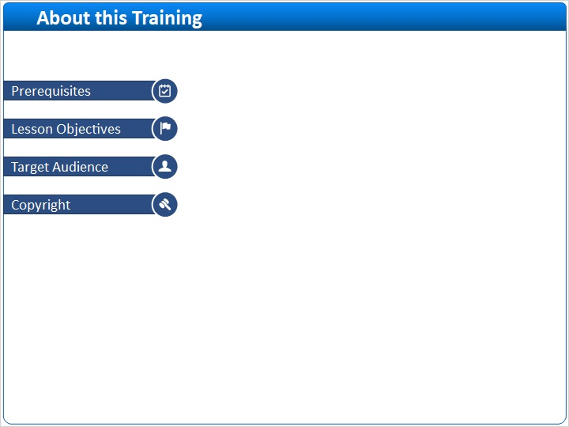
Notes:

1 (Slide Layer)
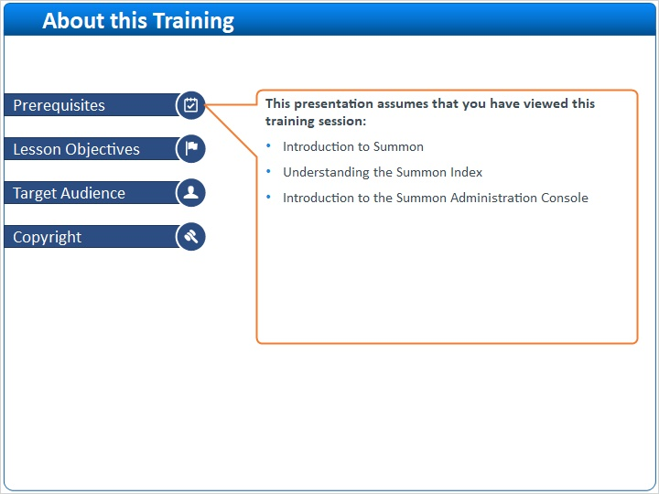

2 (Slide Layer)
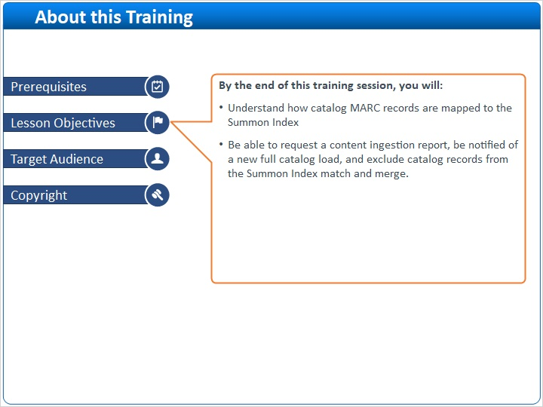

3 (Slide Layer)
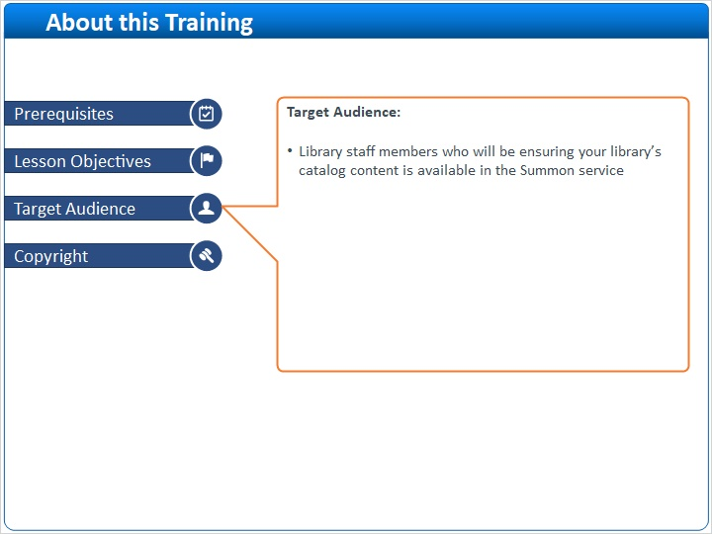

4 (Slide Layer)


