Controlled Digital Lending for Course Materials
You can use Leganto and Alma Digital to manage the full lifecycle of a Controlled Digital Lending course reserves program:
- Get the information from teaching faculty (Leganto)
- Managing the digitization process and access rights (Alma Digital)
- Provide the resource to students as part of their course (Leganto)
For more information, see the Controlled Digital Lending for Course Materials demo.
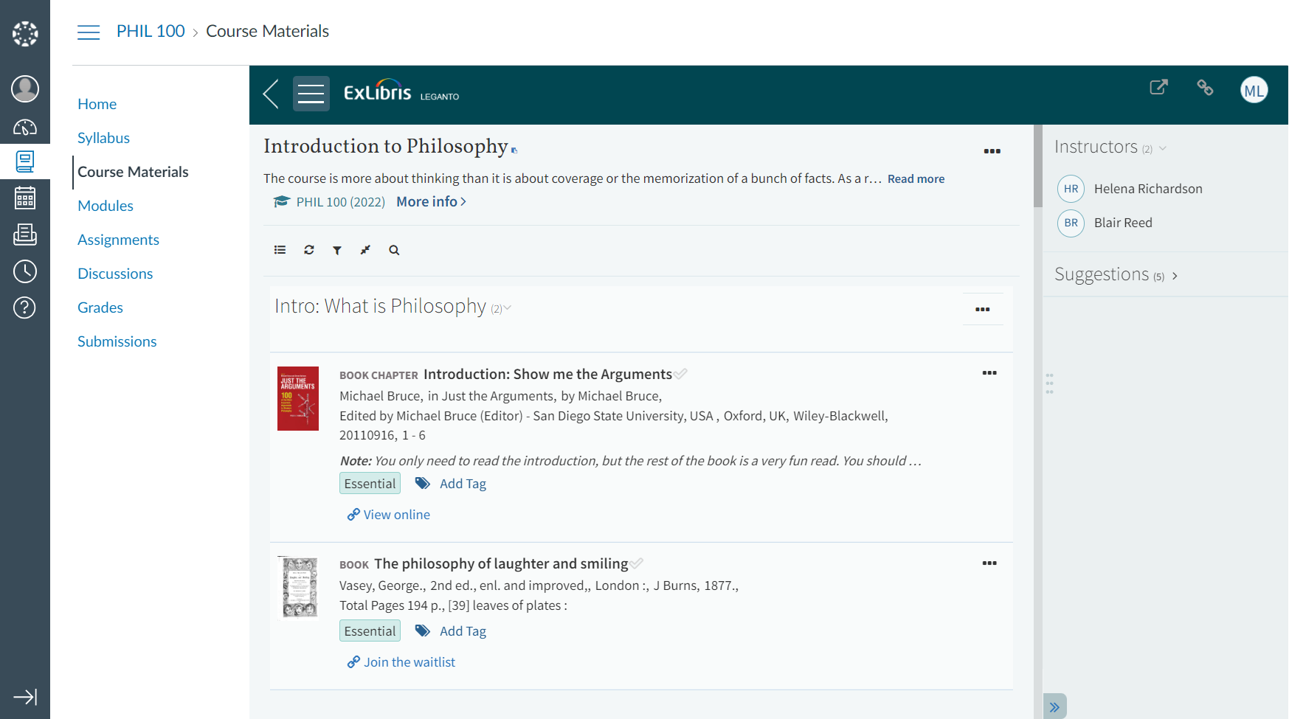
Screenshot: Student view of a Leganto reading list
CDL book

How to Configure Controlled Digital Lending with Leganto and Alma
- Configure the access right(s). This is where you will configure how many users can use the item at a time, the length of the checkout period, block the option to download the resources and configure the waitlist. You can also configure additional details, such as which user groups will be allowed to access the resource.
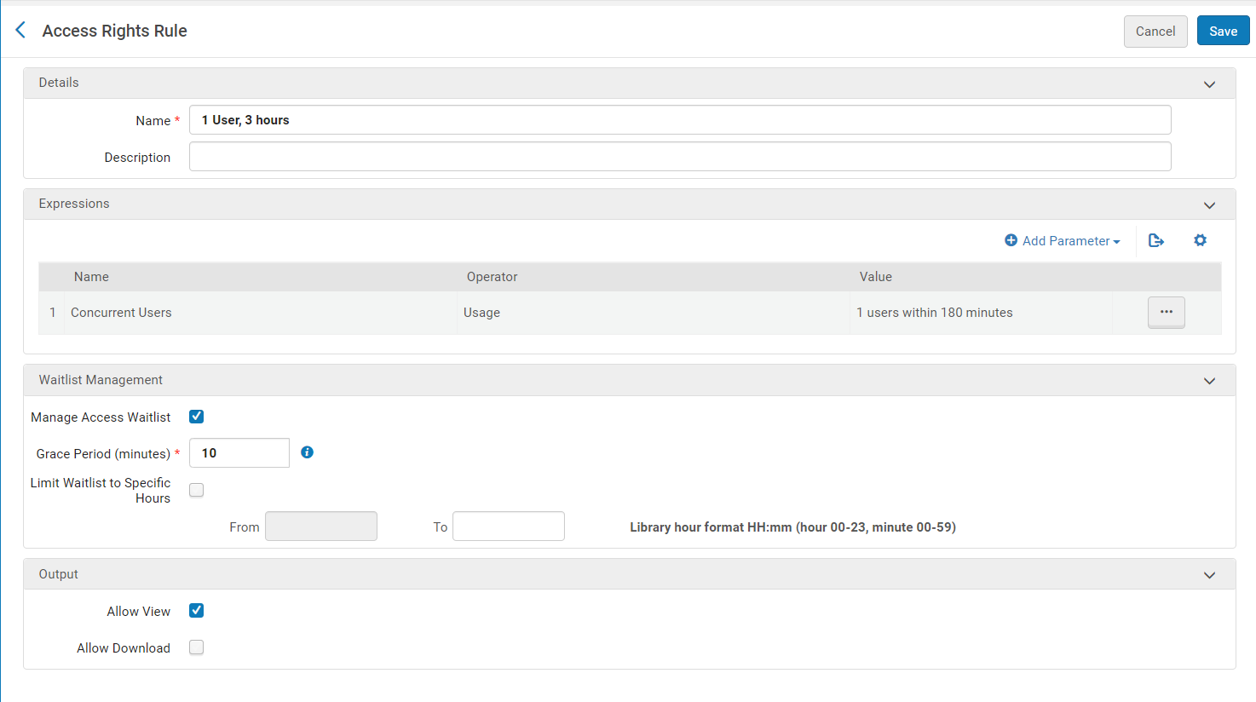
Screenshot: Sample Access Rights Rule
- Configure the digitization and copyright rule(s) which will determine the digitization workflow. Ensure that you choose “Digital inventory (representation) for the digitization target. You can also specify and dedicated access rights policy which will be the default for all digital inventory scanned using this rule.
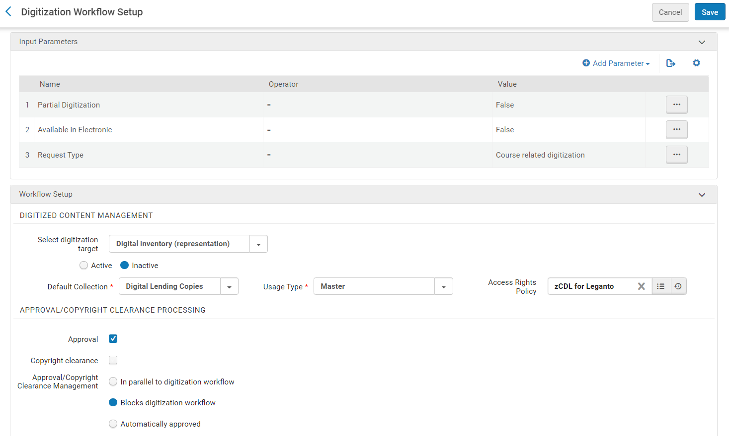
Screenshot: Sample Digitization and Copyright Rule
- Configure digital representation display options for Leganto. Here you will determine whether Leganto will display digital inventory by default or if library staff will instead manually select which representations will appear in Leganto. You can also configure whether Leganto will display representations which are suppressed from discovery.
- Depending on your workflows, you may also want to configure the Course Reserves Automatic Statuses table and the Citation Default Copyright Status table.

