Measuring and Reporting on Student Savings
“It’s really incredible to see these numbers after all the years of not having a solid way to quantify any of our impact on teaching and learning!”
-Cate Kaufman
Library Services Director, Illinois Central College

How much would a student have paid for their course materials if they hadn’t been able to get them through the library? The Sticker Price feature in Leganto can enable the library to quantify the financial value that library resources bring to students in their courses, which can help the library measure and promote the impact they provide to teaching and learning and the institution at large.
You might consider using this feature to:
- Demonstrate how much the library collection potentially saves students
- Demonstrate the impact of the library collections budget
- Demonstrate to instructors the cost of their course materials to promote the need for more affordable resources
Enabling Sticker Price:
To enable the Sticker Price feature, see Configuring Sticker Prices and Price Currencies
When first using this feature, we recommend setting the display_sticker_price parameter to librarians, which will display the feature only to the library. This will enable you to decide on the appropriate use case for your library and determine the best way to share information with others.
Entering and Viewing Sticker Price:
Once enabled, each citation will have a sticker price field, and librarians can enter the price or cost of the resource. Your library will need to determine what value to use for the sticker price. For example, you may choose to enter the price that a student would have paid to rent or purchase this item, new or used, or the price they would have paid for copyright licensing fees for individual articles or book chapters.
As an alternative, you could enter the price that the library paid for a resource, if you’re interested in reporting on impact of the collections budget, or the price the student pays through the bookstore, if you’re interested in highlighting costly materials.
When first using this feature, we recommend setting the sticker price on a limited number of citations. For example, you may choose to add it only to books and/or only to reading lists for high-impact or high-enrollment courses. The library will add sticker prices manually, so consider which resources or lists might enable you to quickly highlight the library value.
Edit the citation in either Alma or Leganto to enter the sticker price. By default, the sticker price is in the “More details” section in the Leganto citation. Rialto customers can obtain the sticker price field from Rialto for individual citations or as part of a bulk job.

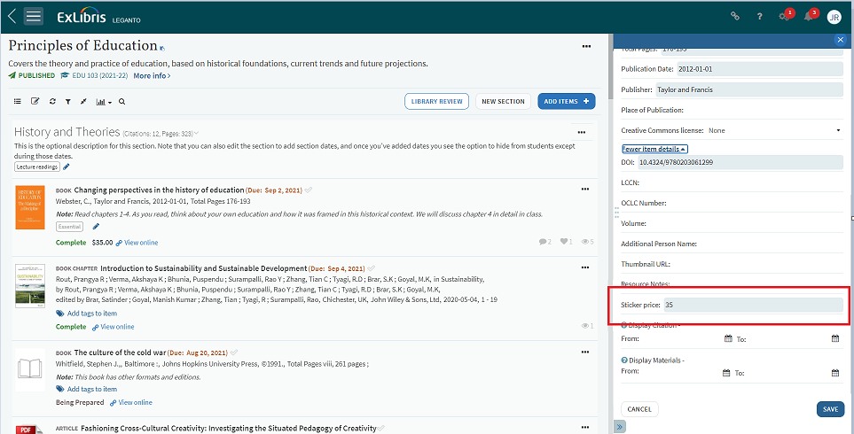
Edit citation to enter sticker price
The sticker price will display as crossed out if the resource is available in the Alma repository. The amounts that are crossed out indicate that the library provides access to this resource and therefore students do not have to pay this price.
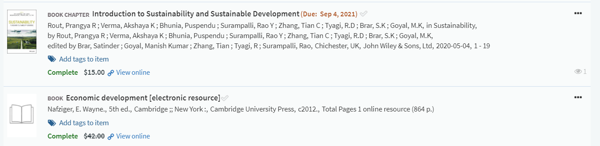
Sticker price view in Leganto
Leganto displays the student savings table, showing how much the course resources on this list would have cost students, and how much is covered by the library.
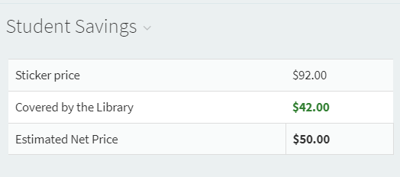
Student Savings table in Leganto
Keep in mind that your library likely provides access to many resources which are not managed in the Alma repository, including articles, book chapters, streaming media, and more. You may choose to share reports via Analytics, rather than exposing potentially misleading sticker price information to instructors in Leganto.
If you plan to use analytics for reporting on student savings or the impact of the collections budget, it is recommended that you only add a sticker price for items that are covered by the library. In this scenario, everything which has a sticker price is covered by the library, and the repository vs. non-repository distinction is not relevant.
Reporting Using Sticker Price:
The Sticker Price information is reportable in Analytics and can be used to report on cost information across academic departments, or across the institution as a whole.
There is a sample report in the Community folder in Alma analytics which can be used as a baseline for reporting on the potential savings the library provides students for their course materials. The report multiples the price of a resource by the number of unique students who accessed it to provide the student savings value, and multiples the price of the resource by the students in the course for the potential student savings.
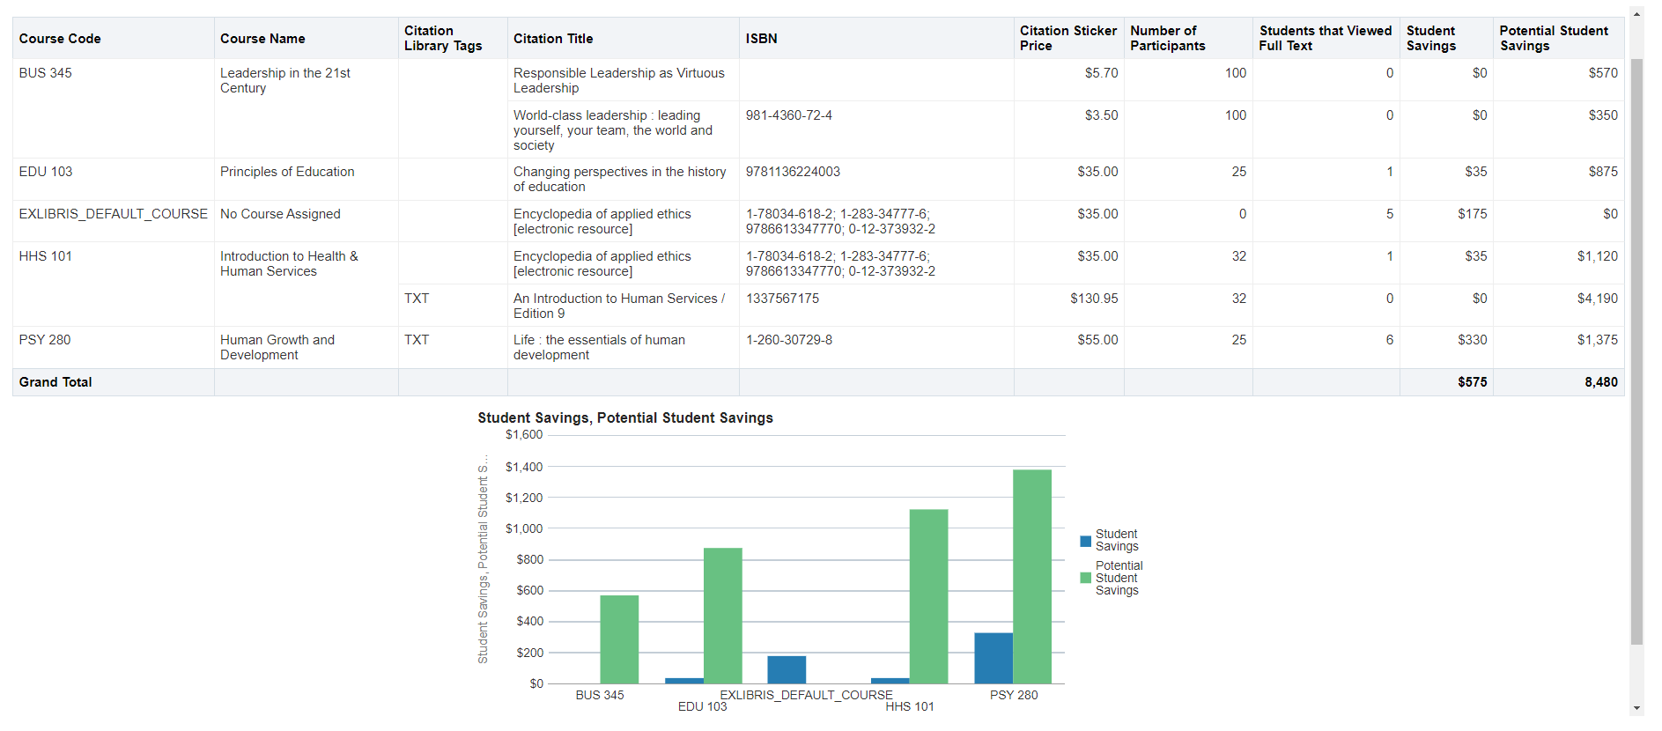
Sample student savings report in analytics
You can customize this shared report to meet your local needs. You will find it in: Shared Folders/Community/Reports/Shared Reports/Reports/Leganto Course Reading Lists, Student Savings Measures.
Keep in mind that sharing summary information will have the biggest impact on stakeholders outside the library. For example, consider sharing reports on how the library supported teaching and learning across all courses, rather than course by course details. You may also wish to remind stakeholders that total savings will increase each year, as additional students use each resource.
The same report can be used to demonstrate the impact of the library collections budget, although with a different report name and different labels for the columns. For example, instead of “Potential Student Savings”, consider naming the column “Economic impact.”
The community report assumes that every citation which has a sticker price is covered by the library. If you want to report on the cost of their course materials as a means to highlight the costs students pay, or to compare the costs of courses which use library resources to those which do not use library resources, you can include the field Citations > Citation covered by library to distinguish between those covered by the library (crossed off in the Leganto interface) and those not covered the library (not crossed off).

Additional Resources:
Documentation:
- Configuring Sticker Prices and Price Currencies
- Displaying Item Sticker Prices in Citations
- Setting and Getting Prices from Rialto
Videos:
- Leganto Student Savings Measures
- Updating Student Savings Measures from Rialto in Bulk

