|  |  |
| --- | --- |
| **How to create an Alma Analytics report of Primary IDs of users with an overdue loan and no active fines and fees** |  |



**Yoel Kortick**

**Senior Librarian**

**Question:**

Do you know if it is possible to create an analytics report for users with overdue items and no active fines and fees.  
I can create two reports of it (one for fulfillment with overdue items and one for fines and fees with no active fines and fees).  
But is it possible to combine this somehow?

**Answer:**

This can be done as follows (see further explanation and screenshots below).

1. Make a report of all Primary IDs of users with a fine or fee in the “Fines and Fees” subject area
2. Make a report in the “Fulfillment” subject of Primary IDs of users which have an overdue loan.
3. In the report in the fulfillment subject area filter out the primary IDs from the report made in the “Fines and Fees” subject area

**ONE**

In the ‘Fines and Fees’ subject area make a report of all Primary Idenifiers of users that have an active fine fee.

Display the “Primary Identifer” and filter by “Fine Fee Status” = “Active” .

We will call the report “PrimaryID have active fine fee”.

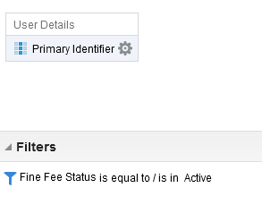

**TWO**

In the fulfillment subject make a report of all Primary IDs of users with an overdue item.

Rather than creating a new report you can use the report “Overdue items” in the folder “/shared/Alma/Fulfillment/Reports”. This report already contains the Primary Identifier.

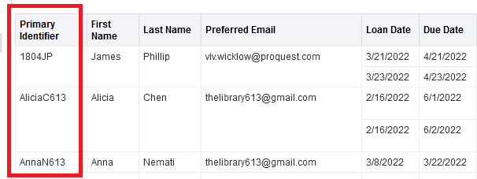

**THREE**

In the report in the Fulfillment subkject area filter by Primary Identifier and choose operator “Is based on results of another analysis”

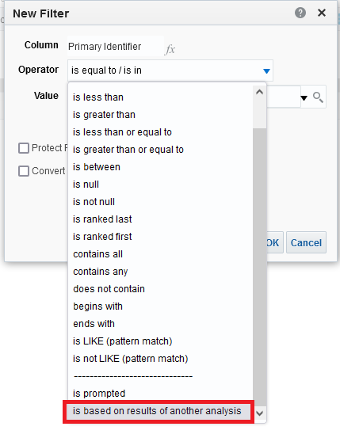

**FOUR**

Select the “Saved analysis” made above from the “Fines and Fees” subject area.

Define that the Primary Idenfier from the source report (the report you are in) is not equal to any Primary ID in the report from the Fines and Fees subject area.

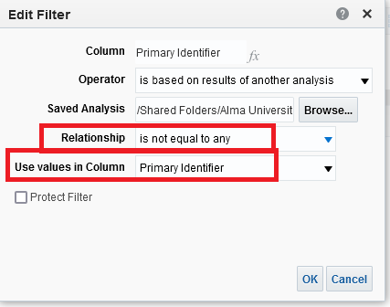

**FIVE**

Save the report with this additional filter, for example call it “Has loans does not have fines and fees”.

All Primary IDs in this report are for users with no active fines and fees.