|  |  |
| --- | --- |
| **Acquisitions exchange - Suggested best practices workflow** |  |
|  | |



**Introduction:**

This workflow refers to a library (perhaps a museum) which has an exchange programme whereby the library both receives and sends out titles as exchanges. In the case here it is irrelevant whether or not the ‘other libraries’ do or do not use Alma.

Below is our ‘best practices’ recommendation/workflow.

**Workflow:**

For purposes of this document we will call our institutions ‘Institution A’ and ‘Institution B’.

* In the first case: ‘Institution A’ receives a museum catalogue from ‘Institution B’.
* In the second case: ‘Institution A’ sends a museum catalogue to ‘Institution B’.

The first case is very standard and straightforward. The second case is a little more “involved’ as here the library is, in a sense, acting as a vendor.

**Case one: ‘Institution A’ receives a museum catalogue from ‘Institution B’.**

**ONE**

‘Institution A’ adds ‘Institution B’ to Alma as a vendor. For example, one of these:

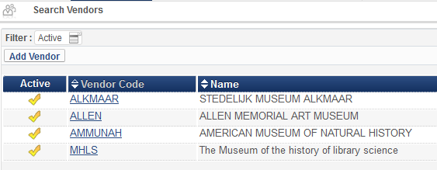

**TWO**

‘Institution A’ makes an order for the museum catalogue and uses ‘institution B’ (in this case the ‘other museum’) as the vendor and makes the purchase type ‘exchange’. The ‘purchase type’ could also be ‘gift’ or ‘deposit’ (or whatever the institution desires), but if the library is receiving the item for free then it should be a purchase method which allows for not needing to enter a price or fund in the POL.

The order can be made even after the item arrives, the purpose being to have it recorded for later reporting and tracking purposes.

The item will be ordered from the museum with no price, a reporting code (if desired) which may for example state ‘Museum Catalogue’, no fund, and acquisition method ‘Exchange’

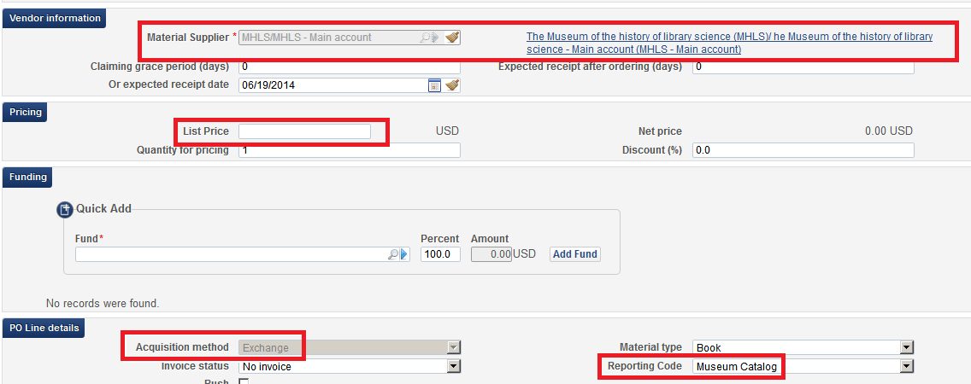

**THREE**

When the item arrives receive it like all other orders

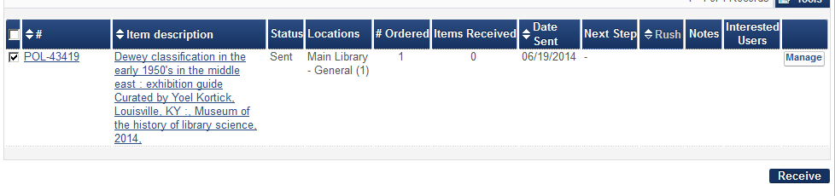

**FOUR**

After receiving the order is closed and process is complete

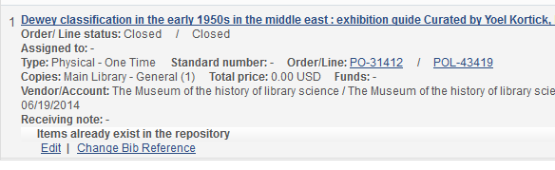

**FIVE**

In analytics you can do a report (for example in the subject area ‘funds expenditure) stating (for example) that the acquisition method does not equal ‘purchase’ or ‘purchase at vendor system’ or ‘approval plan’. If a reporting code was used then that too can be included in the report.

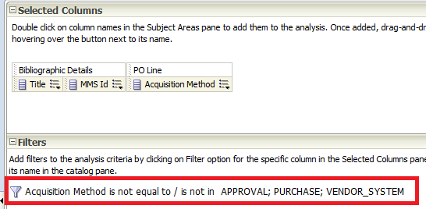

**SIX**

Here is a retrieval specially by acquisition method ‘Exchange’

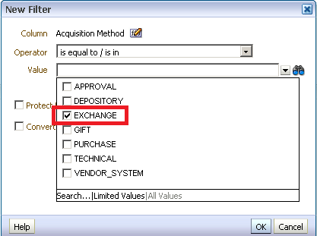

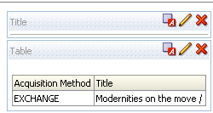

**Case two: ‘Institution A’ sends a museum catalogue to ‘Institution B’**

Now the catalog is not ‘received’ by the library. Rather, it is ‘sent’ by the library. The library is, in a sense, acting here as the vendor. The library will want to be able to report on all items sent out as part of the exchange.

**ONE**

‘Institution A’ will create a bibliographic record and an item for the item they want to send to ‘Institution B’.

In the item ‘Institution A’ adds a predefined Provenance code from pull down box (library can make their own predefined list). Here for example we have Provenance codes:

Supplied to the Museum of Library Science

Supplied to the Museum of Natural History

Supplied to the Museum of Information Science

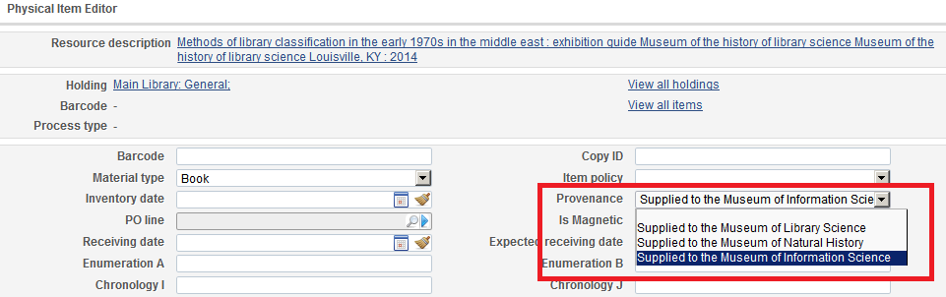

**TWO**

‘Institution A’ then withdraws (deletes) the item and sends it to ‘Institution B’.

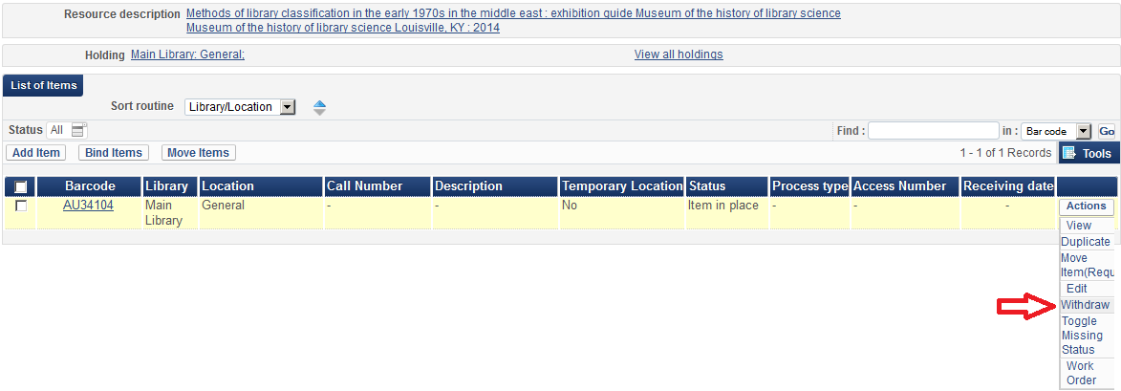

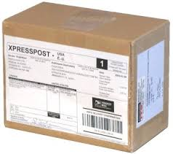

http://www.photologic.ca/tashipping.htm

**THREE**

Now the ‘Institution A’ can easily make a report in analytics ‘Physical items’ subject areas by retrieving according to ‘Life Cycle’ = ‘Deleted’ and ‘Provenance Code’.

