|  |  |
| --- | --- |
| **Publishing a bibliographic records with a change to the holding record** |  |



**Yoel Kortick**

**Senior Librarian**

In this example we will publish a bibliographic record using the general publishing profile while enriching information from the holdings record to the bibliographic record. After the record is published, we will change the holdings record. Then we will again run the publishing profile to see if the bibliographic record is again published.

We will see that the bibliographic record does get published, and this means that the changing of the holdings record triggers the bibliographic record to again be published.

**ONE**

Title “The Mysteries of the Middle Ages : the rise of feminism, science, and art in Taiwan” is in set named “set 20221027”.

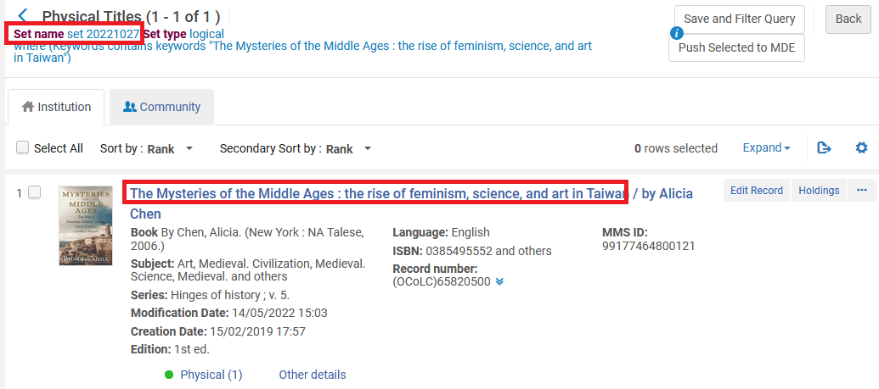

**TWO**

Publishing profile “20221027 publishing” publishes set “set 20221027” on the bibliographic level.

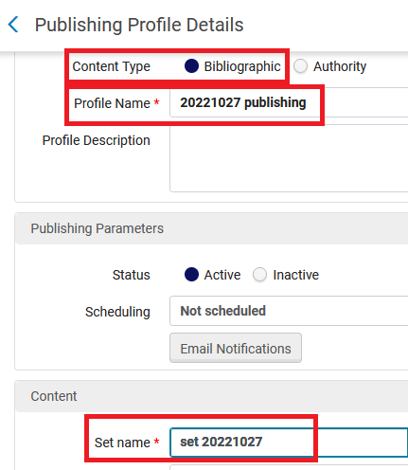



**THREE**

In the publushing profile we are using holdings enrichment

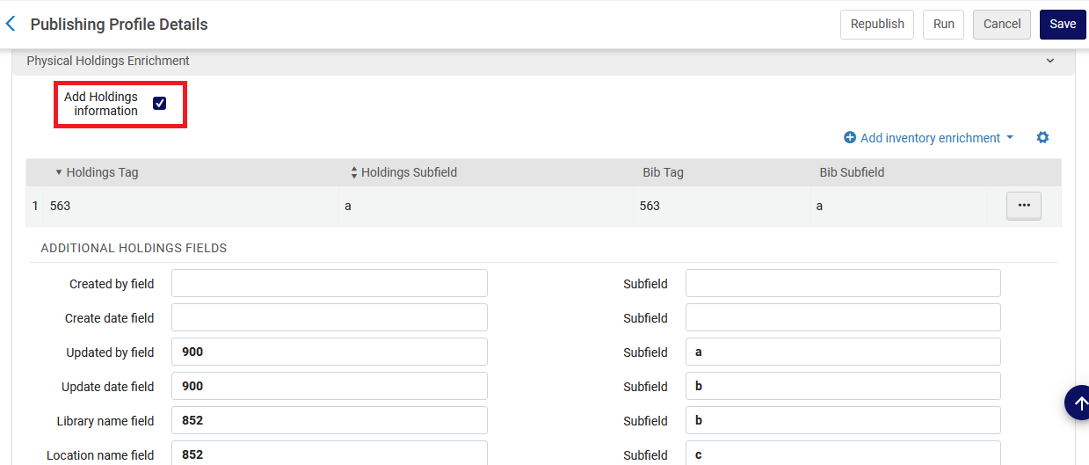

**FOUR**

The job runs the first time and the one record is published as “new”:

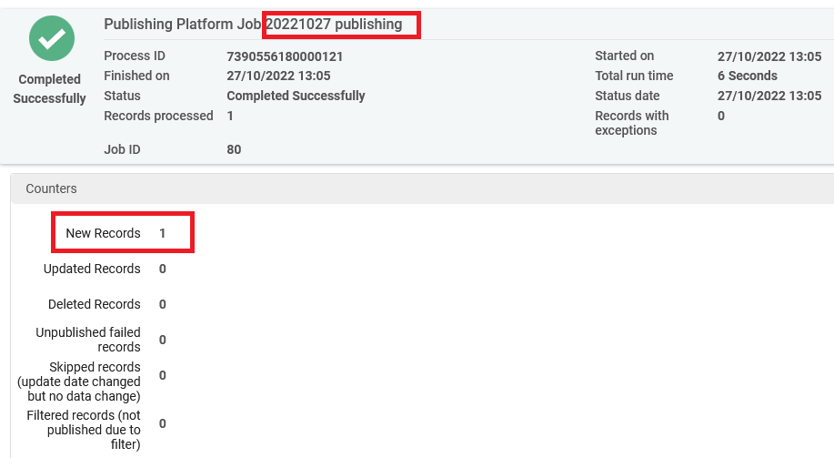

**FIVE**

The holdings record is edited and a new field is added:

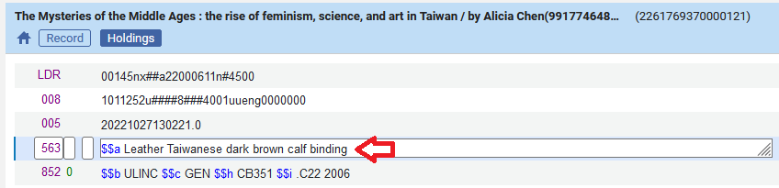

**SIX**

The publishing job is run again and the record is published. It is considered “updated” even though the bibliographic record was not changed and only the holdings record was changed.

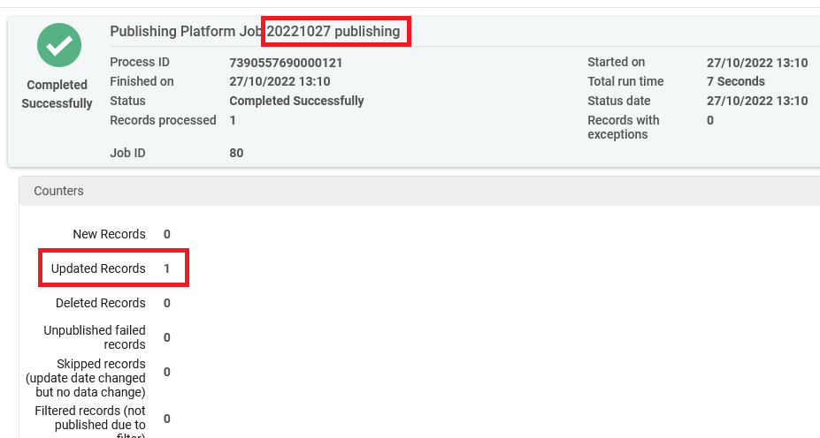

**SEVEN**

The bibliographic record has been pubished and the bibliographic record includes the data from the holdings record in the bibliographic record.

