- What is the Central Customization Package?
ExL—This refers to the package defined centrally by a consortium for its members

- In planning for the AngularJS version update for Primo Studio users, is the custom.js file accessed and updated in the same way as it is for users who download and manage the customization package without using Primo Studio?
ExL—Yes. You can use the Transformer tool to update all customizations (Studio or otherwise).

- Can it be edited (custom.js) in the window?
ExL—Yes, in Primo Studio

- Where can we find the configuration values for adding a primo-explore-search-bar-sub-menu? I didn't catch every field as Jenny was demoing.
ExL—You can visit the Github page for each add-on for more info. This one: https://github.com/NYULibraries/primo-explore-search-bar-sub-menu

- Is this new? I never heard of it.
ExL—Primo Studio was introduced in 2018 and available for the New UI of Primo Classic.

- A library_logo.png doesn't appear in the Preview pane when I upload. However, our package does include a prm-logo-after.js file. I think this is an add-on. Is that doing something that conflicts with an uploaded logo image?
ExL—This requires a specific analysis. Please open a case with Support.

- Where did you get the information about how to set Action, Action set, CSS, classes, etc. in the Addons example just showed?
ExL—Each Addon has a link in Github where additional information is found. Click on the text that reads View in Github.
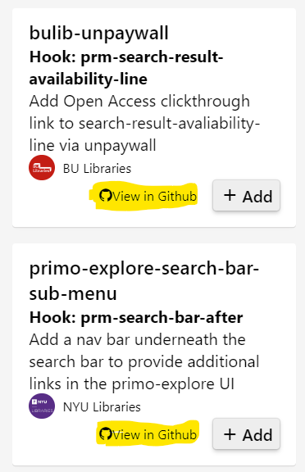
- I've noticed a Problem when using the Editor tab in Primo studio. I wanted to review the css elements on the full display via Primo Studio but when I access Primo Studio and try to navigate in PrimoVE via the Studio Editor tab, I cannot view the full display of a locally created bib record. The result list/brief display is fine but when I click to get to the full display it does not work (it does work ok if I go to the full display of an article record in the result set but again it does not work for a locally created bib). Any idea what the cause could be, maybe a known issue?
ExL—All the Primo VE functionality is not intended to work in Primo Studio. Primo Studio was not designed to fully support Primo VE.

- How do you customize the colors. I want to change the second bar (under the links banner) to a different color
ExL—The primary setting on the Theme tab does control both lines in the red box below. More complex changes to the color choices would be done using CSS Components and Customizations.
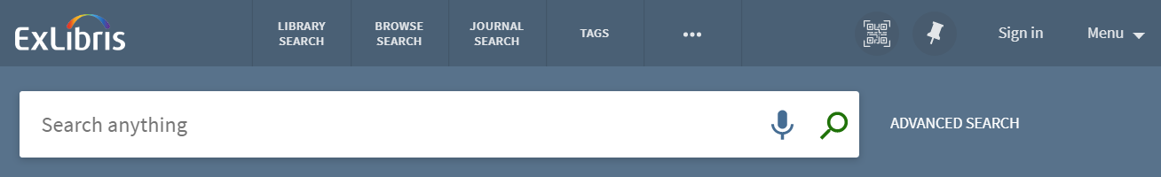

- I have seen an additional logo to the left of the search box. How is that done?
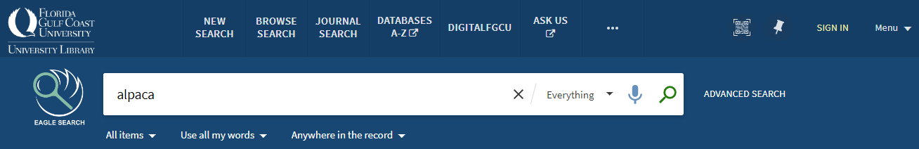
ExL—Those customizations are done outside of Primo Studio. I’m not positive if it’s only CSS or if it’s CSS and HTML. You could reach out to Florida Gulf Coast University to ask them. Question 9, above, has a link to documentation on CSS Components and Customizations.

- Can widgets be added through Primo Studio?
ExL—Anything outside of the Addons would not be able to be added via Primo Studio.

- For those of us with little to no experience customizing Primo VE pages do you recommend using Primo Studio?
ExL—Yes. Primo Studio was created to make it easier to do customizations of the user interface.

- What I do is I copy the default view of a production environment, rename the new view, give it a name of NAME_TEST, for example, and edit those files directly. Would that present issues? Primo Studio seems to present some difficulties. It's also quite crammed on the display. Maybe the GitHub will offer more insight
ExL—You can create a Customization Package and edit the files directly and then load them into Alma/Primo VE. In that situation, we do not recommend doing additional customizations using Primo Studio. There can be errors as Primo Studio writes its CSS in a specific way and if the custom work does not match, Primo Studio can’t reconcile the changes.

- What is the relevance of the angular update? How do we know if we need to make changes?
ExL—Please set he page in the Customer Knowledge Center to address Preparing for the upgrade to Angular 1.8 in Primo/Primo VE

