Customizing Summon: Search Boxes and Search Widgets

1. Summon Abstracting and Indexing Content

1.1 Customizing Summon: Search Boxes and Search Widgets
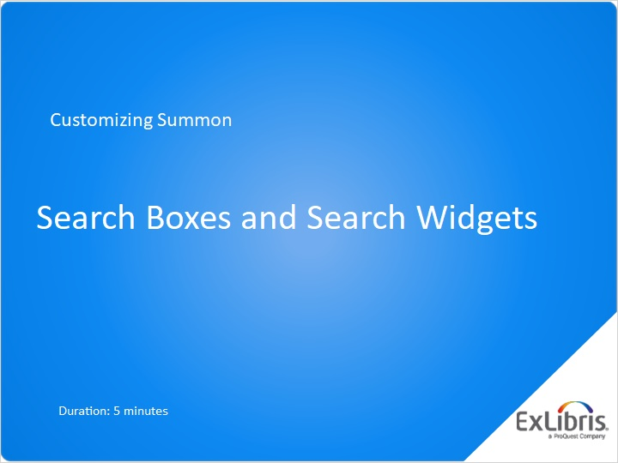
Notes:
Welcome to this session on creating Summon search boxes and search widgets.

1.2 Agenda
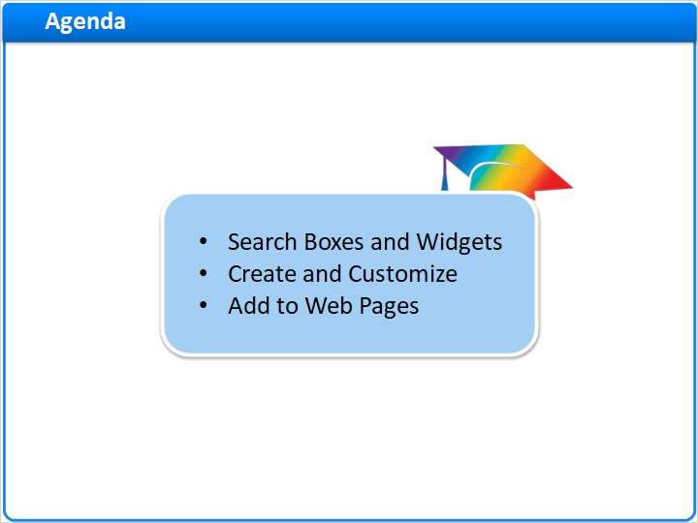
Notes:
In this short session, we’ll talk about how search boxes and search widgets work, how to create and customize them, and how to install them onto web pages.

1.3 Search Boxes
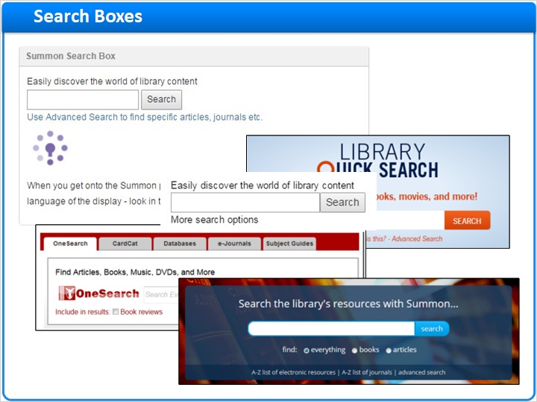
Notes:
When libraries want to provide quick access to Summon content, they usually put a search box somewhere on the library home page. These examples show many different ways they do it … from simple search boxes to complex, tabbed structures that provide access to other ways of searching for library content.

But in it’s most basic form, the search box looks like this.

1.4 Search Widgets
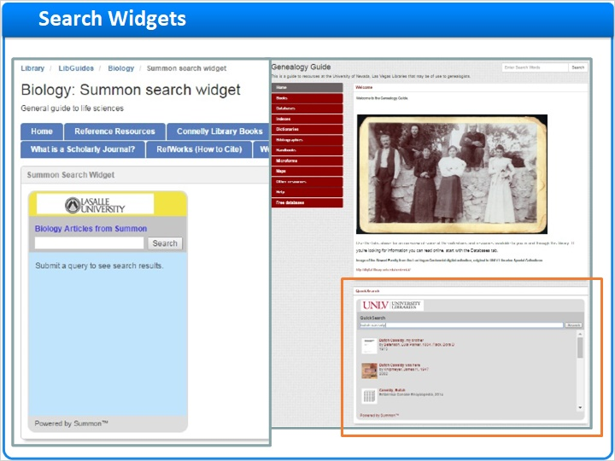
Notes:
The search widget is a larger structure on a web page, where the results appear in abbreviated form in the large area below the search box. Some libraries choose to use this structure on a web page where there is more room, such as these examples from some research guides.

1.5 Create Search Box or Search Widget
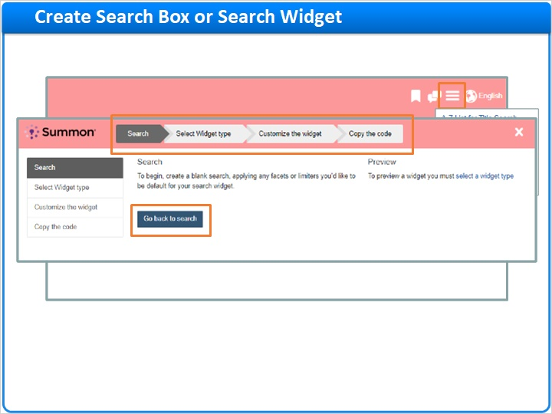
Notes:
To create a search box or search widget, start from your Summon page, and from the menu on the upper-right side, select Widget Builder.

There are four steps to create a search box or widget, and these are shown across the top of the page.

The first step is to pre-scope your search. In other words, you can add predefined filters and facets that automatically activate when a Summon researcher uses this search box or widget. To start this pre-scoping effort, click the button Go to Search.

1.6 Create Search Box or Search Widget – Steps 1 and 2
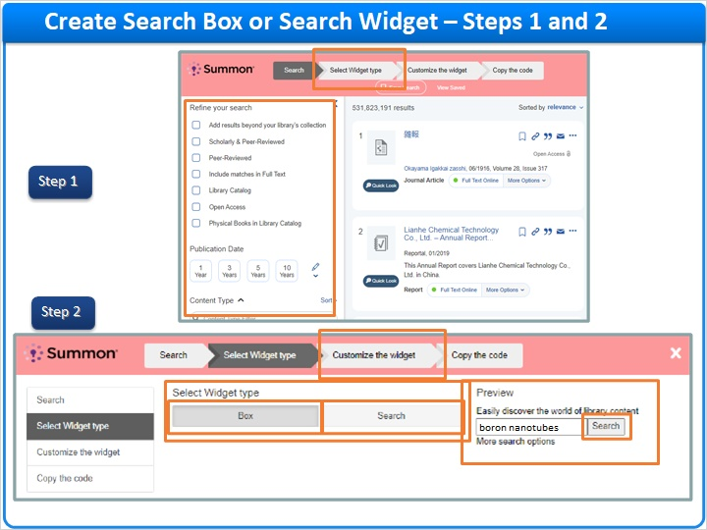
Notes:
Your Summon result page will open, although it is in a slightly different form because it has the search-box builder steps across the top. Nonetheless, you can use the facets and filters just like with a real Summon search, except this time you use them to pre-scope your search box or widget.

When you’re done selecting filters and facets, click the button at the top that says Select Widget Type, and a new page opens. This is where you choose whether you’re building a search box or a search widget, using the two buttons here: Choose “Box” to make a search box, or “Search” to make a search widget.

On the right side is a preview of your choice, so you can see the default version of how it will look. This preview is also a real search box or widget, so you can test it and see if it really does search and filter the way you wanted in Step 1.

After you choose a search box or a search widget, click the button Customize the Widget to go to Step 3.

1.7 Create Search Widget – Step 3
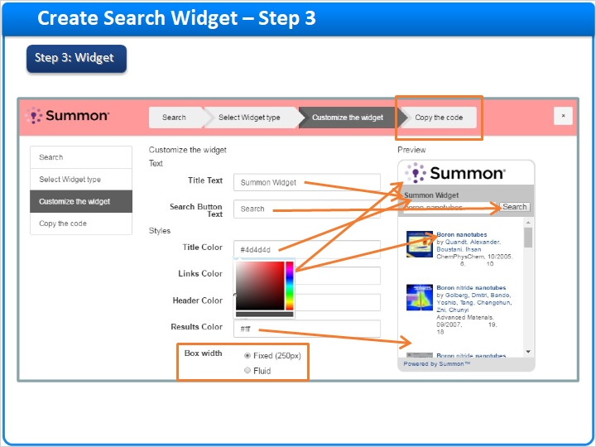
Notes:
If you choose to make a search widget, Step 3 shows a few things you can do to customize it:

You can change the title.

You can change the text on the search button.

You can change the color of the title text.

You can change the color of the links in the search results.

You can change the color of the header, which is the background area behind the logo.

You can change the color of the results, which is the background area behind the search results.

And you can select whether the widget will be a fixed width of 250 pixels or will be fluid width and adapt to the width of the web page on which it is placed.

By the way, for any of the color options, when you click in the field to change color, a color picker appears. If you know the hexidecimal color code needed, you can just enter it in the field. If not, you can use the color picker to find the color you want.

When you’re done customizing the search widget, click the button at the top – Copy the code – to move on to Step 4.

1.8 Create Search Box – Step 3
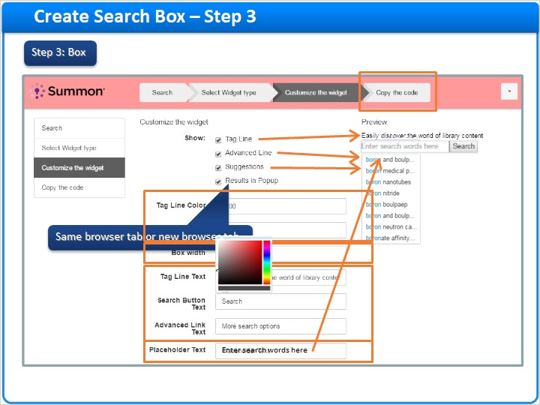
Notes:
On the other hand, if you choose to make a search box, Step 3 shows the different options you have:

You can add a Tag Line, which could be used to title the box or just provide a note about what is being searched.

You can have the link to Summon’s Advanced Search page.

Summon can provide search suggestions based on the keywords that Summon researchers enter into the box.

You can choose whether the Results page that comes up after the researcher clicks Search will open in the same browser tab as the search box, or it will open in a “popup,” which really means a new browser tab.

After that, you can customize colors for the Tag Line and links, how wide the search box will be, and the exact wording of the various pieces of text.

By the way, the Placeholder text is the faint, grey text that appears in the search box itself, before the Summon researcher starts typing in the box.

And again, clicking on any of the color fields will bring up the color picker to help you find the right color.

When you’re done customizing the search box, click the button at the top – Copy the code – to move on to Step 4.

1.9 Create Search Box or Search Widget – Step 4
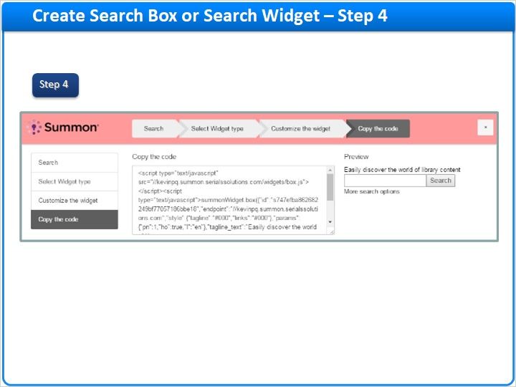
Notes:
The fourth step is to copy the code. On this page is the JavaScript code you need to make your search box or search widget. Copy it to your computer’s clipboard or save it in a temporary text file.

1.10 Add to Web Pages
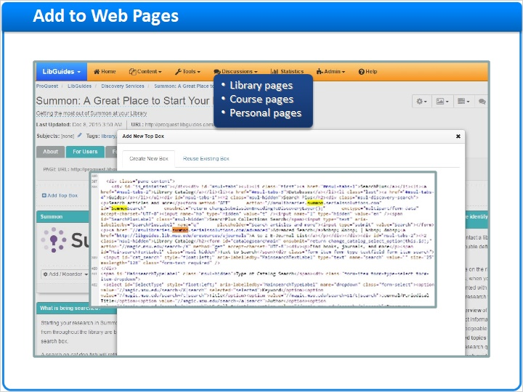
Notes:
Finally, you need to put the JavaScript code on your web page. Whether it’s a research guide or your library’s home page, you’ll have to figure out how to get the code into the right spot on the page, test it, and then launch it for your Summon researchers.

Just remember, Summon search boxes and search widgets can go anywhere. In addition to library pages, faculty members could put search boxes on their course pages, researchers could add them to their personal web pages, and so on.

1.11 Thank You!

Notes:
And that’s how you can create and use Summon search boxes and widgets. Thank you for joining this session!

1.12 About this Training
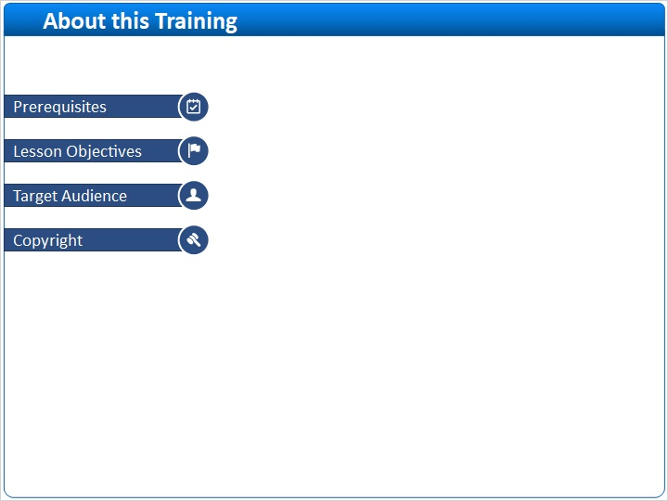
Notes:

1 (Slide Layer)
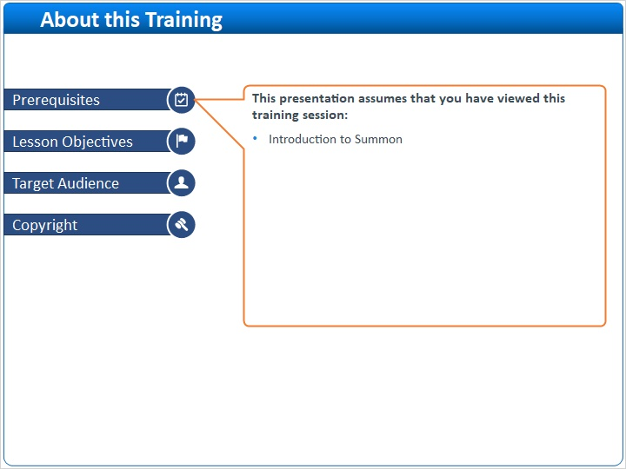

2 (Slide Layer)
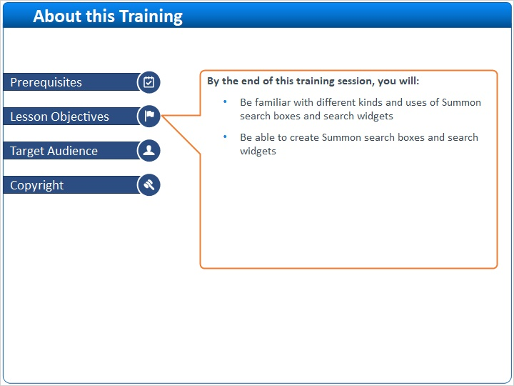

3 (Slide Layer)
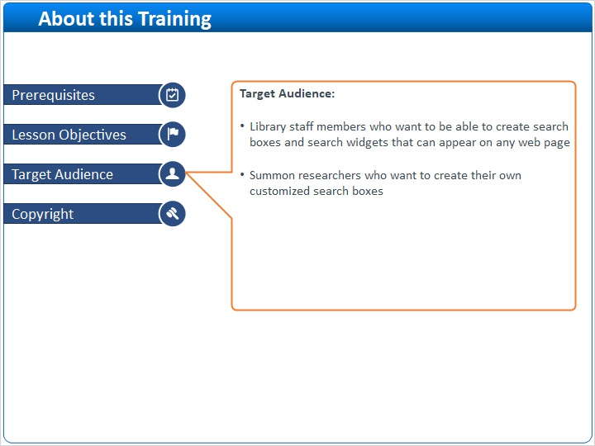

4 (Slide Layer)


