|  |  |
| --- | --- |
| **How to create a search scope for only electronic resources in Primo VE** |  |



**Yoel Kortick**

**Senior Librarian**

We will describe here how to create a search scope in Primo VE for which all results will be bibliographic records which have electronic inventory.

1. Define a custom scope
   1. Navigate to “Configuration > Discovery > Search Configuration > Search Profiles”
   2. Switch to middle tab “Custom Local Data Scopes”
   3. On right side click “Add a Custom Scope”
   4. Fill in a code and name, for example code “ONLY_E_RESOURCES” name “Only E Resources”
   5. On right side click “Add a Condition”
   6. Choose search index “Inventory: Available Electronic”. Choose operator “Exists”.  
        
      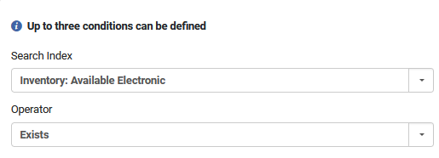
   7. Add the condition
   8. Save the custom scope  
        
      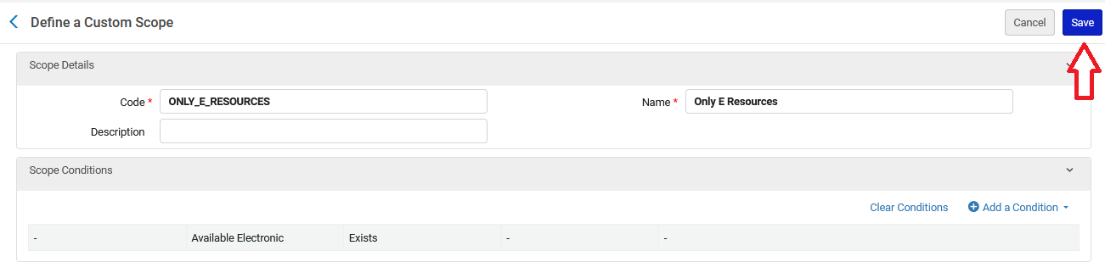
2. Navigate to “Configuration > Discovery > Search Configuration > Search Profiles”
   1. Switch to first tab “Search Profiles”
   2. Click “Add a search profile”
   3. Fill in a code and name, for example code “E_RESOURCES” name “E Resources”
   4. On bottom click “Add Scope”
   5. In field "Select Scope Type" choose "Custom (Local Data)"  
        
      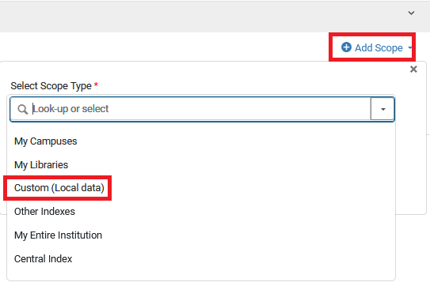
   6. In field "Select Custom Scope" choose the scope created above.  
        
      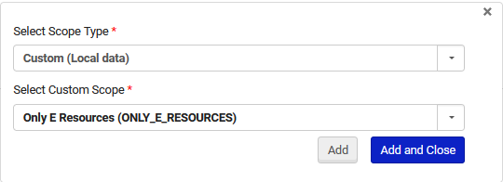
   7. Save  
        
      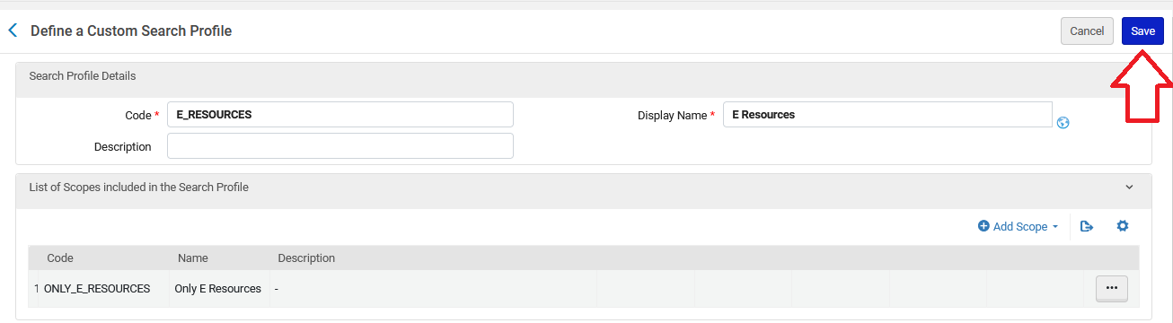
3. Navigate to “Configuration > Discovery > Display Configuration > Configure Views”
   1. Edit the view to which you want to add the new search profile
   2. Go to tab “Search profile slots”
   3. Click "Add a slot"
   4. Fill in code and name, for example code “ERESOURCES” and name “Electronic Resources”
   5. On bottom select the slot created above
   6. Save  
        
      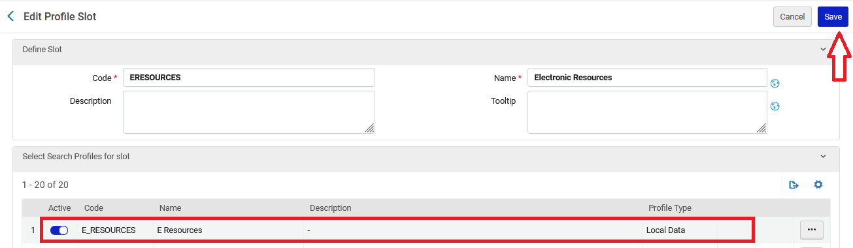
4. Test it out.
   1. If we search the scope “Library Catalog” for “sheryl sandberg lean in” we get nine results, and some have physical inventory and some have electronic inventory.   
        
      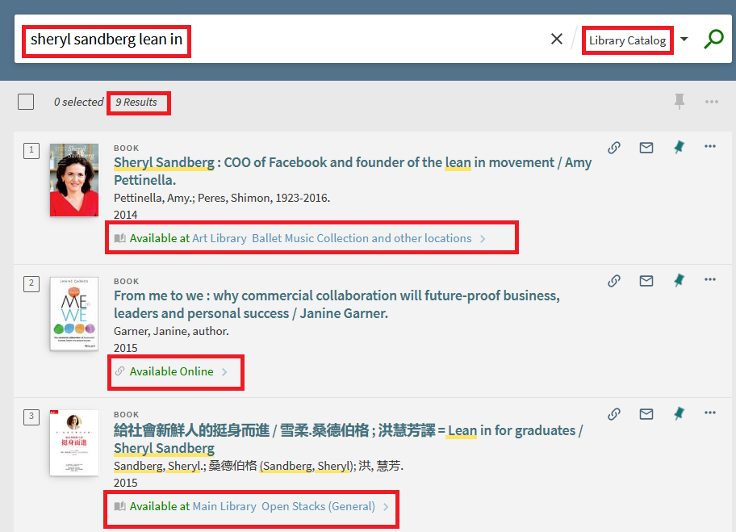
   2. If we search the scope “Electronic Resources” for “sheryl sandberg lean in” we get two results, and they both have electronic inventory. There are no results in this scope that do not have electronic inventory. **This means the scope works.**  
        
      