|  |  |
| --- | --- |
| **How to change the list of possible values in a dashboard prompt** |  |



**Yoel Kortick**

**Senior Librarian**

**Question:**

In a dashboard prompt by "Library Name (Active)" in the "Location" folder of the “Physical Items” subject area all of our libraries appear. We do not want all of the libraries to appear. For example, we do not want the “Resource Sharing Library” and the “Creighton Reinert-Alumni Library” to appear. This is what our dashboard prompt looks like now:

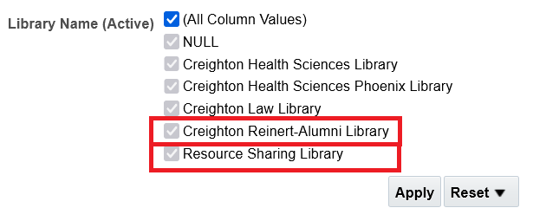

**Answer:**

This can be done using SQL in the prompt as follows:

**ONE**

Create the dashboard prompt as described at [How to create Dashboard Prompt](https://knowledge.exlibrisgroup.com/@api/deki/files/80385/How_to_create_Dashboard_Prompt.pptx).

**TWO**

Edit the prompt.

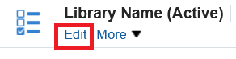

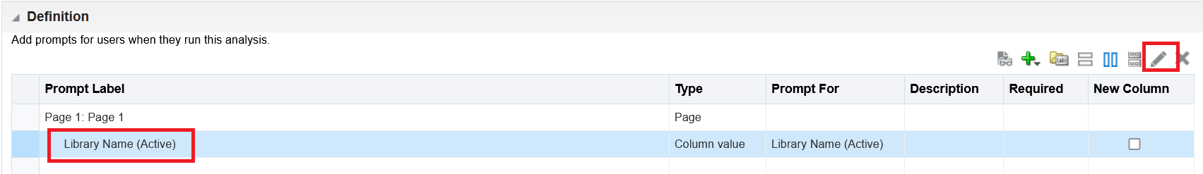

**THREE**

Open the “options”

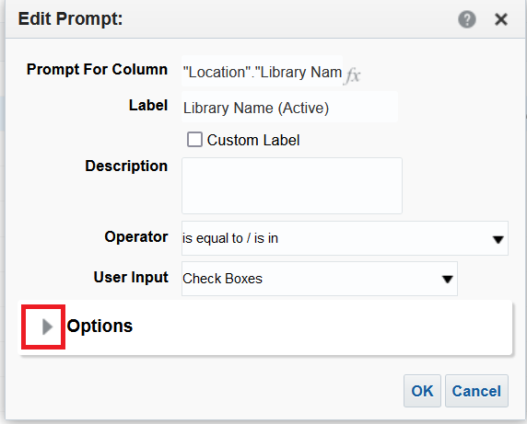

**FOUR**

Change the field “Check Boxes Values” to “SQL Results”

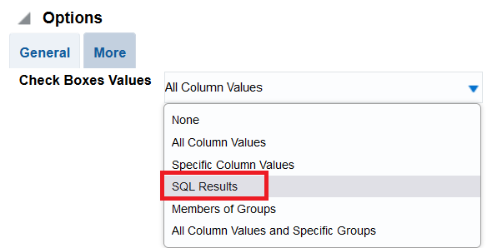

**FIVE**

Edit the default SQL

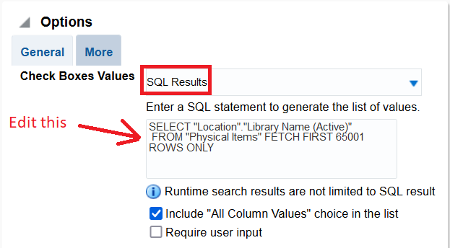

**SIX**

In our case (for the need described above where we remove certain libraries) we will change this default SQL:

|  |
| --- |
| SELECT "Location"."Library Name (Active)"  FROM "Physical Items" FETCH FIRST 65001 ROWS ONLY |

To this:

|  |
| --- |
| SELECT "Location"."Library Name (Active)"  FROM "Physical Items" where "Location"."Library Name (Active)" NOT IN ('Resource Sharing Library','Creighton Reinert-Alumni Library')  FETCH FIRST 65001 ROWS ONLY |

The SQL can be changed as needed to include or not include other libraries.

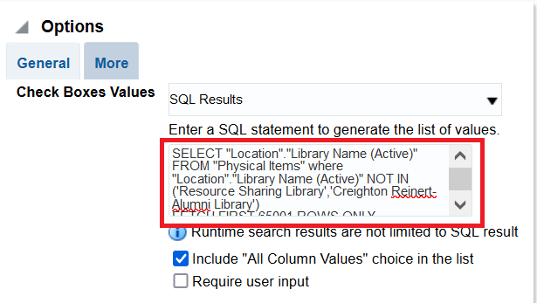

**SEVEN**

Save the changes

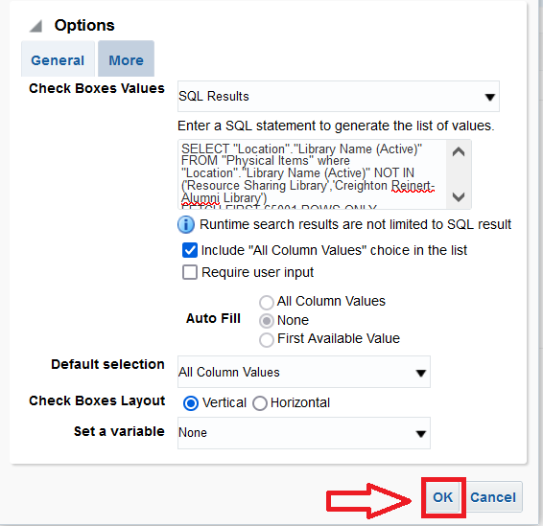

**EIGHT**

The Prompt now appears as follows. Note that **the “Resource Sharing Library” and the “Creighton Reinert-Alumni Library” no longer appear**

