Test Esploro Normalization Rules
1. Create a publishing profile (screenshots from out test-environment) to retrieve the XML record for testing
The Output format needs to be Esploro
You can use both protocols – FTP or OAI
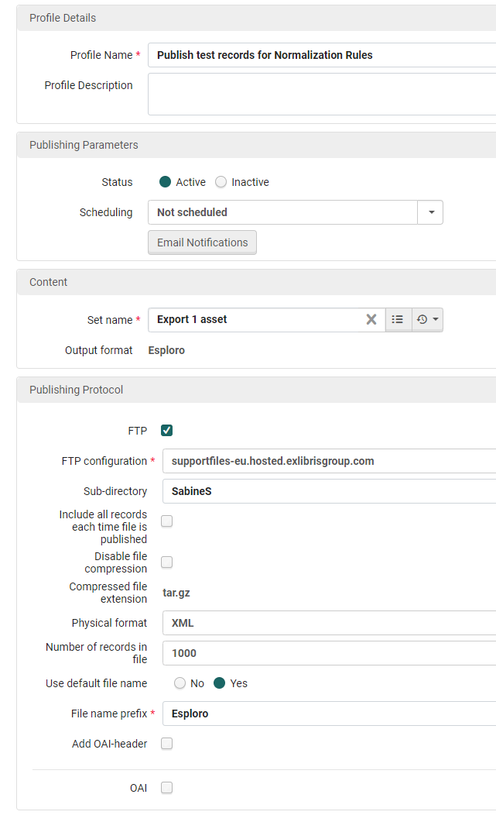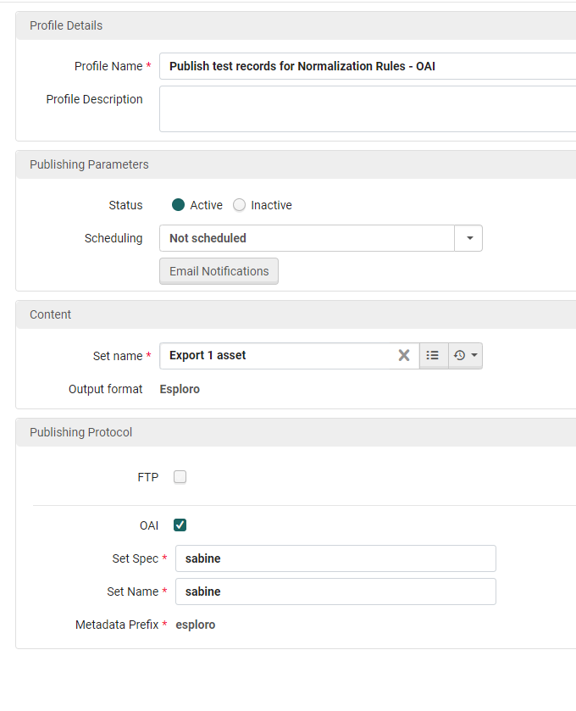
Both profiles will publish the record in the Esploro XML format.
If you publish to FTP, the XML record needs to be modified a little bit before you can use it for the Rule Testing:
The output XML will have
<?xml version="1.0" encoding="UTF-8"?>
<collection>
<record status="new/updated" xmlns="http://www.loc.gov/MARC21/slim" xmlns:xsi="http://www.w3.org/2001/XMLSchema-instance" xsi:schemaLocation="http://www.loc.gov/MARC21/slim http://www.loc.gov/standards/marcxml/schema/MARC21slim.xsd" >
…
</collection>

Please remove these elements and add as header:
<record xmlns:ns2="http://esploro_record">

Example:
<record xmlns:ns2="http://esploro_record">
<identifier.doi>10.1016/j.procs.2014.06.011</identifier.doi>
…
</record>

Save this XML file on your PC.
2. How to test the rule using this example XML
Esploro menu > Repository > Test Normalization Rules
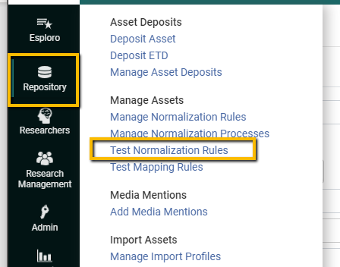
Browse for the file:
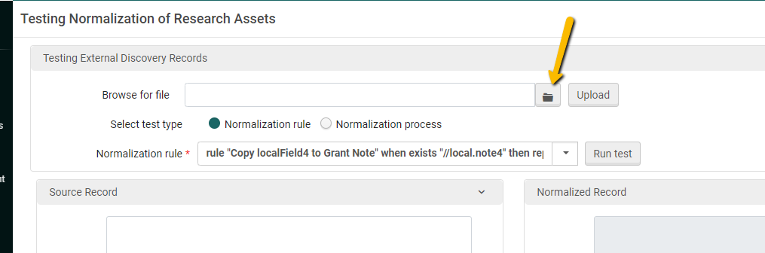

Upload the file:
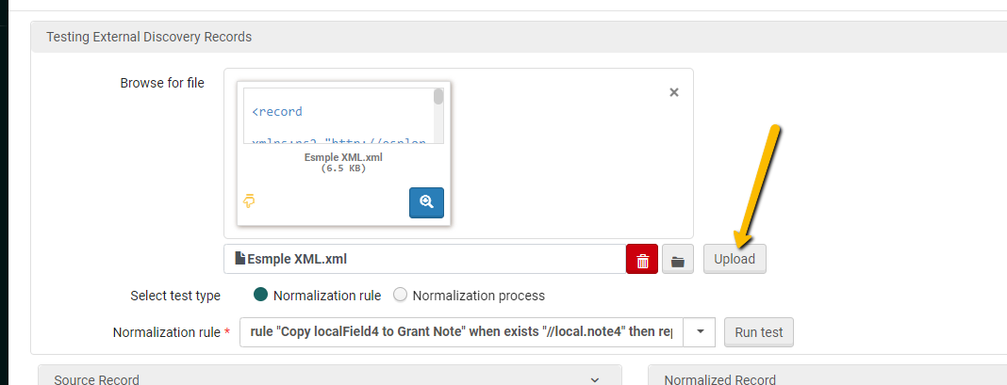
Now you can see your test record in the Source Record frame:
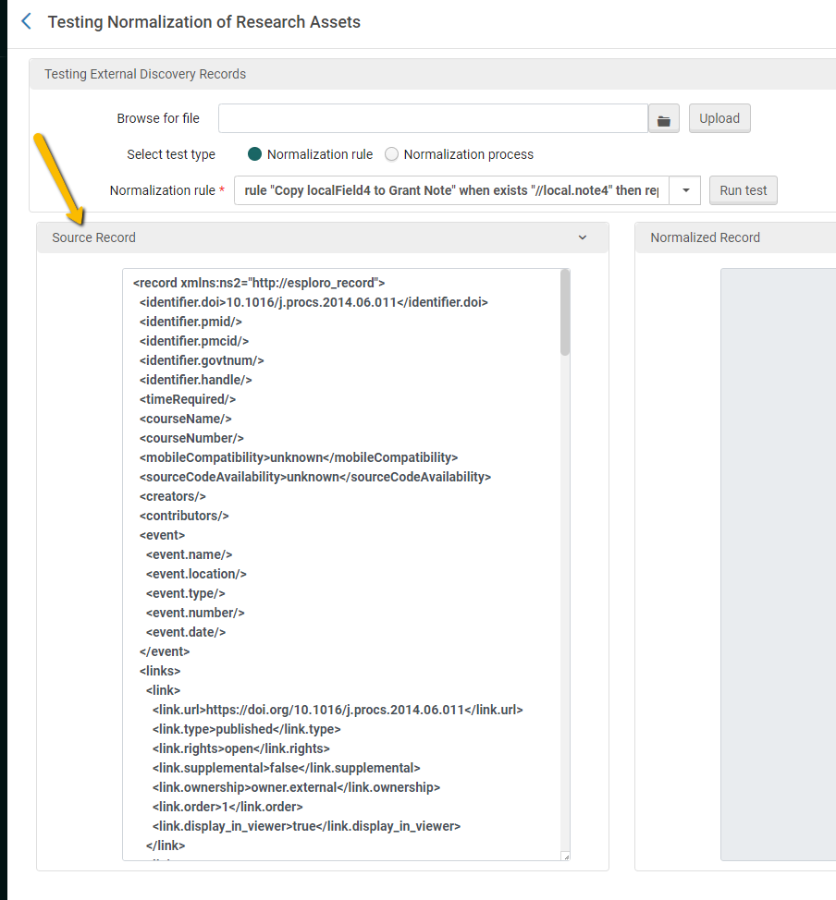
Open the list of available Normalization Rules and select the one you want to test:
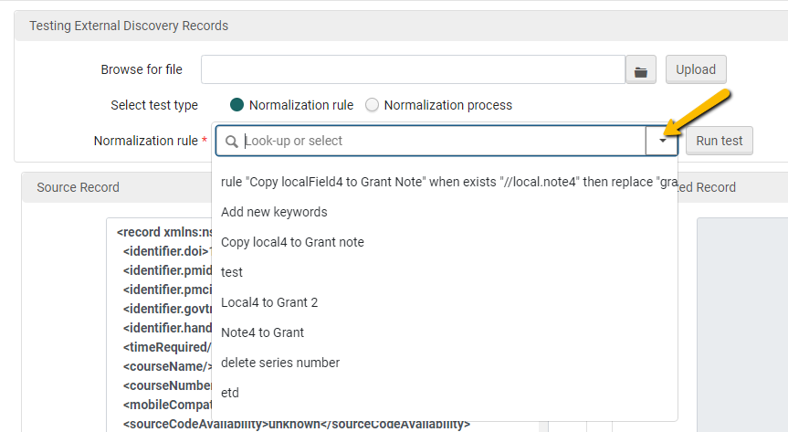
Run the test:
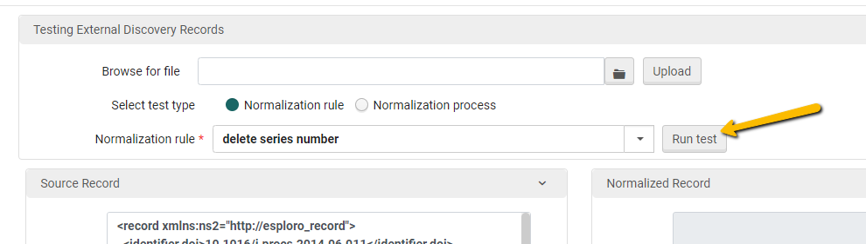
The normalized record will be displayed on the right:
