How to edit a Parser parameter or Coverage and contribute the change to the Alma CZ
For the following collections only, you can edit the portfolio Pars Param and Coverage and contribute your changes to the Alma Community zone:
- Free E- Journals
- Miscellaneous Ejournals
- Miscellaneous Free eBooks
- U.S. Government Documents

To change the URL at the edit portfolio page in your own institution, change the URL in the "Static URL" field [1] Then save the change [2] Or change the coverage.
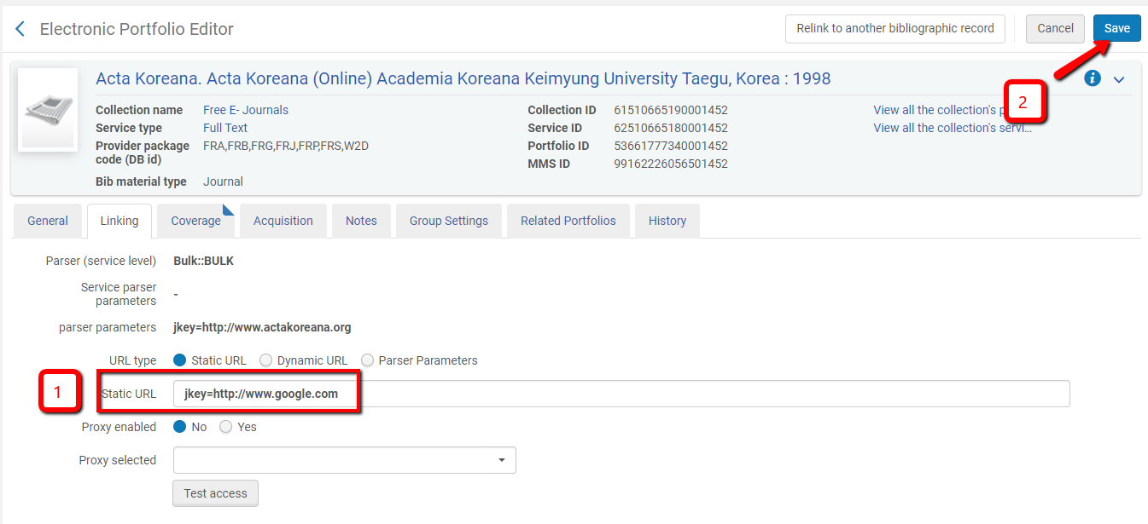
To change the portfolio coverage in the "coverage" tab, change coverage date (or/and add an embargo) [1], change the coverage statement to "Only Local" [2] and save. [3]

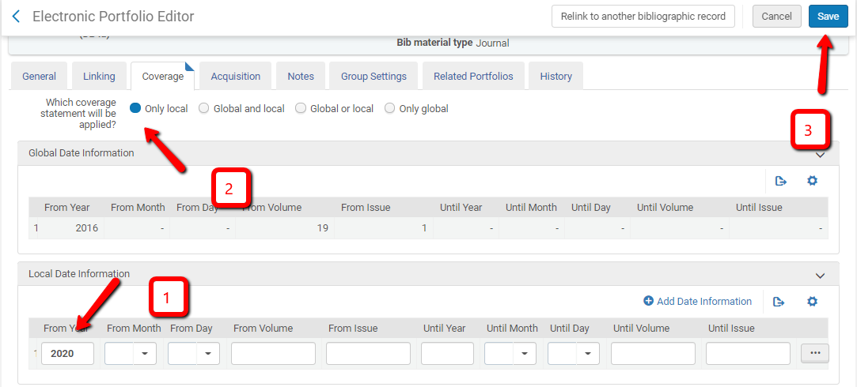

After saving, enter the edit portfolio mode again.
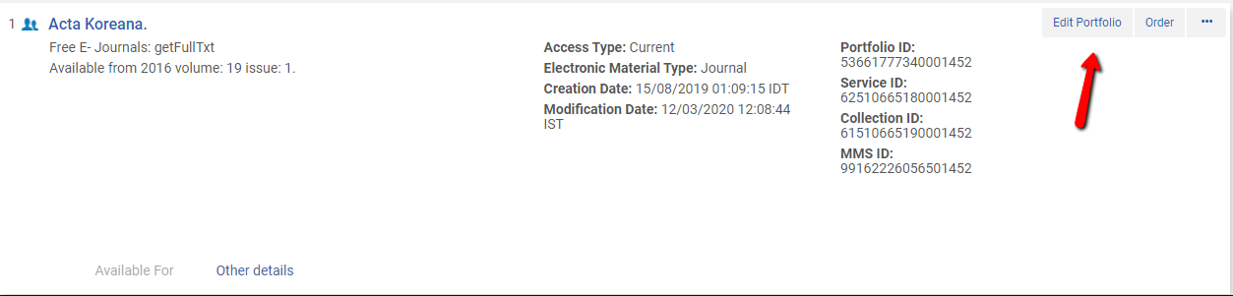
Click on the" Full Text" Service type.
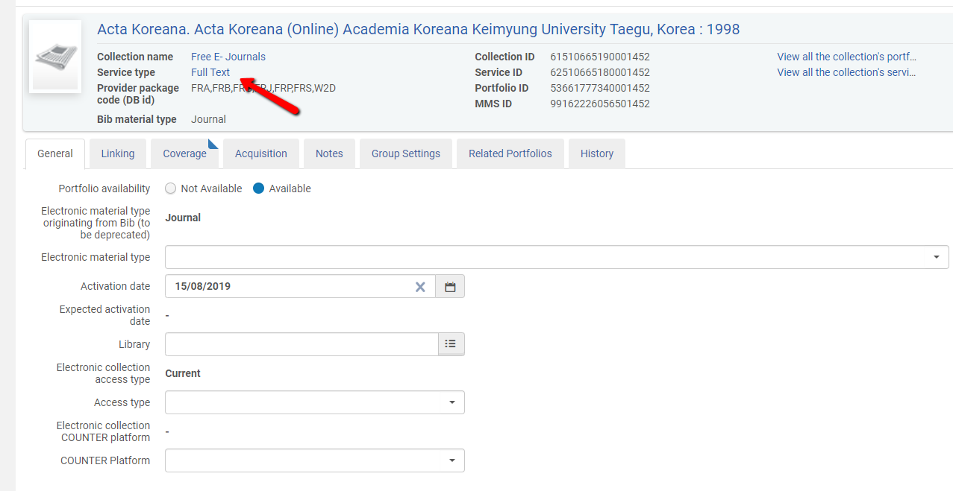
Click on the portfolio tab.
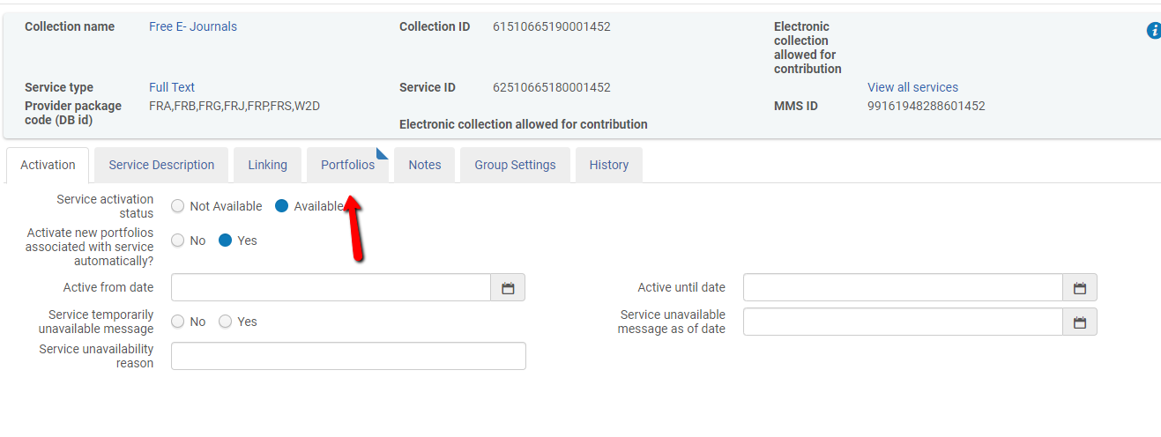
In the filter window, search for the portfolio, by Title, ISSN or ISBN [1] then search [2].
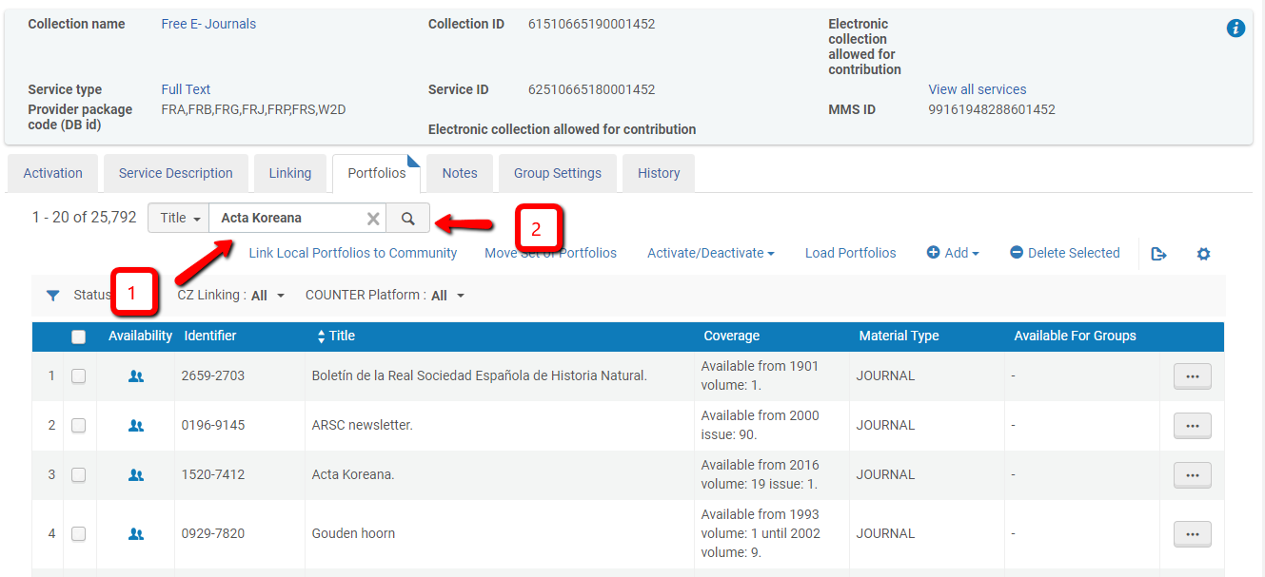
For the portfolio you edited, click on the button [1] then choose "Contribute".
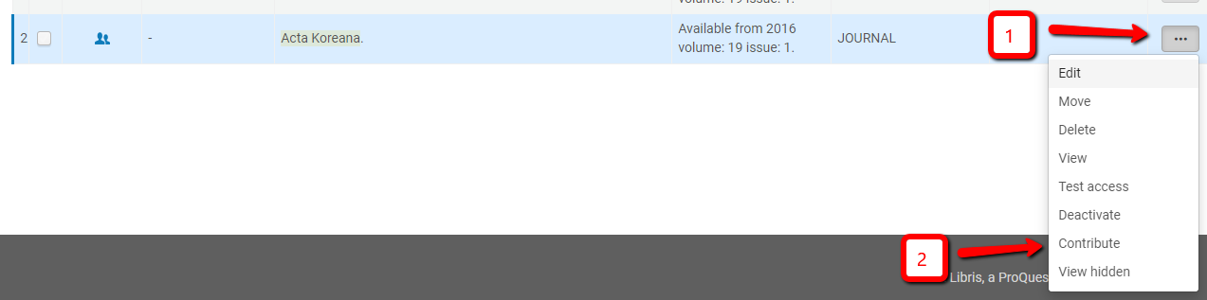

- See that your changes appear [1] than click on "Next" [2].
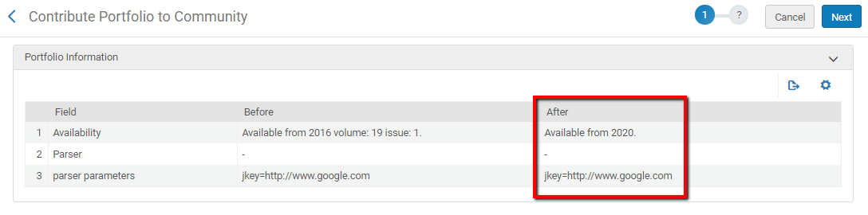

- Click on the "Contribute" button.
