|  |  |
| --- | --- |
| **How to create a report of number of items held by publication decade** |  |
|  | |

**Yoel Kortick**

**Senior Librarian**

**Question:**

I am trying to create a report to show number of items held by publication decade.

How do I show, for example:  # books held in XX library are published between 1960-1970?

**Answer:**

Note that there are multiple ways to do this and below is just one method.

**ONE**

We have a report in the physical items subject area with the following fields (as seen in the “criteria” tab):

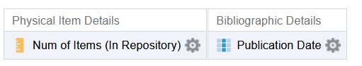

**TWO**

In the “criteria” tab dd another field “Publication Date” because we will use the new field to create the “Publication Decade”

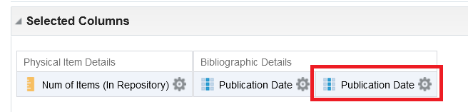

**THREE**

Do “Edit Formula” on the second “Publication Date”

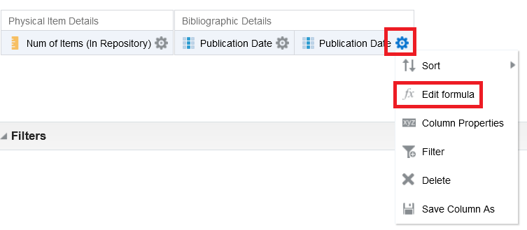

**FOUR**

Rename the field to “Publication Decade”:

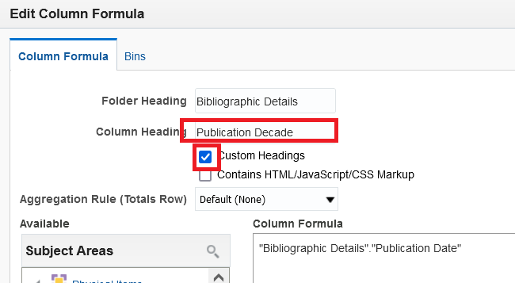

**FIVE**

In the “Column Formula” replace the "Bibliographic Details"."Publication Date" with the following text

This covers from 1900 to 2029. For more years add using the same syntax for additional years.

You may wish to modify this for local needs:

|  |
| --- |
| CASE  WHEN "Bibliographic Details"."Publication Date" LIKE '%190%' THEN '1900-1909'  WHEN "Bibliographic Details"."Publication Date" LIKE '%191%' THEN '1910-1919'  WHEN "Bibliographic Details"."Publication Date" LIKE '%192%' THEN '1920-1929'  WHEN "Bibliographic Details"."Publication Date" LIKE '%193%' THEN '1930-1939'  WHEN "Bibliographic Details"."Publication Date" LIKE '%194%' THEN '1940-1949'  WHEN "Bibliographic Details"."Publication Date" LIKE '%195%' THEN '1950-1959'  WHEN "Bibliographic Details"."Publication Date" LIKE '%196%' THEN '1960-1969'  WHEN "Bibliographic Details"."Publication Date" LIKE '%197%' THEN '1970-1979'  WHEN "Bibliographic Details"."Publication Date" LIKE '%198%' THEN '1980-1989'  WHEN "Bibliographic Details"."Publication Date" LIKE '%199%' THEN '1990-1999'  WHEN "Bibliographic Details"."Publication Date" LIKE '%200%' THEN '2000-2009'  WHEN "Bibliographic Details"."Publication Date" LIKE '%201%' THEN '2010-2019'  WHEN "Bibliographic Details"."Publication Date" LIKE '%202%' THEN '2020-2029'  ELSE "Bibliographic Details"."Publication Date" END |

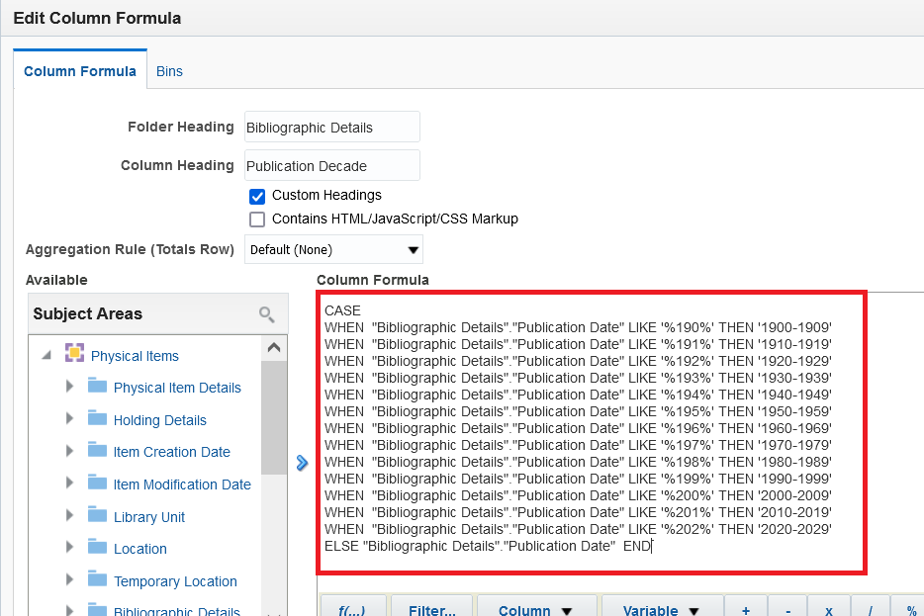

**SIX**

Look at “results” tab and see both the “Publication Date” and corresponding “Publication Decade”

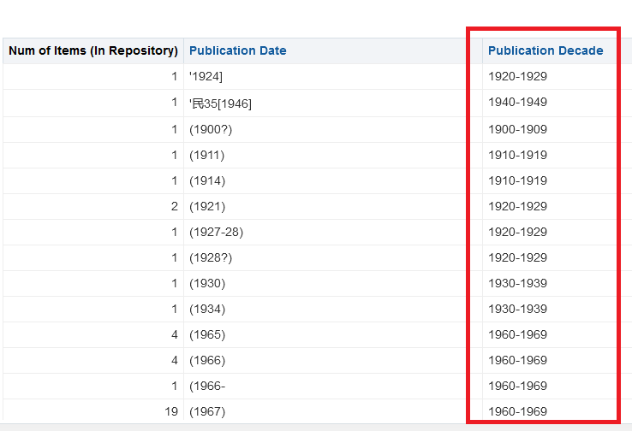

**SEVEN**

Now return to criteria tab and remove the “Publication **Date**” because we only want the “Publication **Decade**”.

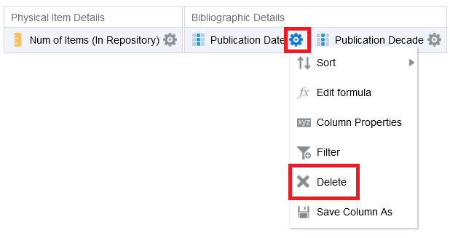

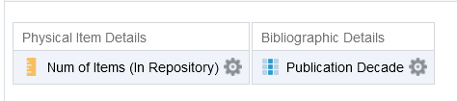

**EIGHT**

Now in :results” tab we have number of items per decade:

