|  |  |
| --- | --- |
| **How to edit the XSL to change the payment method text according to the language of the letter in the Fine Fee Payment Receipt Letter** |  |



**Yoel Kortick**

**Senior Librarian**

**Short answer**

In the xsl of the letter change

<td><xsl:value-of select="fines_fee_transactions/fines_fee_transaction/transaction_method"/></td>

To:

<td><xsl:value-of select="fines_fee_transactions/fines_fee_transaction/transaction_payment_method_display"/></td>

**Full answer:**

**ONE**

Currently when a patron pays a fine and the patron has preferred language “French” (we are using French as an example, this will work for other languages as well):

If the payment method is “Cash” then the method of payment in the French letter states CASH.

If the payment method is “Credit Card” then the method of payment in the French letter states CREDIT_CARD

The letter which is printed is the “Fine Fee Payment Receipt Letter”.

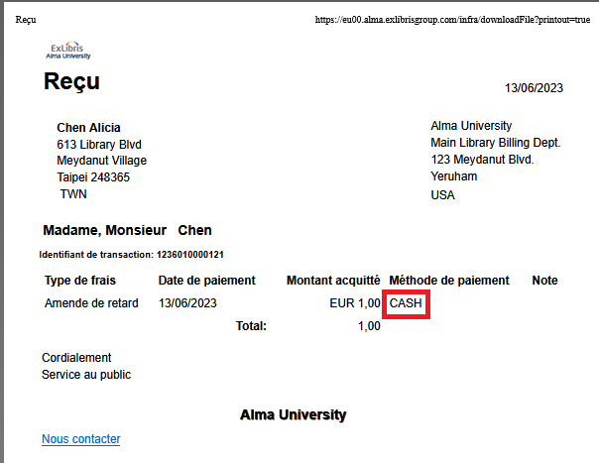

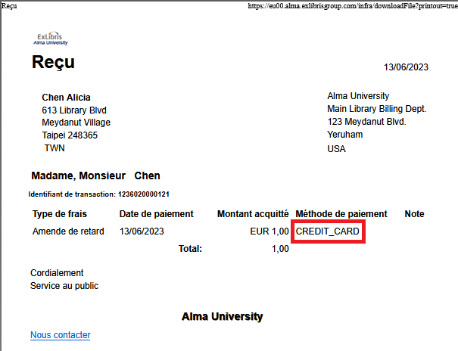

**TWO**

View the xml of the letter to understand where the CASH and CREDIT_CARD are coming from rather than text in the specific language.

Configuration > General > Letters > Letter Configuration > Find “Fine Fee Payment Receipt Letter” > edit > switch to “Letter Examples” tab > download xml of the letter

**In the XML you see that we are seeing in the sent letter from Alma the <transaction_method> instead of the <transaction_payment_method_display>**





The full path is:

/notification_data/user_fines_fees_list/user_fines_fees/fines_fee_transactions/fines_fee_transaction/transaction_payment_method_display

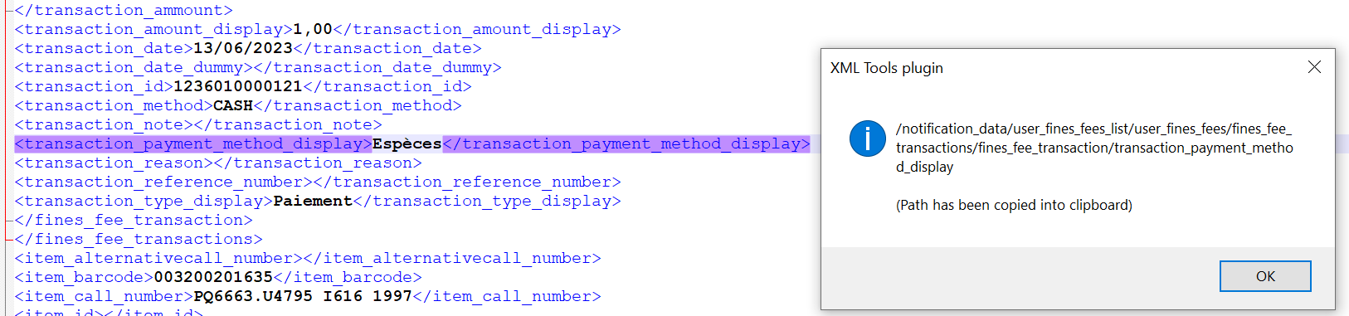

**THREE**

Switch to the “Template” tab and edit the XSL.

Replace this (yellow text):

|  |
| --- |
| </xsl:attribute>  <tr>  <th>@@fee_type@@</th>  <th>@@payment_date@@</th>  <th align="right">@@paid_amount@@</th>  <th>@@payment_method@@</th>  <th>@@note@@</th>  </tr>  <xsl:for-each select="notification_data/user_fines_fees_list/user_fines_fees">  <tr>  <td><xsl:value-of select="fine_fee_type_display"/></td>  <td><xsl:value-of select="create_date"/></td>  <td align="right"><xsl:value-of select="fines_fee_transactions/fines_fee_transaction/transaction_ammount/currency"/>&#160;<xsl:value-of select="fines_fee_transactions/fines_fee_transaction/transaction_amount_display"/></td>  <td><xsl:value-of select="fines_fee_transactions/fines_fee_transaction/transaction_method"/></td>  <td><xsl:value-of select="fines_fee_transactions/fines_fee_transaction/transaction_note"/></td>  </tr>  </xsl:for-each> |

With this (yellow text):

|  |
| --- |
| </xsl:attribute>  <tr>  <th>@@fee_type@@</th>  <th>@@payment_date@@</th>  <th align="right">@@paid_amount@@</th>  <th>@@payment_method@@</th>  <th>@@note@@</th>  </tr>  <xsl:for-each select="notification_data/user_fines_fees_list/user_fines_fees">  <tr>  <td><xsl:value-of select="fine_fee_type_display"/></td>  <td><xsl:value-of select="create_date"/></td>  <td align="right"><xsl:value-of select="fines_fee_transactions/fines_fee_transaction/transaction_ammount/currency"/>&#160;<xsl:value-of select="fines_fee_transactions/fines_fee_transaction/transaction_amount_display"/></td>  <td><xsl:value-of select="fines_fee_transactions/fines_fee_transaction/transaction_payment_method_display"/></td>  <td><xsl:value-of select="fines_fee_transactions/fines_fee_transaction/transaction_note"/></td>  </tr>  </xsl:for-each> <th>@@note@@</th>  </tr> |

**FOUR**

Here is what now appears for cash:

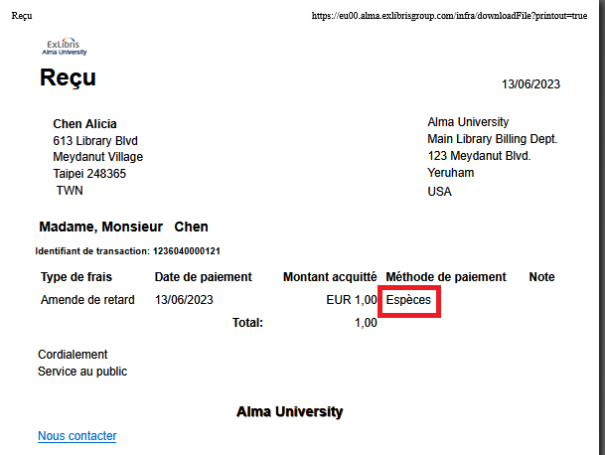

Here is what now appears for credit card:

