|  |  |
| --- | --- |
| **How to make the report prompt year date begin at 2020** |  |
|  | |



**Yoel Kortick**

**Senior Libraian**

**Question**

How can a prompt be filtered according to be showing in the dropdown box just the creation year values higher than 2020)

**Answer**

**ONE**

We have a report (in the “Titles” subject area) with the number of bibliographic records created per creation year. The report is filtered by creation year >= 2020

Here is the “criteria” tab

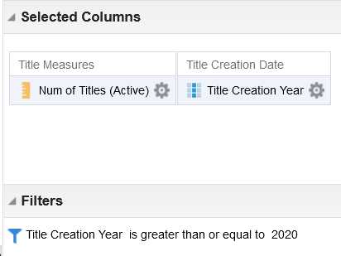

Here is the “results” tab

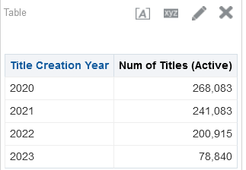

**TWO**

From the “Prompts” column of the report add a new prompt and choose “Column Prompt”.

Select the desired column if it already appears or click “More Columns”

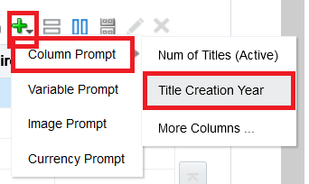

1. In the “Operator” field choose “is greater than or equal to”.
2. In the “User Input” field choose “Choice List”.
3. Click the triangle next to the ‘Options” section to expand it.

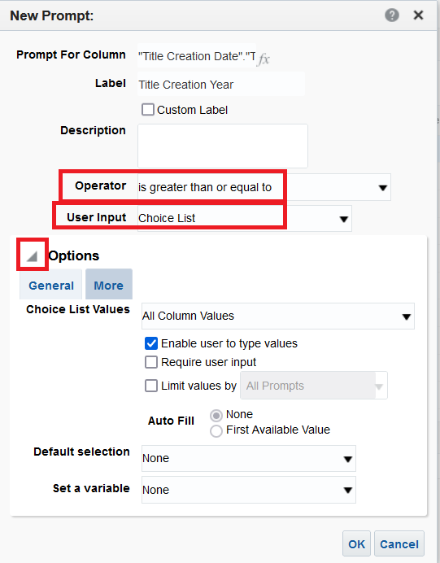

**THREE**

1. In the “Chouce List Values” choose “SQL Results”.
2. In section “Enter a SQL statement to generate the list of values” put as follows (and amend / edit as desired)

SELECT "Title Creation Date"."Title Creation Year" FROM "Titles" WHERE "Title Creation Date"."Title Creation Year" BETWEEN '2020' AND YEAR(CURRENT_DATE) ORDER BY "Title Creation Date"."Title Creation Year" FETCH FIRST 65001 ROWS ONLY

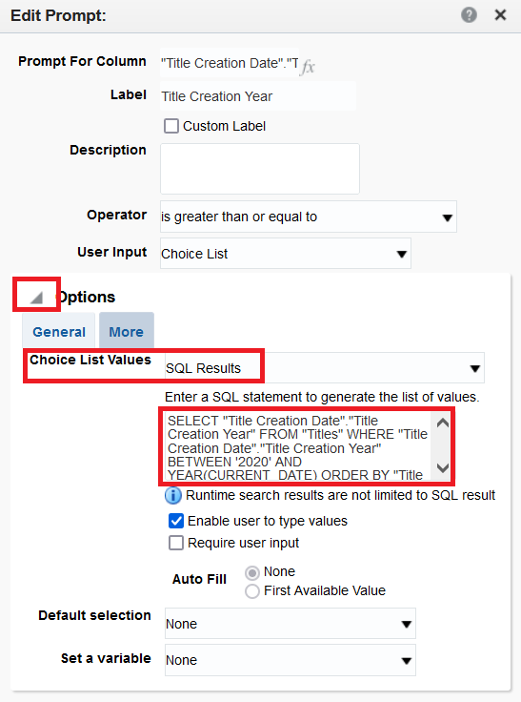

**FOUR**

Open the report and see that the years in the prompt are now 2020, 2021, 2022 and 2023 (2023 is the current year as defined in the sql)



