|  |  |
| --- | --- |
| **Binding items (issues) into a new separate issue and then viewing the withdrawn (deleted) items** |  |
|  | |



**Yoel Kortick**

**Senior Librarian**

In this document we will show it is possible to view items which get withdrawn (deleted) during the binding process.

**ONE**

The journal “Journal of neuroendocrinology” (MMSID 991233030000121) has 5 items.

Four of the items are issues from 2022.

The first issue of 2023 has also arrived

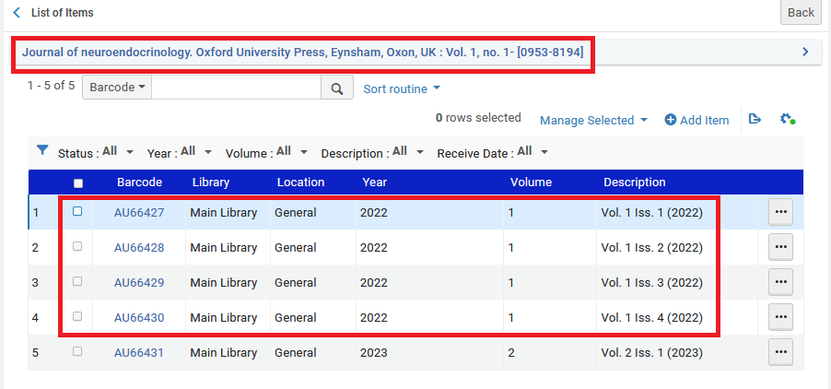

**TWO**

We will bind the four issues of 2022 into one volume and call it “Vol. 1 Iss. 1-4 (2022)”

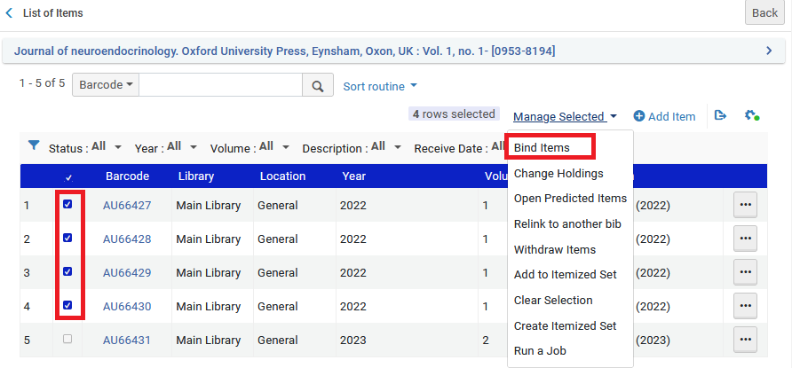

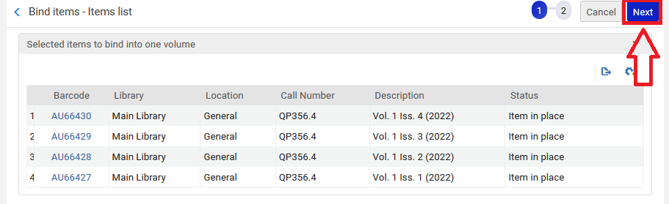

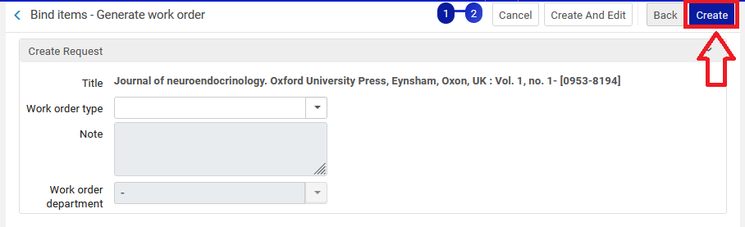

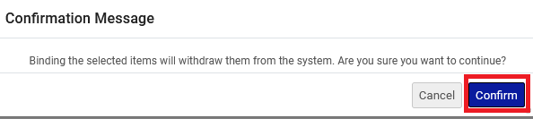

**THREE**

Now we have the bound issue and the one issue from 2023. The four issues from 2022 have been deleted (withdrawn).

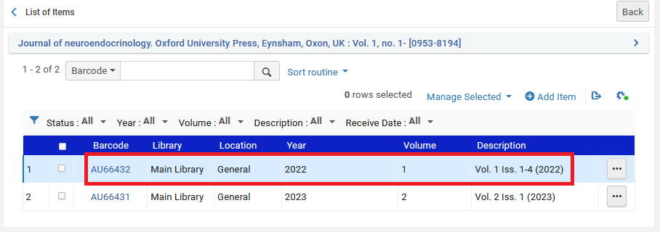

**FOUR**

Now we will look at all the items in Alma Analytics. We see (in red square below) the deleted ones. Not in the red square we see the active ones. We could of course add many more fields to this report.

