|  |  |
| --- | --- |
| **How to handle one order to a vendor for both physical and electronic material and link them together** |  |
|  | |

**Question:**

Is it possible in Alma to have a single order that is defined as both print and electronic at the same time?

**Answer:**

It is possible to handle this type of order using associated PO lines.

In Alma each order is given one POL type and the one POL type corresponds to one type of inventory. However, if one payment is made for both print and electronic then it is considered best practice to do as follows, which will create ‘Associated PO Lines’:

**If using the same bibliographic record for both orders and corresponding type of inventory:**

1. Make order 'A' on one of the types (for example Purchase Type = Physical One Time)
   1. Have payment information in the order. This will be Acquisition Method ‘Purchase’
2. Using same bibliographic record make an additional order 'B' for the other order type (for example electronic) and have this order be of an electronic type (for example Purchase Type = Electronic title One Time).
   1. Have no fund or payment information in order ‘B’.
   2. Use the same supplier (vendor) as order ‘A’.
   3. Have Acquisition Method be ‘Technical’
3. Switch to the ‘Associated PO Lines’ tab of either order and see that Alma has **automatically** linked each of the Purchase Order Lines.
   1. The ‘Physical One Time’ is linked to the ‘Electronic title One Time’ and appears in the ‘Associated PO Lines’ tab
   2. The ‘Electronic title One Time’ is linked to the ‘Physical One Time’ and appears in the ‘Associated PO Lines’ tab

**If using different bibliographic records for both orders and corresponding type of inventory:**

1. Make order 'A' on one of the types (for example Purchase Type = Physical One Time)
   1. Have payment information in the order. This will be Acquisition Method ‘Purchase’
2. Using different bibliographic record make an additional order 'B' for the other order type (for example electronic) and have this order be of an electronic type (for example Purchase Type = Electronic title One Time).
   1. Have no fund or payment information in the order.
   2. Use the same supplier (vendor) as order ‘A’.
   3. Have Acquisition Method be ‘Technical’
3. In the ‘Summary’ tab order ‘B’ scroll down to the ‘Additional’ section and in the ‘Associated PO Lines’ field choose the related PO Line with different inventory type (in the case order 'A')
   1. If desired you can also do the same from order ‘A’ and link it to order ‘B’
4. Switch to the ‘Associated PO Lines’ tab of either order and see that Alma has linked the Purchase Order Lines.

**If using the same bibliographic record for both orders and corresponding types of inventory:**

In the following example we are ordering record MMSID 99119210900121 Title “**Daughters of earth : feminist science fiction in the twentieth century**”. We have one order (and one corresponding payment) to vendor ‘J & S Ltd.’

**ONE**

Create first order for purchase type ‘Physical One Time’

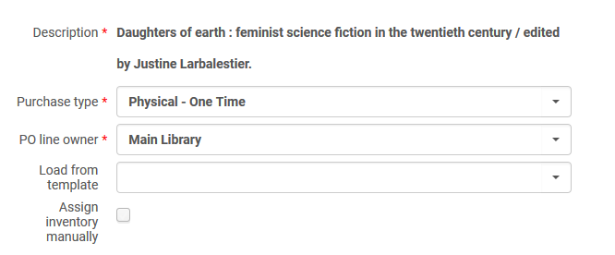

**TWO**

In the PO Line Details choose Acquisition Method ‘Purchase’

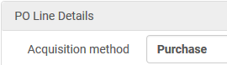

**THREE**

Here we have POL-44553 for “Daughters of earth : feminist science fiction in the twentieth century” for type ‘Physical – One Time’ with a price of 10 EUR.

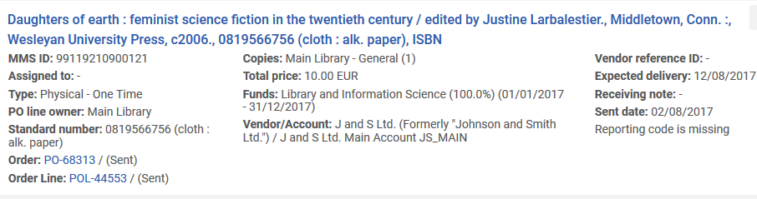

**FOUR**

Create second order for purchase type ‘Electronic title One Time’.

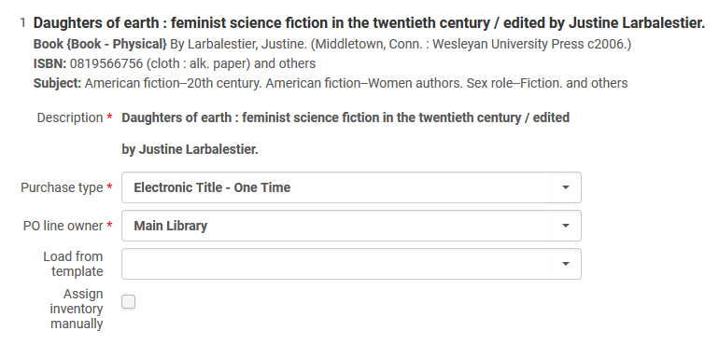

**FIVE**

The order will have no price or fund.

The supplier (vendor) will be the same as the In the PO Line Details choose Acquisition Method ‘Technical’

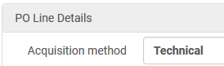

**SIX**

Here we have POL-44554 for “Daughters of earth : feminist science fiction in the twentieth century” for type “Electronic title – One Time” with no price

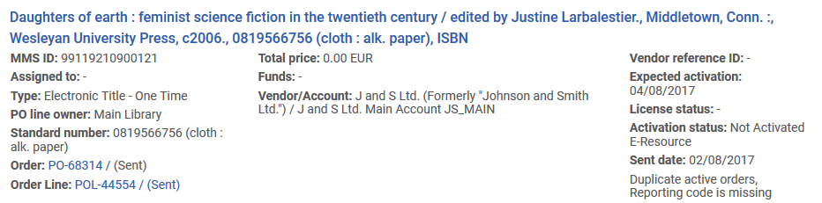

**SEVEN**

Now switch to the ‘Associated PO Lines’ tab of each order and see that it is related to the order of the different purchase type:

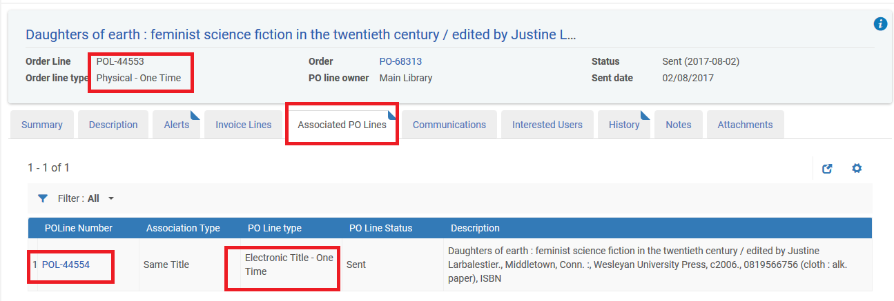

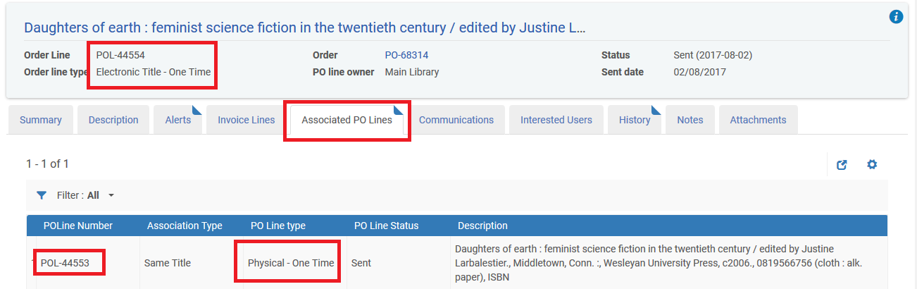

**If using different bibliographic records for both orders and corresponding types of inventory:**

**ONE**

Here we have two orders, one for electronic and one for physical.

They each have a different bibliographic record but the same title: “**Feminism and Renaissance studies”**

POL-44555 is for electronic and is ‘technical’ with no price

POL-44556 is for physical and is ‘purchase’ with for 10.00 EUR

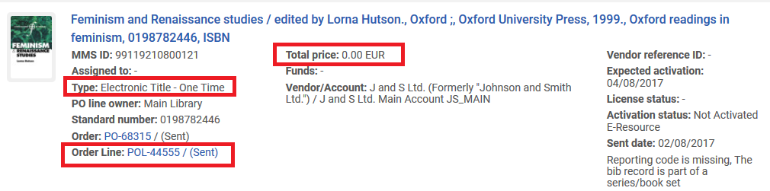

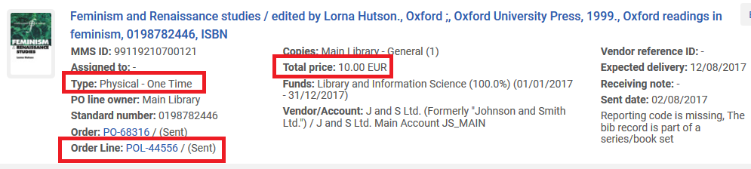

**TWO**

We edit the physical POL-44556 and in the ‘additional’ section we manually link it to associated POL-44555 (the electronic POL)

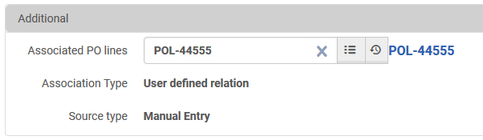

**THREE**

Now in POL-44556 (physcial) we have an associatd POL which is POL-44555 (electronic).

In POL-44555 the associated POL is **automatically** added from the additional section associated POL of POL-44556

